ゆうめいな ひと
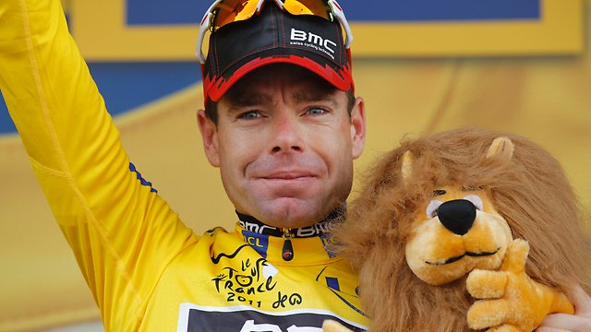  1. Cadel Evans 14/2/1977 | 2. Julia Gillard 29/9/1961 | 3. Kevin Rudd 21/9/1955 | 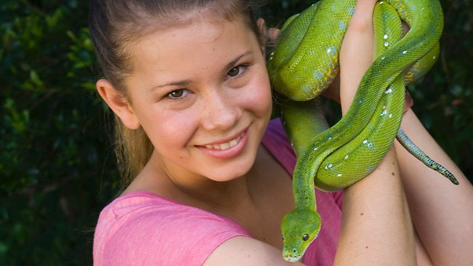  4. Bindi Irwin 24/7/1998 | 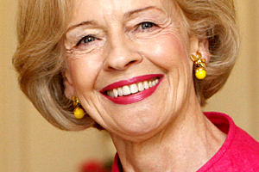  5. Quentin Bryce 23/12/1942
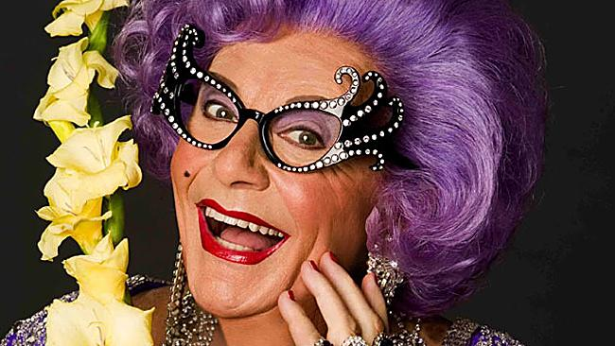  6. Dame Edna 17/2/1934 | 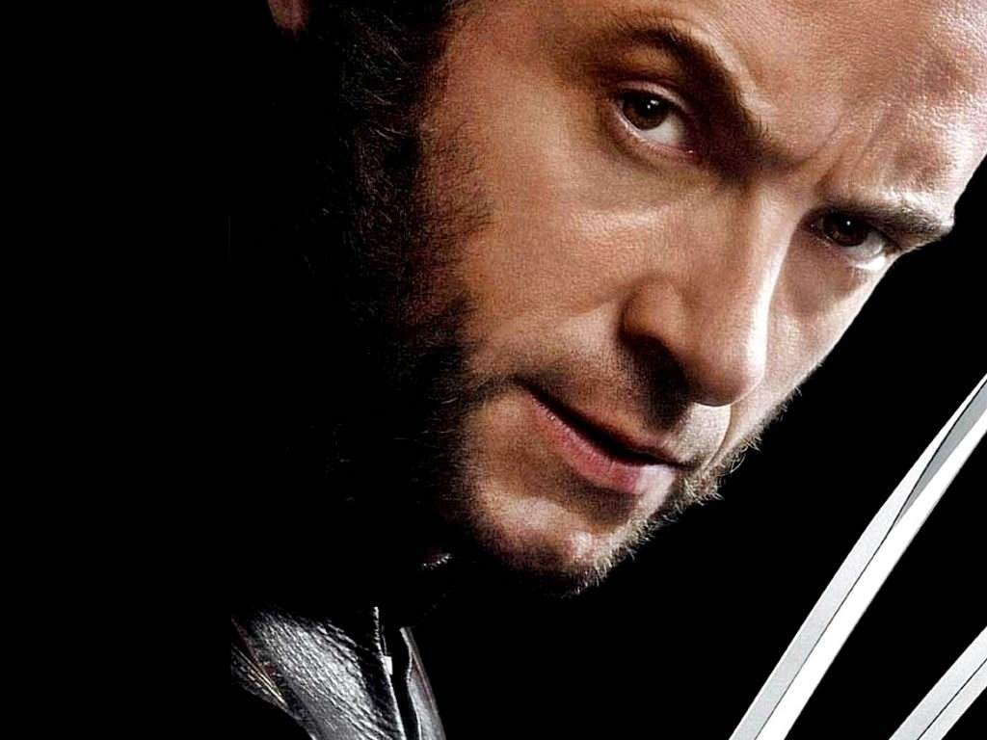  7. Hugh Jackman 12/10/1968 | 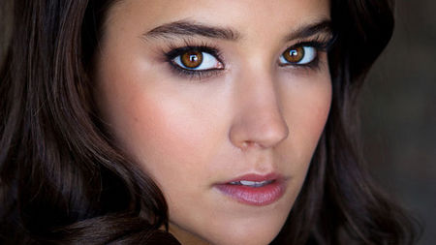  8. Rhiannon Fish 14/3/1991 | 9. Josh Hutcherson 12/10/1992 | 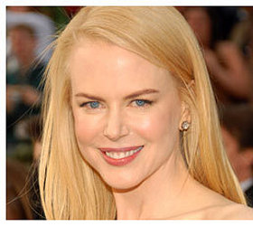  10. Nicole Kidman 20/6/1967
11. Matt Smith 28/10/1982 | 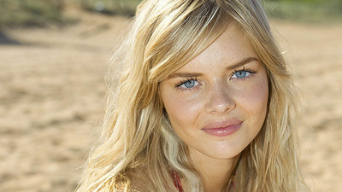  12. Samara Weaving 23/2/1992 | 13. Michael Gambon 19/10/1940 | 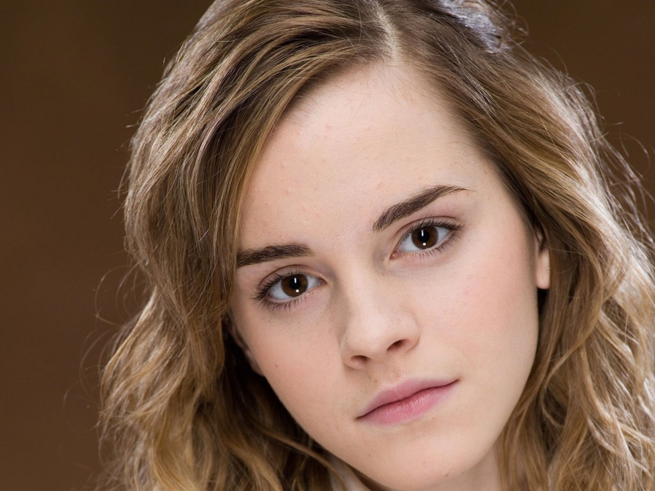  14. Emma Watson 15/4/1990 | 15. Robert Pattinson 13/5/1986
16. Samantha Jade 18/4/1987 | 17. PSY 31/12/1977 | 18. Ke$ha 1/3/1987 | 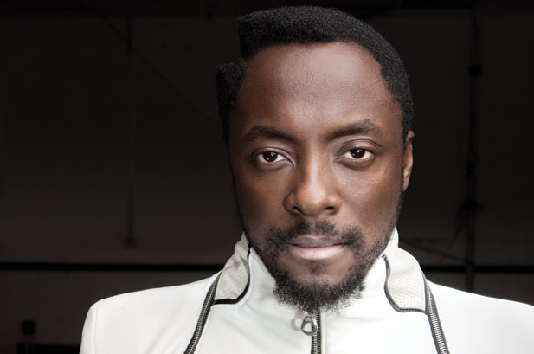  19. Will.i.am 15/3/1975 | 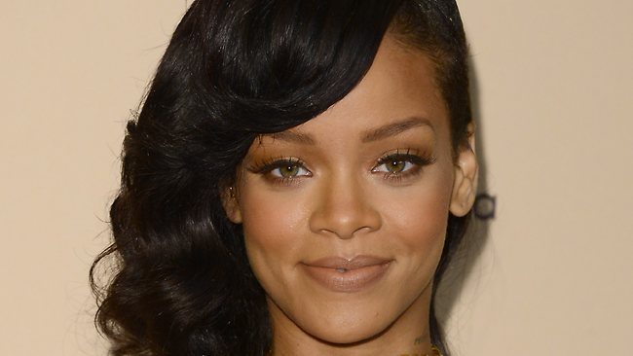  20. Rihanna 20/2/1988
21. Skrillex 15/1/1988 | 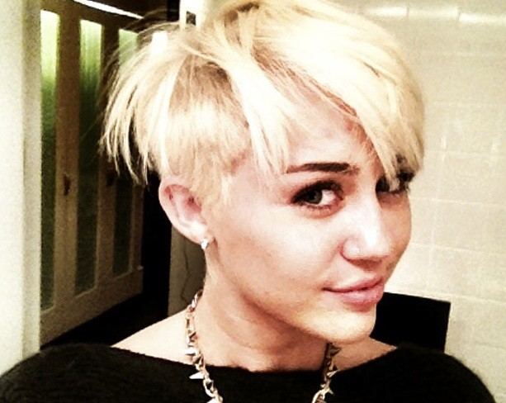  22. Miley Cyrus 23/11/1992 | 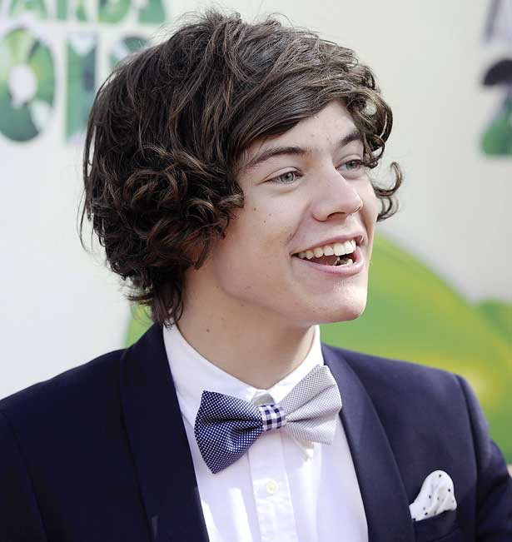  23. Harry Styles 1/2/1994 | 24. Taylor Swift 13/12/1989 | 25. Justin Bieber 1/3/1994
十二し

- Use your famous people chart to practise asking and answering the following questions with your partner. Example:
Q & A

Question: 一 ばん は だれ です か。 Answer: エヴァンス カデル です。
(Ichi ban wa dare desu ka.) (Evans Cadel desu.)

Who is number 1? It’s Cadel Evans.

- Now use your lunar new year chart to find out the どし (doshi – animal sign) of 10 of these famous people. Write their どし in hiragana or romaji next to their photo and then practise asking and answering the following questions with your partner. Example:

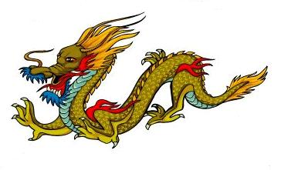
Question: エヴァンス カデルさん は なに どし です か。 Answer: たつ どし です。 (Evans Cadel san wa nani doshi desu ka.) (Tatsu doshi desu.)

What sign is Cadel Evans? (He is) dragon sign.
Vocabulary

~ばん number __ | なに what | うさぎ rabbit | さる monkey
は ha, as topic particle  says ‘wa’ | どし sign | たつ dragon | とり rooster *
だれ who | ねずみ rat | へび snake | いぬ dog
です = is/am/are depending  on the sentence | うし cow | うま horse | いのしし boar
か question particle | とら tiger | ひつじ sheep

あなた は なに どし です か。
?

