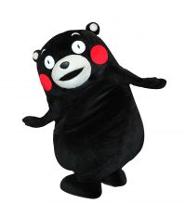
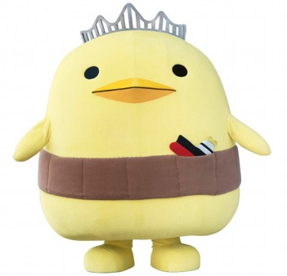
マスコット・キャラクター：
Task 1:
1) What is ‘yurukyara’?
くま

…………………………………………………………………………………………………..
にわ とり

2) Why are mascot characters popular in Japan?

………………………………………………………………………………………………………………………………...............
3) What is Kyushu’s yurukyara? What kind of mascot character is it?
…………………………………………………………………………………………………………………………………………….
4) What is Nagoya’s yurukyara? What kind of mascot character is it?
…………………………………………………………………………………………………………………………………………….
5) Whose mascot is the bear and the chicken? What are their real names?
…………………………………………………………………………………………………………………………………………..
…………………………………………………………………………………………………………………………………………..
6) Find 6 mascot characters which represent a prefecture, a city or a company. Then describe their relationship to the place or company. Answer in Japanese or English.
マスッコト Name | Their relationship to the place or company.

7) Who is your favourite mascot and why? 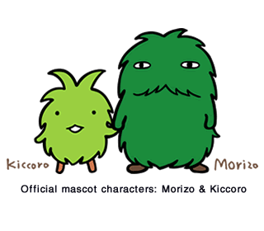
…………………………………………………………………………………………………………………………………………
…………………………………………………………………………………………………………………………………………
Task 2:
Task 3: Design your own ゆるちゃらto represent your city, town team or school. Write its name in the top box.

b) Describe your character and its relationship with the place/team you have chosen for it to represent.
…………………………………………………………………………………………………………………………………………………………….
…………………………………………………………………………………………………………………………………………………………….
…………………………………………………………………………………………………………………………………………………………….
…………………………………………………………………………………………………………………………………………………………….
……………………………………………………………………………………………………………………………………………………………

