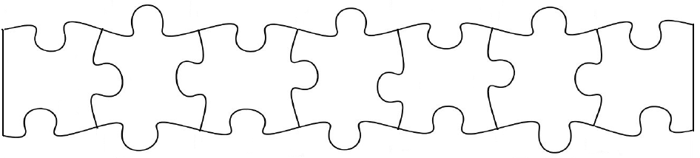
verb ending 。
verb
(of motion)
stem
place
へ
or に
reason
に
means of
で
transport
Person
は
general time
Specific time
に
Use the pattern below and the words in the boxes – がんばってね！

My family went to the pool last Thursday for a swim.

A full stop takes up a whole square.
There should be no squares left empty!
Mr Tanaka is going to Japan tomorrow.

I go to school every day by bus.

We want to go to the mountains for a picnic tomorrow.

My friend is coming to my house at six o’clock.

My younger sister rode her bike to the mountains for a picnic on Saturday.

My friend’s mum went to Tokyo last week do some shopping.

I didn’t go to the beach to surf on Saturday. (I) am going tomorrow.

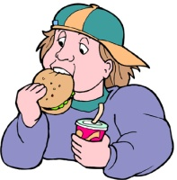
Here’s another pattern. This is for verbs that can take an object
(i.e. you can perform the action of the verb on something)

For example: Read a book. / Eat a hamburger.
(You perform the action of reading on the book and eating on the hamburger so book and hamburger are the objects of the verbs read and eat.

verb ending 。
verb
(transitive)
stem
object
(of the verb)
を
instrument
or tool
で
place
Person
は
general time
Specific time
に

で

Mum bought some food at the supermarket on Tuesday.

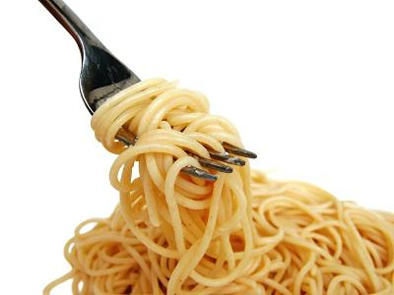
The teacher has a coffee every morning.

Dad doesn’t eat spaghetti with chopsticks. (He) eats it with a fork.

Let’s eat dinner in a restaurant tonight.

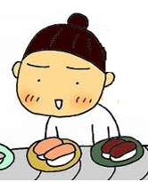
We watched a movie at school yesterday.

I saw my friend’s dad at about 9.30 at the sushi bar last Thursday.

Mr Tanaka reads the newspaper at the office every morning.

Verb Stems
buy かい
come き
drink のみ
eat たべ
go いき
listen to きき
sing うたい
speak はなし
read よみ
return かえり
watch / look at み
write / draw かき

General Times
every morning まいあさ
everyday まいにち
in the afternoon ごご
in the evening ゆうがた
in the morning あさ
last week せんしゅう
today きょう
tomorrow あした
tonight こんや
yesterday きのう

Specific Times
about 9.30 九時半ごろ
about 10.30 十時半ごろ
at 6 o’clock 六時
at 8 o’clock 八時
last Thursday せんひゅうの木よう日
next Monday らいしゅうの月よう日
on Tuesday 火よう日
on Saturday(s) 土よう日
on Sunday(s) 日よう日

Reasons
for a swim およぎ
for a walk さんぽ
to shop かいもの
for a picnic ピクニック
for a party パーティー
to see the flowersはなみ
to surf サーフィング

Places
beach うみ
flower shop はなや
friend’s home ともだちのうち
home うち
Japan 日本
Mountain やま
movie theatre えいがかん
my house うち
office かいしゃ
park こうえん
pool プール
restaurant レストラン
school がっこう
shop みせ
supermarket スーパー
sushi bar すしや
Tokyo とうきょう
Objects of Verbs
book ほん
breakfast あさごはん
coffee コーヒー
dinner ばんごはん
essay さくぶん
flowers はな
food たべもの
French フランスご
ice cream アイサクリーム
Japanese 日本ご
letter てがみ
lunch ひるごはん
mountain やま
movie えいが
music おんがく
news ニュース
photos しゃしん
pictures え
radio ラジオ
spaghetti スパゲッティ
sushi すし
TV テレビ
udon うどん

Transport
bicycle じてんしゃ
bus バス
car くるま
plane ひこうき
taxi タクシー
train でんしゃ

Tool or Instrument
chopsticks おはし
fork フォーク
hands て
pen ペン
pencil えんぴつ
Verb Endings
Present /future affirmative ます
Present /future negative ません
Past affirmative ました
Past negative ませんでした
Let’s ましょう
Want to たいです
Don’t want to たくないです
People
dad ちち
I わたし
mum はは
Mr Tanaka 田中さん
my family かぞく
my friend ともだち
my friend’s dad ともだちのおとうさん
my friend’s mum ともだちのおかあさん
my friend’s older sister ともだちのおねえさん
my older brother あに
my younger sister いもうと
the students せいと
the teacher せんせい
we わたしたち

ANSWERS
か | ぞ | く | は | せ | ん | し | ゆ | う | の | 木 | よ | う | 日 | に | プ | ― | ル | へ | お | よ | ぎ | に | い | き | ま | し | た | 。
My family went to the pool last Thursday for a swim.

Mr Tanaka is going to Japan tomorrow.
田 | 中 | さ | ん | は | あ | し | た | 日 | 本 | に | い | き | ま | す | 。

I go to school every day by bus.
わ | た | し | は | ま | い | に | ち | バ | ス | で | が | つ | こ | う | に | い | き | ま | す | 。

We want to go to the mountains for a picnic tomorrow.
わ | た | し | た | ち | は | あ | し | た | や | ま | へ | ピ | ク | ニ | ッ | ク | に | い | き | た | い | で | す | 。

My friend is coming to my house at six o’clock.
と | も | だ | ち | は | 六 | 時 | に | う | ち | に | き | ま | す | 。

My younger sister rode her bike to the mountains for a picnic on Saturday.
い | も | う | と | は | ど | よ | う | び | に | じ | て | ん | し | や | で | や | ま | へ | ピ | ク | ニ | ツ | ク | に | い | き | ま | し | た | 。

My friend’s mum went to Tokyo last week do some shopping.
と | も | だ | ち | の | お | か | あ | さ | ん | は | せ | ん | し | ゆ | う | と | う | き | よ | う | へ | か | い | も | の | に | い | き | ま | し | た | 。

I didn’t go to the beach to surf on Saturday. (I) am going tomorrow.
わ | た | し | は | ど | よ | う | び | に | う | み | へ | サ | ― | フ | イ | ン | グ | に | い | き | ま | せ | ん | で | し | た | 。

あ | し | た | い | き | ま | す | 。

Mum bought some food at the supermarket on Tuesday.
は | は | は | か | よ | う | び | に | ス | ― | パ | ― | で | た | べ | も | の | を | か | い | ま | し | た | 。

The teacher has a coffee every morning.
せ | ん | せ | い | は | ま | い | あ | さ | コ | ― | ヒ | ― | を | の | み | ま | す | 。

Dad doesn’t eat spaghetti with chopsticks. (He) eats it with a fork.
ち | ち | は | お | は | し | で | ス | パ | ゲ | ツ | テ | イ | を | た | べ | ま | せ | ん | 。 | フ | オ | ― | ク | で | た | べ | ま | す | 。

Let’s eat dinner in a restaurant tonight.
こ | ん | や | レ | ス | ト | ラ | ン | で | ば | ん | ご | は | ん | を | た | べ | ま | し | よ | う | 。

We watched a movie at school yesterday.
わ | た | し | た | ち | は | き | の | う | が | つ | こ | う | で | え | い | が | を | み | ま | し | た | 。

I saw my friend’s dad at about 9.30 at the sushi bar last Thursday.
わ | た | し | は | せ | ん | し | ゆ | う | の | も | く | よ | う | び | に | 九 | 時 | 半 | ご | ろ | に

す | し | や | で | と | も | だ | ち | の | お | と | う | さ | ん | を | み | ま | し | た | 。

Mr Tanaka reads the newspaper at the office every morning.
田 | 中 | さ | ん | は | ま | い | あ | さ | か | い | し | や | で | し | ん | ぶ | ん | を | よ | み | ま | す | 。

