Where do you live?

Where do you live? どこ　に　すんでいますか

C:\Program Files\Microsoft Office\MEDIA\CAGCAT10\j0185604.wmfI Live in_______ ＿＿＿に　すんでいます

1. Read the following conversation to find out where Kumiko and Yuki live.

Kumiko: ゆきさん　どこにすんでいますか。

Yuki: わたしはひろしまにすんでいます。

Kumiko lives in:________________

Yuki lives in:___________________

くみこさん　どこにすんでいますか。

Kumiko: よこはまにすんでいます。

1. Write your own conversation between Yourself and Kenji (K)

 (K) Hello________________________________________

( ) Hello_________________________________________

(K) Whats your name?_____________________________

( ) My name is(___) ______________________________

(K) My name is Kenji ______________________________

( ) How old are you? ______________________________

(K) I am (__)yrs ______________________________

( )How old are you? _______________________________

(K) I am___yrs _______________________________

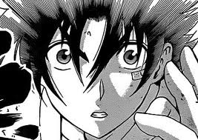(K) Whats your phone number? ______________________

( )My number is(____) __________________________

(K) Where do you live? __________________________

( ) I live in (______) __________________________

(K) Nice to meet you __________________________

( ) Nice to meet you __________________________