なに を します か。
- Under each picture, write an appropriate verb.
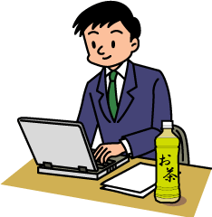
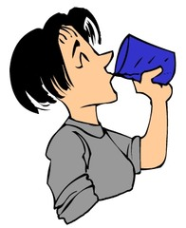
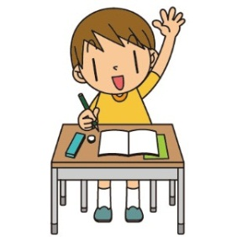
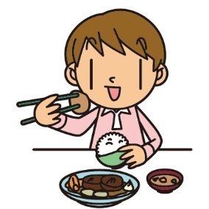

________________ ________________ ________________ ________________
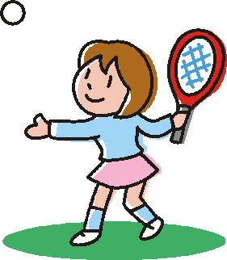
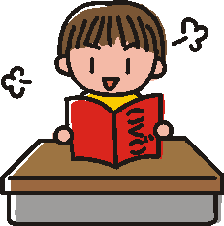
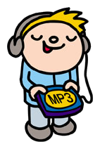
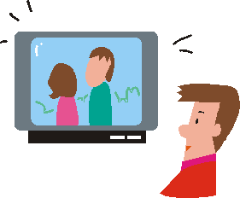

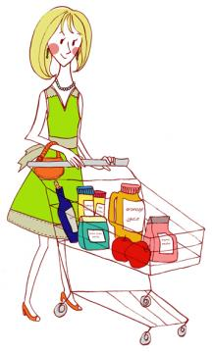
_______________ _______________ _______________ ________________
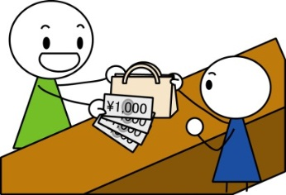

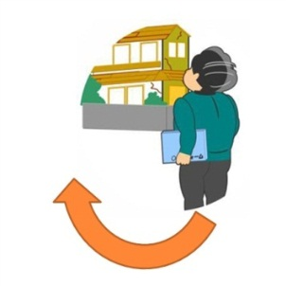
________________ _________________
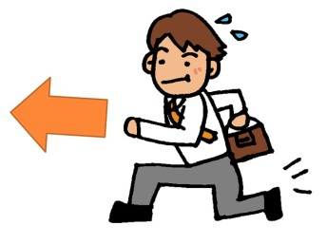
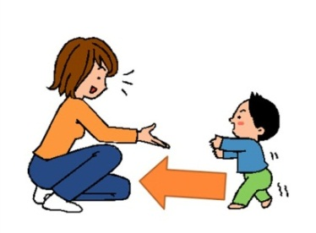

________________ __________________ _ ________________
Present (routines, everyday activities – I do something) and/or future tense (I will do something)

OBJECT ＋ particle を ＋ VERBます

OBJECT ＋ particle に ＋ MOVEMENT VERBます

N.B. Verbs of movement don’t use particle を but need a particle ni に (meaning ‘to’)

- Using the pictures in ‘A’, write sentences describing what each person does every day.
Example:
あさごはん を たべます。
I eat breakfast.
しごと に いきます。
I go to work.

________________________________________________________________________
________________________________________________________________________
________________________________________________________________________
________________________________________________________________________
________________________________________________________________________
________________________________________________________________________
________________________________________________________________________
________________________________________________________________________
________________________________________________________________________
________________________________________________________________________
________________________________________________________________________
________________________________________________________________________
________________________________________________________________________

- Ask your partner these questions:
- What do you do every day? まいにち、なに を します か？
- What will you do tomorrow? あした、 なに を します か？
- What will you do this weekend? しゅうまつ に なに を します か？
Negatives are formed by changing the ます toません.

OBJECT ＋ particle を ＋ VERBません

- Using the pictures in ‘A’, make a negative sentence for each.
Example:
あさごはん を たべません。
I don’t eat breakfast.
しごと に いきません。
I don’t go to work.

________________________________________________________________________
________________________________________________________________________
________________________________________________________________________
________________________________________________________________________
________________________________________________________________________
________________________________________________________________________
________________________________________________________________________
________________________________________________________________________
________________________________________________________________________
________________________________________________________________________
________________________________________________________________________
________________________________________________________________________
________________________________________________________________________

- Tell your partner in full sentences 2 things you usually don’t:
    - eat
    - drink
    - read
    - watch
    - play
    - go
Past tense (I did something) ます changes to ました

OBJECT ＋ particle を ＋ VERBました
Past tense (I didn’t do something) ません changes to ませんでした

OBJECT ＋ particle を ＋ VERBませんでした

- Complete this table of verbs:
English | Present or future tense | Negative  present or future | Past tense | Negative past tense
eat | たべます | たべません | たべました | たべませんでした
study
drink
work
listen
read
watch
play
buy
go shopping
go
come
go back (return)

- Ask your partner these questions:
- What did you do yesterday? きのう、なに を しました か？
- What did you do last weekend? せんしゅう の しゅうまつ に なに を しました か。
- What did you do on the summer holidays? なつやすみ に なに を しました か。
- Did you ＿＿＿＿ yesterday? きのう、_______ ました か？

    - watch a movie
    - play golf
    - buy an Ipod
    - eat sushi
    - study Japanese

    - go to school

