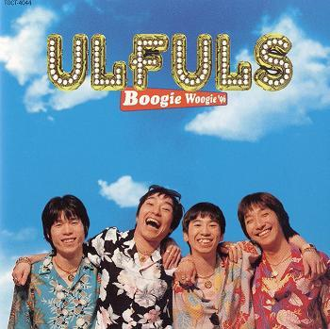
これは ウルフレズです。
ウルフルズ は ロックバンド です。おさか から です。
まつもと トータス は リードボーカル です。
たんじょうび は 1966年12月28 日 です。
かれ は ザ・ビートルズ が 好き です。

- What type of band is the Ulfuls?
_________________________________________________________________________________

- Who is Tootasu Matsumoto?
_________________________________________________________________________________

- When is Tootasu’s birthday?
_________________________________________________________________________________

- What are his likes?
_________________________________________________________________________________

- Watch the video of the Ulfuls. What’s the name of the song? Do you like them? Why/why not?
_________________________________________________________________________________
_________________________________________________________________________________

