|  |  |  |
| --- | --- | --- |
| SUPOOTSU | LIKES (SUKI) | DISLIKES (KIRAI) |
| SUKII |  |  |
| SAKKAA |  |  |
| GORUFU |  |  |
| KARATE |  |  |
| BASUKETTOBOORU |  |  |
| RAGUBII |  |  |
| NETTOBOORU |  |  |
| JOOBA |  |  |
| TENISU |  |  |
| SUMOO |  |  |
| OTHER |  |  |

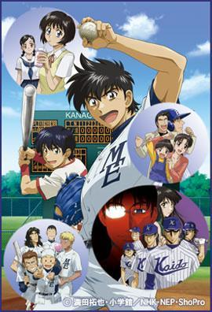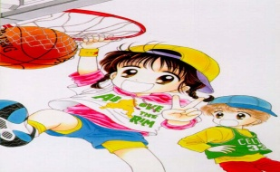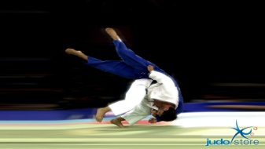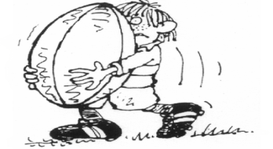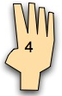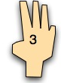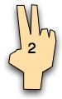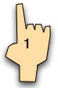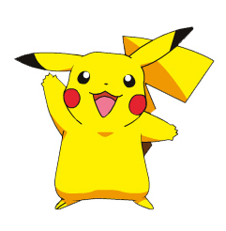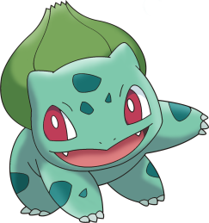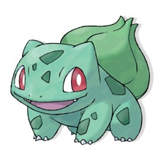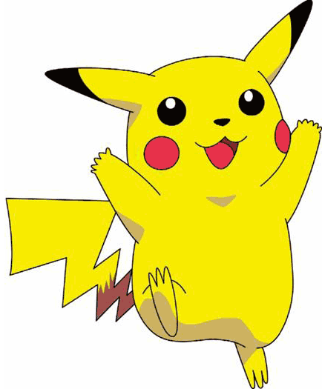[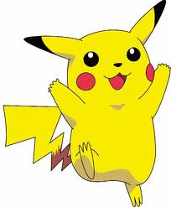](http://www.google.co.nz/imgres?imgurl=http://pikachuandpals.files.wordpress.com/2008/07/pikachu21.gif&imgrefurl=http://www.smogon.com/forums/showthread.php?t%3D73823&usg=__FJj4ft6p9pNPGf_F_oKL_0Nqsys=&h=525&w=434&sz=32&hl=en&start=1&zoom=1&tbnid=xeeT0rrKu-1WEM:&tbnh=132&tbnw=109&ei=yUX5TYHbJY-qvQOa7_iSAw&prev=/search?q%3Dpikachu%26hl%3Den%26biw%3D1132%26bih%3D677%26gbv%3D2%26tbm%3Disch&itbs=1)

**Likes-**

**Dislikes-**

**Ask what kind of sports your class likes and dislikes in Japanese.**

**What sports are liked most? What sports are disliked most?**

**NANI GA KIRAI DESU KA**

**What do you dislike?**

**NANI GA SUKI DESU KA**

**What do you like?**

**WATASHI WA SUIEI GA KIRAI DESU**

**I dislike swimming.**

**WATASHI WA SUMOU GA SUKI DESU**

**I like sumo.**