Sports & Hobbies Grammar Review

Label the following sports and hobbies with the appropriate word in Japanese.
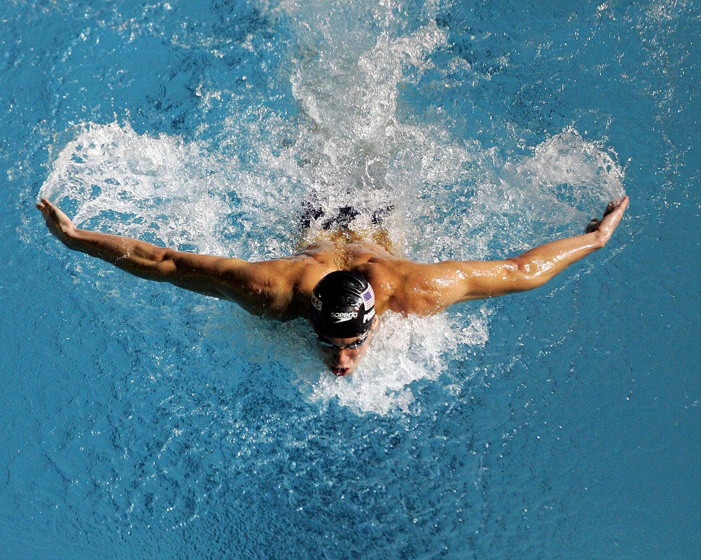

____________ _____________ ____________
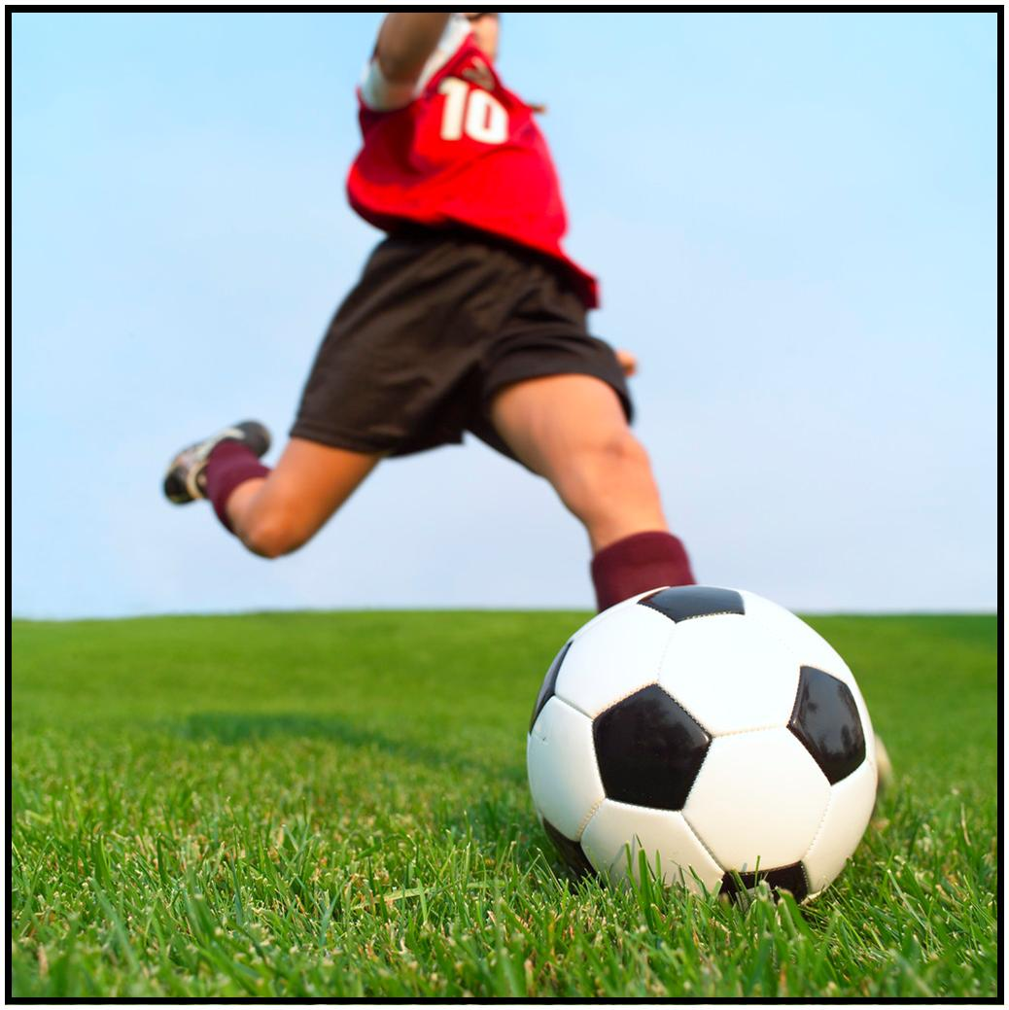

_____________ _____________ ___________

To say that something is your hobby, use the following grammatical structure:
My hobby is .
しゅみ は です。
My hobby+ particle + hobby + is

Translate the following sentences:

- しゅみ は おんがく です。

＿＿＿＿＿＿＿＿＿＿＿＿＿＿＿＿＿＿＿＿＿＿＿＿＿＿＿＿＿＿＿
- しゅみ は りょうり です。

＿＿＿＿＿＿＿＿＿＿＿＿＿＿＿＿＿＿＿＿＿＿＿＿＿＿＿＿＿＿＿
- My hobby is reading.

_______________________ __________________________
- My hobby is volleyball.

_________________________________________________

To say that you play a particular sport, use the following grammatical structure:
I play ___________.
____________ をします。
sport + particle + verb

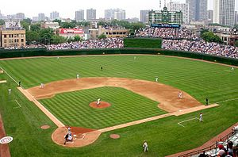
Translate the following sentences into English:

- やきゅう を します。

＿＿＿＿＿＿＿＿＿＿＿＿＿＿＿＿＿＿＿＿＿＿＿＿＿＿＿＿＿＿＿
- フットボール を します。
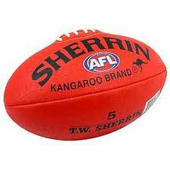
＿＿＿＿＿＿＿＿＿＿＿＿＿＿＿＿＿＿＿＿＿＿＿＿＿＿＿＿＿＿＿
- すいえい を します。

＿＿＿＿＿＿＿＿＿＿＿＿＿＿＿＿＿＿＿＿＿＿＿＿＿＿＿＿＿＿＿
- サッカー を しますか。

＿＿＿＿＿＿＿＿＿＿＿＿＿＿＿＿＿＿＿＿＿＿＿＿＿＿＿＿＿＿＿

To say that you can play a particular sport, use the following grammatical structure:
I can play _________.
____________ ができます。
sport + particle + verb

Translate the following sentences:

- ネットボール が できます。

＿＿＿＿＿＿＿＿＿＿＿＿＿＿＿＿＿＿＿＿＿＿＿＿＿＿＿＿＿＿＿
- サーフィン が できます。

＿＿＿＿＿＿＿＿＿＿＿＿＿＿＿＿＿＿＿＿＿＿＿＿＿＿＿＿＿＿＿
- I can play baseball.

_________________________________________________
- Can you play basketball?

_________________________________________________
- Yes, I can.

_________________________________________________

