せつぶん- Setsubun
February is the last month of winter in Japan and the festival of Setsubun せつぶんmarks the end of winter and welcomes the arrival of spring. Setsubun せつぶん also signifies the day on which any evil spirits that might be lurking are chased away to ensure a fortunate year. This is done by tossing roasted beans here, there and everywhere.
An important aspect of this ritual is that the person who does the bean throwing is the "Toshi otokoとしおとこ" the "man of the year." This connects to the juunishi じゅうにしanimals...mouse, cow, tiger etc...anyone born in the animal of the year is the one who throws the beans.
It is also said that if you pick up and eat the same number of beans as your age, you will have good luck and health for the next year!
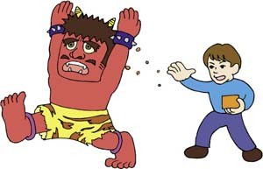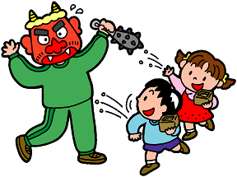
Children cry, "Oni wa soto! Fuku wa uchi!" Which means "Out with the bad luck, in with good fortune!"
おに は そと ふく は うち
Read the text about Setsubun, then trace all the hiragana you see in the text.

