Sadako and the thousand paper cranes千羽鶴

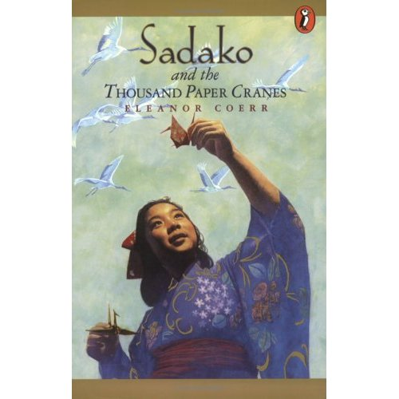
Thousand origami cranes (千羽鶴 Senbazuru) is a group of one thousand origami paper cranes held together by strings. An ancient Japanese legend promises that anyone who folds a thousand origami cranes will be granted a wish by a crane, such as long life or recovery from illness or injury.

Sadako and the Thousand Paper Cranes is a non-fiction children's book written by American author Eleanor Coerr and published in 1977.
This true story is of a girl, Sadako Sasaki, who lived in Hiroshima at the time of the atomic bombing by the United States. She developed leukemia from the radiation and spent her time in a nursing home creating origami (folded paper) cranes in hope of making a thousand of them. She was inspired to do so by the Japanese saying that one who created a thousand origami cranes would then be granted a wish. Her wish was simply to live. However, she managed to fold only 644 cranes before she became too weak to fold any more, and died shortly after. Her friends and family helped finish her dream by folding the rest of the cranes, which were buried with Sadako. They also built a statue of Sadako holding a giant golden origami crane in Hiroshima Peace Park.
http://en.wikipedia.org/wiki/Senbazuru
Research topic 1-Leukemia
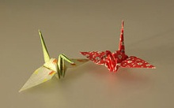
Use a power point slide show to explain the following questions
- What cause Sadako dead at age of 12?
- How old was Sadako when the atomic bomb was drop in Horoshima?
- Use your own words to explain what Leukaemia is.
- List at least 3 symptoms of Leukaemia, such as headache, vomiting
- What cause Sadako get Leukaemia?
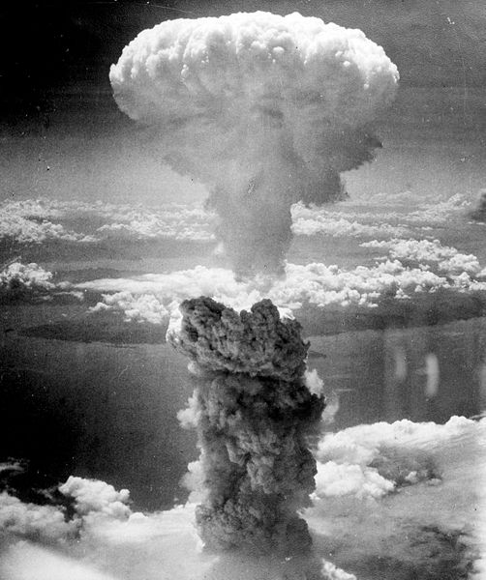
Research topic 2-Atomic bombing of Hiroshima
Use a power point slide show to explain the following questions
- At least 2 images of Atomic bombing
- Why did the American plane, Enola Gay, drop an atomic bomb on Hiroshima, Japan on August 6, 1945?
- How many Japanese people were killed by the atomic bombs that were dropped on Hiroshima on August 6, 1945 and on Nagasaki, another Japanese city, on August 9, 1945?
- What inspired the Japanese and American people to establish peace parks in Hiroshima?
- What can you and your classmates do to promote conflict resolution in your classroom, at your school, in your neighborhood, in your town, in the country, and in the world?

Research topic 3-thousand paper cranes
Use a power point slide show to explain the following questions
- What is the meaning of thousand paper cranes in Japanese culture?
- According to the Japanese legend, what will happen if you fold 1000 cranes?
- At least 2 images of thousand paper cranes
- Why did Sakado start to make paper cranes when she was very sick? How many origami cranes did she make before she died?
Research topic 4-Sadako ‘s story
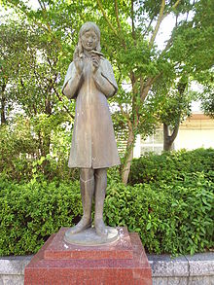
Use a power point slide show to explain the following questions
- How old was Sadako when the bomb was dropped in Hiroshima?
- Show at least 2 images of Sadako.
- Why did Sadako get cancer-Leukemia?
- Why did Sadako decide to make origami cranes? How many did she make before she died?
- Sadako has become a leading symbol of the impact of nuclear war. What inspired the Japanese and American people to establish peace parks in Hiroshima and Seattle ?

Sadako and thousand paper cranes presentation criteria-peer
Group name__________
Criteria | Marks
Answered all the questions with good understanding | 4 3 2 1
At least 6 slides with engaging presentation | 4 3 2 1
Speaks clearly with loud enough volume | 4 3 2 1
Posture and eye-contact | 4 3 2 1
Listen to other presentations | 4 3 2 1
Total

Marked by________

Sadako and thousand paper cranes presentation criteria-peer
Group name__________
Criteria | Marks
Answered all the questions with good understanding | 4 3 2 1
At least 6 slides with engaging presentation | 4 3 2 1
Speaks clearly with loud enough volume | 4 3 2 1
Posture and eye-contact | 4 3 2 1
Listens to other presentations | 4 3 2 1
Total
Marked by________

