Japanese Adjectives
Japanese | Picture | English
kirei |  | beautiful/clean
ookii |  | big
kitanai |  | dirty
futoi |  | fat
ke |  | fur
nagai |  | long
kawaii |  | cute
mijikai |  | short
chiisai |  | small
takai |  | tall
hosoi |  | thin

Read all the clues to find the identity of the mystery animal and then colour it in.

- nagai kubi desu.
- mijikai kami desu.

- chiisai me desu.
- nagai ashi desu.

- chiisai mimi desu.
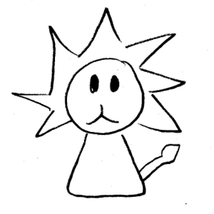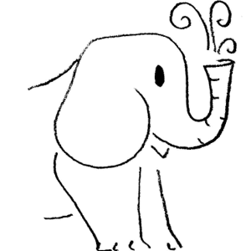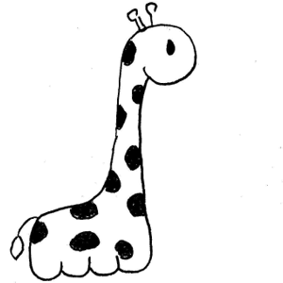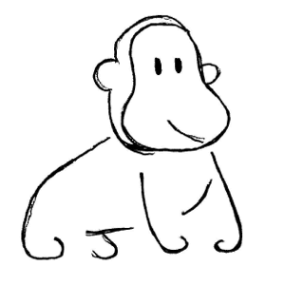

Read all the clues to find the identity of the mystery animal and then colour it in.

- ookii desu.
- nagai kami desu.

- chiisai me desu.
- nagai ashi desu.

- kirei desu.
