　　　。　　です。

　　　です。　　　　。

　　いきます。　　いきます。

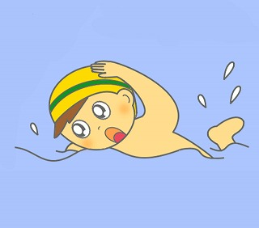



ぼく　は　　です。　です。

　　　に　いきます

　　いきます。　に　いきます。

　　。

　は　　です。　さい

です。

　に　いきます

　　　に　いきます。

　と　　　　いきます。



**Read the about the three people and their holidays. Then, in English answer the following questions:**

1.

What is his name? _______________________________

How old is he? _______________________________

Where is he going on his summer holiday? _______________________________

Why? _______________________________

How is he getting there? _______________________________

What will he do there? _______________________________

2.

What is his name? _______________________________

How old is he? _______________________________

Where is he going on his winter holiday? _______________________________

How is he getting there? _______________________________

What two things will he do there? _______________________________

3.

What is her name? _______________________________

How old is she? _______________________________

Where is she going on her holiday? _______________________________

When is she going on her holiday? _______________________________

How will she get there? _______________________________

Where will she go? (Name 4 things) _______________________________________________________

**Reflection**

Which person’s holiday do you like the most? Why?

________________________________________________________________________________________________________________________________________________________________________________

**Write about your next holiday in Romaji.**

1. Your name Boku/Watashi wa NAME desu.
2. Your age NUMBER sai desu.
3. Where and when you are going MONTH ni PLACE ni ikimasu.
4. How you will get there VEHICLE de ikimasu.
5. What you will do when you get there ACTIVITY ni ikimasu.

___________________________________________________________________________

___________________________________________________________________________

___________________________________________________________________________

___________________________________________________________________________

___________________________________________________________________________

**Write about your next holiday in hiragana. Then, draw a picture of yourself on holiday.**

1. Your name ぼく／わたし　はNAME です。
2. Your age NUMBER さい　です。
3. Where and when you are going MONTH に PLACE にいきます。
4. How you will get there VEHICLE で　いきます。
5. What you will do when you get there ACTIVITY に　いきます。

______________________________________________

______________________________________________

______________________________________________

______________________________________________

______________________________________________

______________________________________________

______________________________________________

______________________________________________

______________________________________________

______________________________________________

______________________________________________