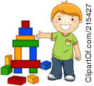

つくって

よんで　

かいて　[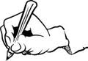](http://www.google.com.au/imgres?imgurl=http://www.art-saloon.ru/mini/item_4281.jpg&imgrefurl=http://www.art-saloon.ru/en/search_item.aspx?CategoryID%3D25%26SearchText%3DWriting&h=104&w=150&tbnid=985br8Z0AzNoJM:&zoom=1&q=write%20clipart&docid=sPwG899or4XH4M&ei=UHZoU8inO8SLkQXT-IHYCw&tbm=isch&ved=0CKIBEDMoSDBI&iact=rc&uact=3&dur=1581&page=3&start=49&ndsp=29)

|  |  |  |  |  |  |  |  |  |  |
| --- | --- | --- | --- | --- | --- | --- | --- | --- | --- |
|  |  |  |  |  |  |  |  |  |  |
|  |  |  |  |  |  |  |  |  |  |
|  |  |  |  |  |  |  |  |  |  |
|  |  |  |  |  |  |  |  |  |  |

[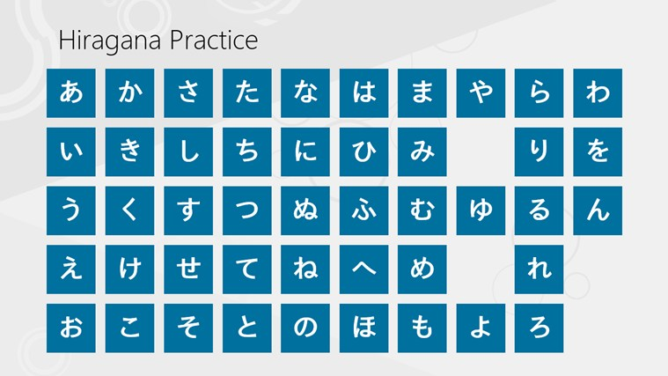](http://www.google.com.au/url?sa=i&rct=j&q=trace+hiragana+chart&source=images&cd=&cad=rja&uact=8&docid=cRRmdglksC6vKM&tbnid=7XOrsIfvuG94QM:&ved=0CAUQjRw&url=http://apps.microsoft.com/windows/en-za/app/hiragana-practice/764d66f8-cdc0-4080-aa2c-4937a1d4d9f3&ei=7IhoU-DIIsS3kAXlmIHoBg&bvm=bv.66111022,d.dGI&psig=AFQjCNHK-TBwdiomXZxuQrmjS2uvHcAQtQ&ust=1399445996238882)