Listen to your sensei and match the English phrases to the Hiragana.
きいて ください
Please be quiet

みて ください
Please look
すわって ください
Please stand
しずか に して ください
Please sit
たって ください
Please listen

Match the English words to their Hiragana.
Book Pencil Desk Teacher
Chair Paper

つくえ いす せんせい かみ
えんぴつ ほん

Write the English translation for these phrases.
ご ちゅうもん は おきまり です か 。
__________________________________
を ください。
_____________________________________
えんぴつ です か。
__________________________________
Write the sound of each Hiragana character.
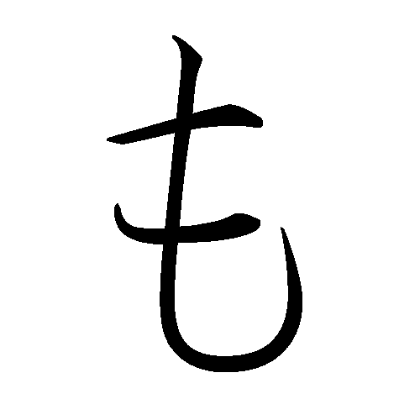
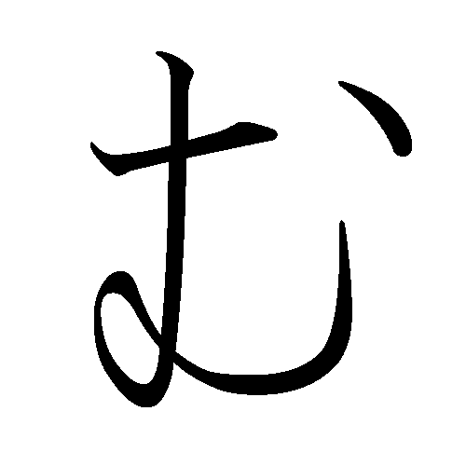
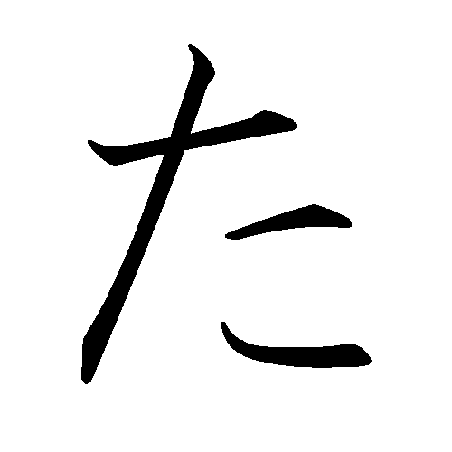
______ ______
______ _______

Draw the hiragana character for each sound.

ku ______ o ________ de _______

