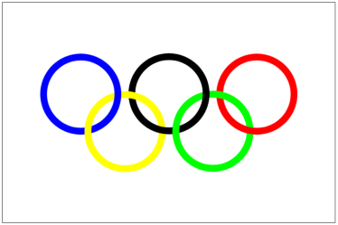

OLYMPICS RESEARCH TASK

Using the internet, research and answer the following questions.
Please complete your answers in a Word document. Make sure you save this task on ‘My Documents’.

- Open a Word document. Your heading is OLYMPIC RESEARCH TASK.
- Download the logo being used at the current Olympic games.
- Japan has hosted three Olympic games. Download the logos from each of these games. (Tokyo, Sapporo, Nagano)
- Which of these games were Winter Olympic games?
- Which current Olympic sport originates from Japan? Find a picture of this sport and download it onto your answer document.
- How many Olympians are on the 2012 Japanese team?
- Have they won any medals so far? If so, in what sports?
- Which traditional Japanese sport (not currently in the Olympics) would you like to see included at the next Olympics, and why? This must be a full paragraph answer.
Useful websites
http://www.olympic.org/
http://www.london2012.com/
http://geography.about.com/od/countryinformation/a/olympiccities.htm

