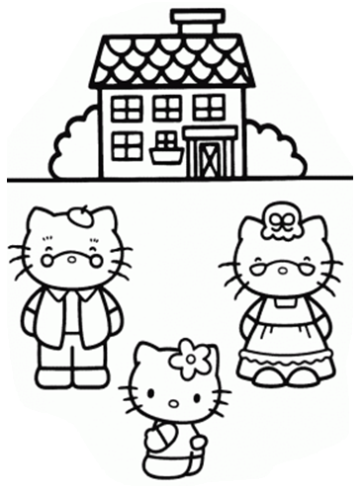
にほんのいえ
NAME: __________________________
CLASS: Year 6 Year 7
SCHOOL: _________________________
Learn these words about Japanese homes
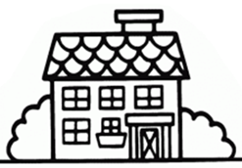
- Japanese homes
Japanese | English
ie いえ | House
manshon マンション | Mansion (In Japan, this means apartment buildings)
genkan げんかん | Entrance area of the house
ima いま | Living room
tatami たたみ | Straw mats
kotatsu こたつ | Low table which has a heating unit attached underneath
futon ふとん | Traditional Japanese bed
fusuma ふすま | Sliding doors covered with decorative paper
toko no ma とこのま | Special raised area in “ima”, for decorative items
ofuro おふろ | Japanese bathroom
toire トイレ | Toilet
daidokoro だいどころ | Kitchen

- Rooms and furniture
Japanese | English
heya へや | Room
terebi テレビ | TV
aipoddo アイポッド | ipod
keitai けいたい | Mobile phone
pasokon パソコン | Personal computer
rajikase ラジカセ | Radio cassette player
manga まんが | Comic books
hon ほん | Books
shashin しゃしん | Photo
denki sutando でんきスタンド | Desk light stand
tokei とけい | Clock
isu いす | Chair
tsukue つくえ | Desk
beddo ベッド | Bed
oshiire おしいれ | Closet
tansu たんす | Japanese style dresser

Task 1
Cut out the room names below.
Stick them in the correct part of the house.

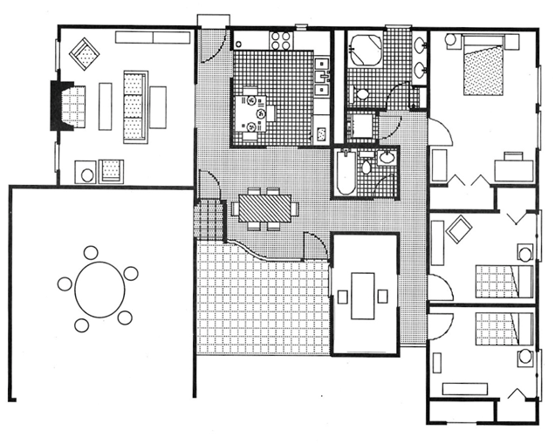
わたし の へや | いま | へや
げんかん | トイレ | へや
おふろ | だいどころ | テレビ

ベランダ beranda
Veranda
Task 2
Read the Japanese word and draw a picture of the item in the box above it.

aipoddo アイポッド | tsukue つくえ | isu いす
manga まんが | keitai けいたい | pasokon パソコン

Task 3
Do you like Hello Kitty’s room?
What do you have in your room?
Name 5 items you have in your room, in Japanese.

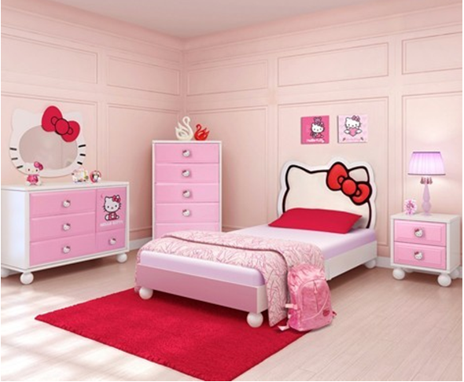

__________________
__________________
__________________
__________________
__________________
Cultural Facts
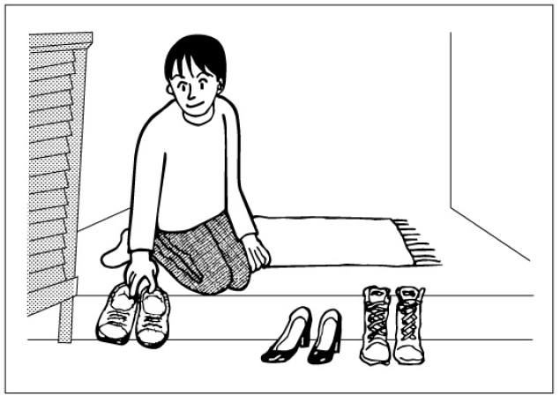

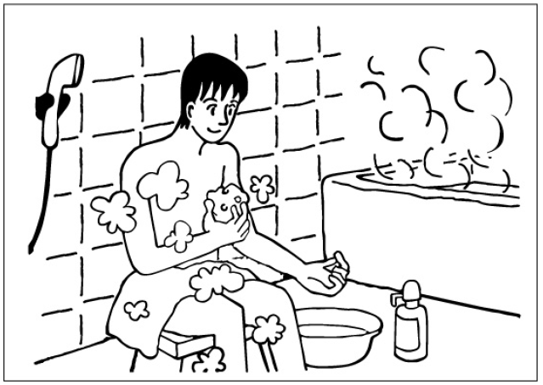
At genkan, which is the entrance to the house, shoes are taken off and lined up with its tip pointing towards the door. Or it is put away in the “kutsubako”, the shoe cabinet.
This is ofuro, or furoba, which is the Japanese for bathroom. There is an area for washing your body, then the bath tub for soaking.
Inside ofuro, the first thing is to wash your hair and body. Then, you can soak in the bath tub filled with hot water to warm your body. Don’t wash your body in the bathtub as the hot water inside the tub is shared by the family. After you are finished, don’t let go of the hot water so the next person can use it.

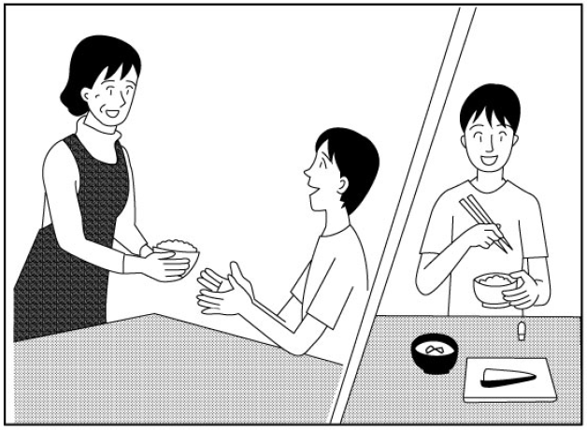

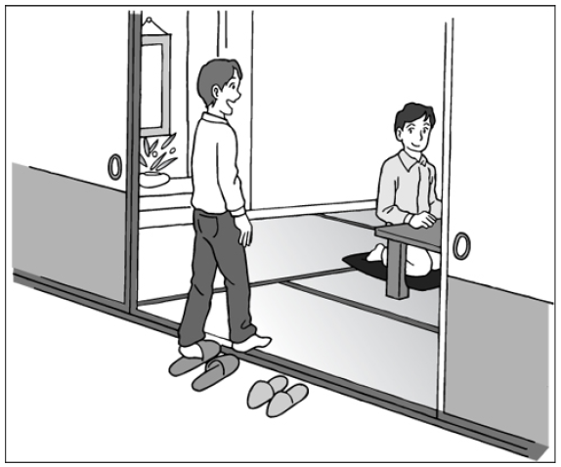
At meal time, usually okaasan will fill up the bowls with rice for all family members. When you wish to have another bowl, you can just say “okawari kudasai!” okaasan will fill up the bowl with rice for you. When receiving the bowl from okaasan, remember to use both hands to show respect and courtesy. When eating, it is better to hold the bowl with one hand and use chopstick on the other hand. Eating from the rice bowl that is placed on the table is considered as lack of manner in Japan.
A tatami mat is made out of dried straws. Traditional Japanese houses usually have a tatami room which is called a “washitsu”. When entering a tatami room, make sure to take off your slippers outside of the room. Slippers are not to be worn inside the tatami room. When sitting down, zabuton, a cushion, is used instead of a lounge set.

Is this the right thing to do in a Japanese house? | ○  する | ×  しない
Line up your shoes after taking them off. Shoes should be pointing to the door.
Wash your body inside the bathtub.
After bath, let go of the hot water in the bath tub.
Hold your bowl while eating a meal.
Use one hand to receive something from another person.
Enter a tatami room with slippers on.
Sit on zabuton (cushions) inside a tatami room.

