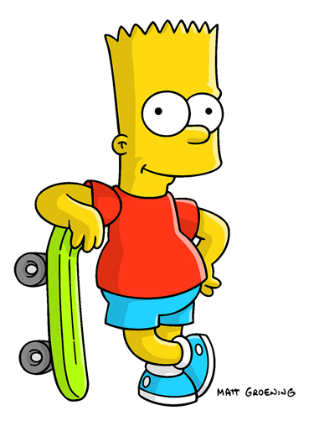

**ぼくは　五年生　です。**

**しょうがっこうの　五年生　です。**

**何年生ですか**

Write the year level next to each picture in Japanese.



Primary school 5th year



Senior high 3rd year



**

Middle school second year

Senior school first year

Middle school first year

University first year