一月
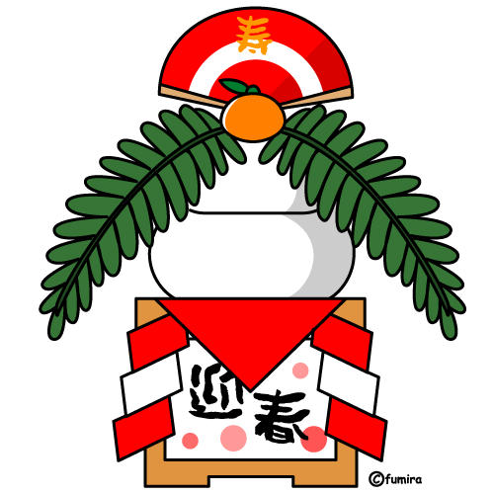
ichigatsu
いちがつ
二月
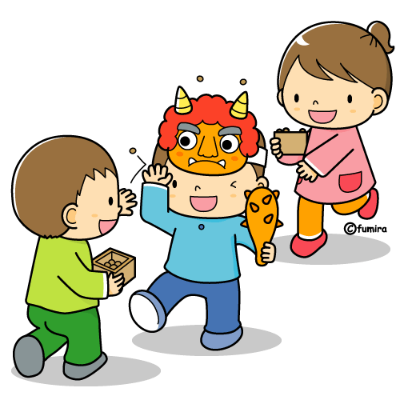
nigatsu
にがつ
三月
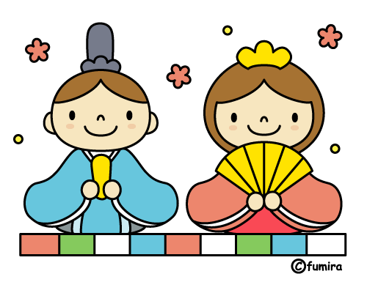
sangatsu
さんがつ
四月

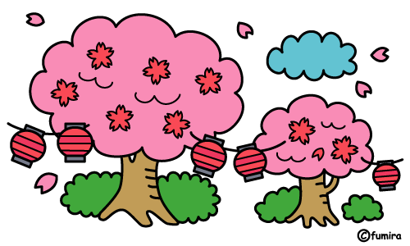
shigatsu
しがつ

五月
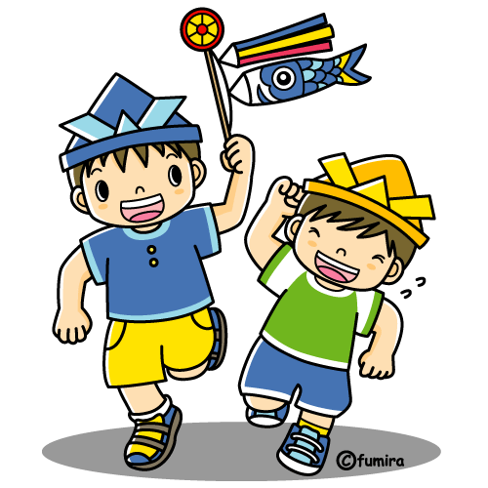
gogatsu
ごがつ
六月
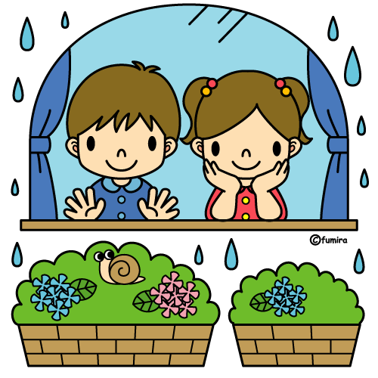
rokugatsu
ろくがつ
七月
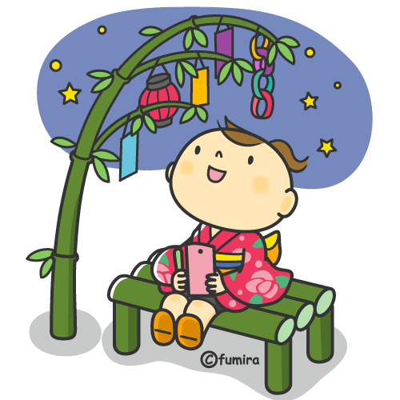
shichigatsu
しちがつ
八月
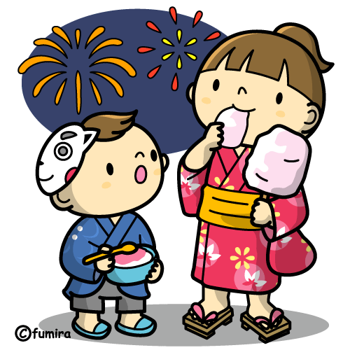
hachigatsu
はちがつ
九月
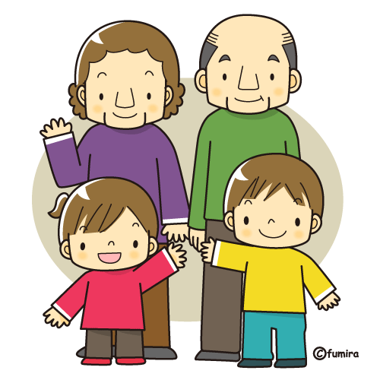
kugatsu
くがつ
十月
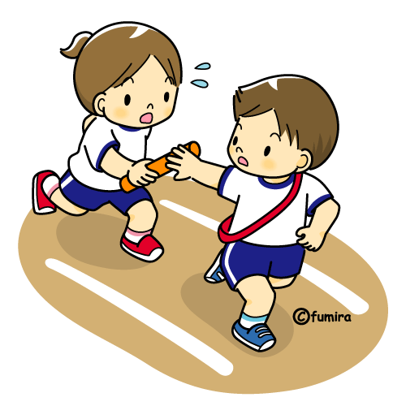
juugatsu
じゅうがつ
十一月
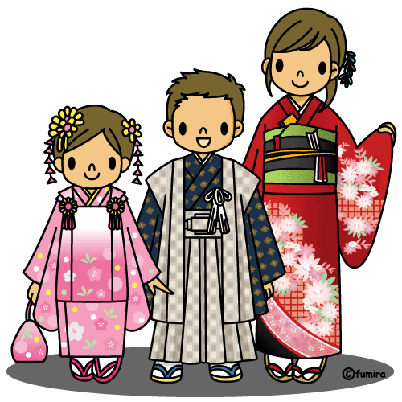
juuichigatsu
じゅういちがつ
十二月

juunigatsu
じゅうにがつ
九月
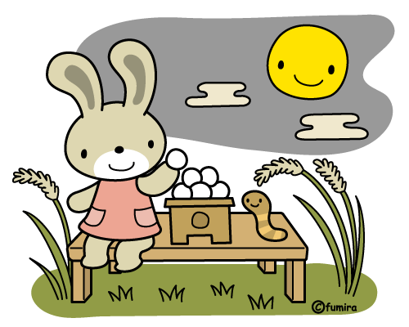
kugatsu
くがつ
四月
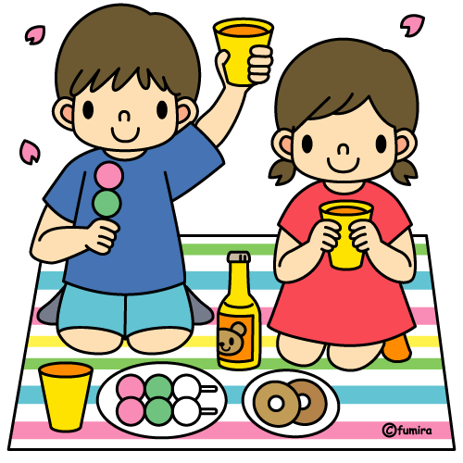
shigatsu
しがつ
January

shoogatsu
しょうがつ

New Year’s
Day

February

setsubun
せつぶん

Bean Throwing Festival

March

hinamatsuri
ひなまつり

Doll Festival

April

hanami
はなみ

cherry blossom viewing

May

kodomo no hi
こどものひ

Children’s Day

June

tsuyu
つゆ

rainy season

July

tanabata
たなばた

Star Festival

August

hanabi
はなび

Fireworks

September

keiiro no hi
けいろのひ

Respect for
the Aged Day

October

taiiku no hi
たいいくのひ

Health and
Sports Day

November

shichigosan
しちごさん

Seven-Five-
Three

December

kurisumasu
クリスマス

Christmas

September

otsukimi
おつきみ

moon viewing

April

hanami
はなみ

cherry blossom viewing

