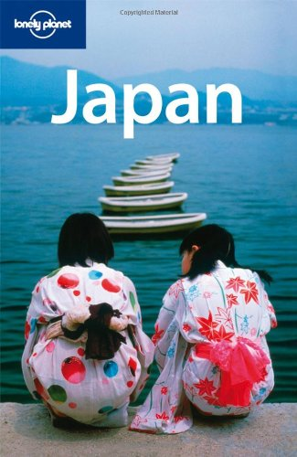
Dear Student,
You have been requested by the Lonely Planet travel guide company to use the internet to construct a Lonely Planet Fact File of Japan & Australia. Write your answers next to the questions and give your answers to your teacher at the end of the period. Ganbatte! (good luck)
Name:
Lonely Planet Guide- Japan
Country:
Capital City:
Major cities:
Major Islands:
Population:
Major Language:
Major Religions:
Highest Mountain:
Area:
Currency:
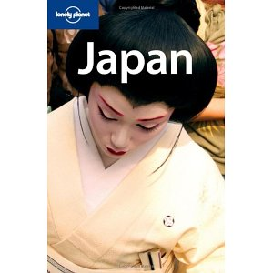
Main imports:
Main exports:
Main trading partners:
Type of Government:
Prime Minister:
Head of State:
Types of Japanese food:
Famous Japanese sports:
Famous Japanese brands:
Flora:
Fauna:
Draw the Japanese flag

Lonely Planet Guide- AUSTRALIA
Country:
Capital City:
Major cities:
Major Islands:
Population:
Major Language:
Major Religions:
Highest Mountain:
Area:
Currency:
Main imports:
Main exports:
Main trading partners:
Type of Government:
Prime Minister:
Governor General:
Types of Australian food:
Famous Australian sports:
Famous Australian brands:
Flora:
Fauna:
Draw the Australian flag

