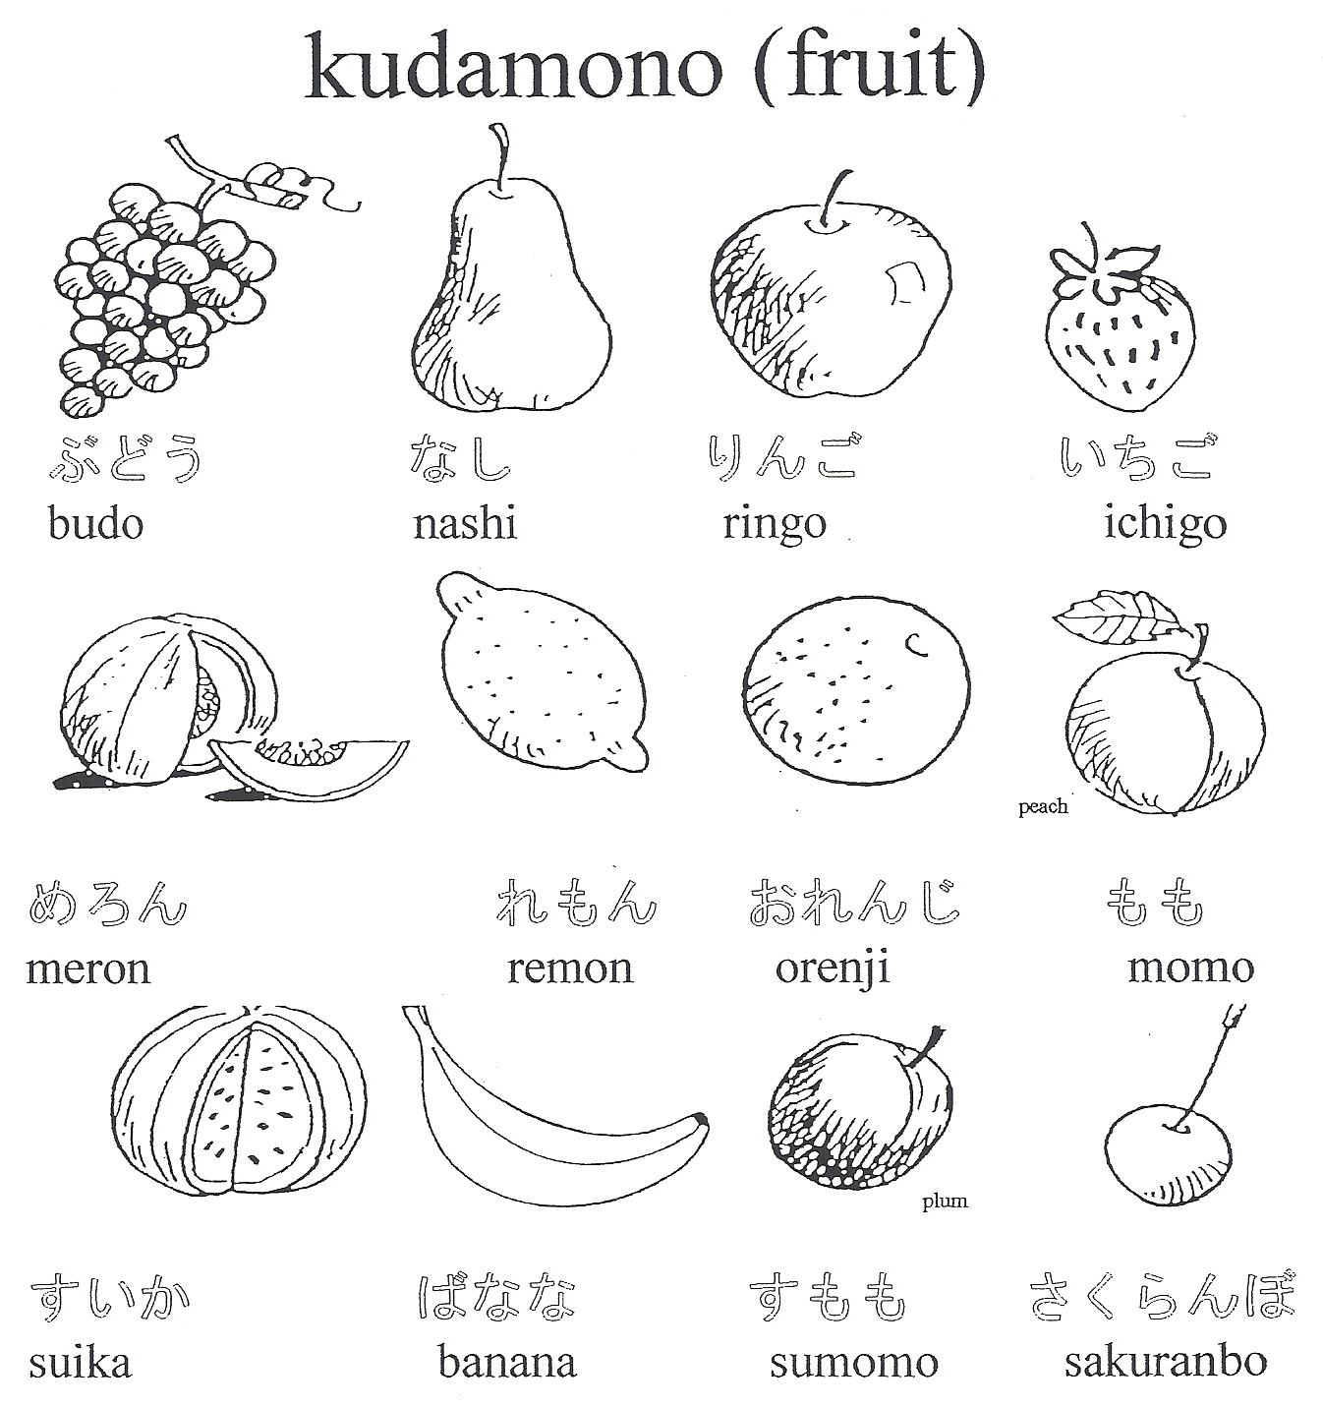

**Kudamono**



banana

ringo





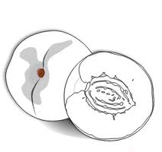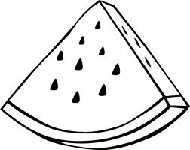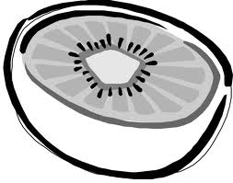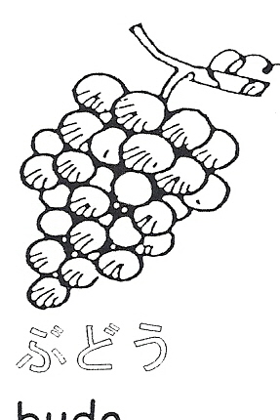

# ***Which fruits do you like?***

# **Draw a happy face for hai (yes) and a sad face for iie (no).**

momo

suika

orenji

kiuii

ichigo

nashi

ichigo