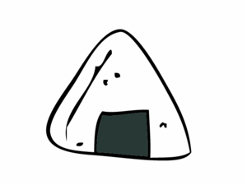

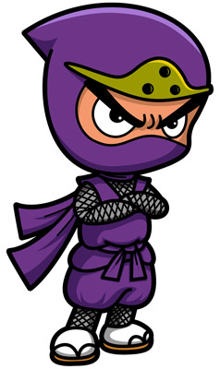

Kitsune Ninja Omusubi
Equipment: 1 dice, 2 coloured magnets, 8 copies of the ninja, 2 copies of kitsune, 2 copies of omusubi, whiteboard marker
The game: Draw a big circle on the board and divide it into twelve segments (so it looks like a large pizza). Put the copies of the ninjas, kitsune and omusubi randomly around the 12 segments. Divide the class into two teams. Allocate a different coloured magnet to each team. Put one magnet on the left hand side of the circle (Team 1) and the other magnet on the right hand side (Team 2). Give each team 10 lives by writing Team 1 and underneath it draw 10 dashes, do the same for Team 2. The object of the game is for each team to try and eliminate the other by killing off their lives. Ask Team 1 a question (OR show a flashcard to review vocabulary, complete a grammar question, ask a cultural question etc.), if they get it correct then they can throw the dice. This team moves their corresponding magnet clockwise around the pizza. If they land on a ninja then they can erase one life from the opposing team. If they land on a kitsune, they themselves lose a life and if they land on an omosubi then they ‘power up’ and gain a life. Now Team 2 has their turn. The game continues until one team loses all ten lives. The winner is the team with lives remaining. EXTRA: If you want the game to last longer add more omusubi, if you want it to be shorter add more ninjas and kitsune.

