Kisetsu no iro
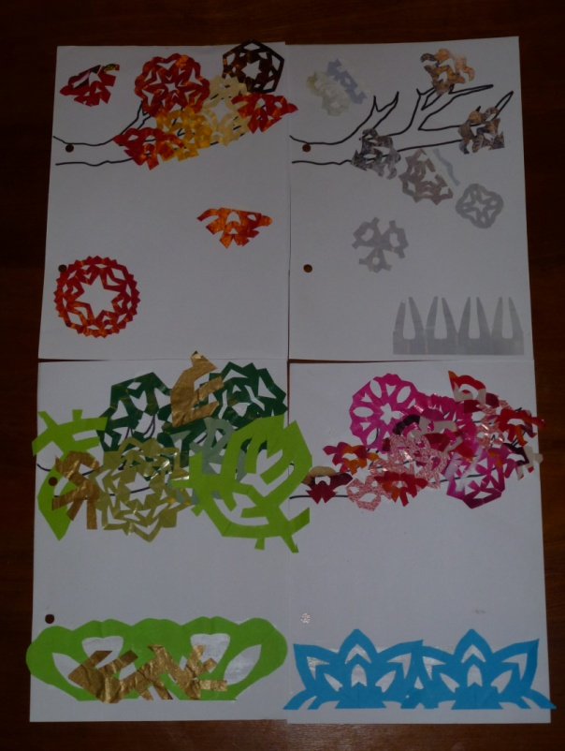
Task: Create a poster to illustrate “Kisetsu no Iro” きせつのいろ
- Choose a kisetsuきせつ. (or four)
- Use an A3 page
- Decide what iro いろmatches the kisetsu きせつyou have chosen.
- Using kirigami きりがみcreate your work. (Kirigamiきりがみ is what we know as cutting snowflakes.)
- Write a sentence or paragraph in hiragana ひらがなto describe the kisetsuきせつ. Label the colours.
- You will be marked on:
  - The appropriate iro いろchoice you have made
  - The sentence you have written – are the hiragana correct, does it make sense, neatness
  - How neat your work is
  - Appropriate use of class time

Kisetsu no iro Marking Sheet 1 Poor – 5 Excellent
Appropriate iro choice
1 | 2 | 3 | 4 | 5
Hiragana sentence correct
1 | 2 | 3 | 4 | 5
Hiragana written carefully
1 | 2 | 3 | 4 | 5
Kirigami
1 | 2 | 3 | 4 | 5
Appropriate use of class time
/20
1 | 2 | 3 | 4 | 5

