おなまえは？
Topic: Introduction

なまえ＿＿＿＿＿＿＿＿＿＿＿＿＿＿＿＿__＿＿＿＿＿＿＿

Name______________________________________________________________

Class ____________________________________________________

Basic Introduction 1
What is your name?
When asking someone their name….

おなまえはなんですか。
Write the Romaji (the English reading above)

There is actually a shortened way of asking for someone’s name.

おなまえは？

Write the Romaji (the English reading above)
Activity: Practice writing in Japanese!
お | な | ま | え | は

My name is…
Activity: Learn to write your name in Japanese…

Saying your name in Japanese is a little different from when you say your name in English. How do you say your name in Japanese? Write your name in Romaji.

______________________________________________________________________
When introducing yourself, we often say…

わたし／ぼく は です。

______________________________________________________________________________
わたし is used for ____________________________
ぼく is used for ____________________________
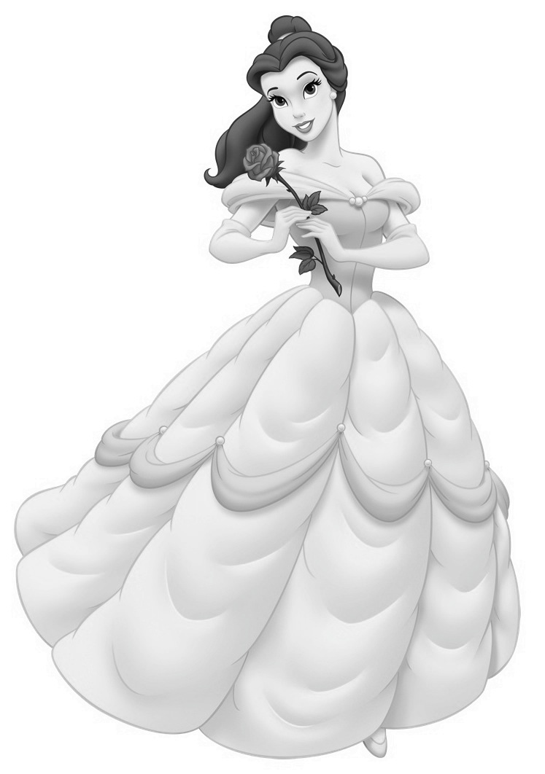
Activity: Using the correct beginning, write their name in Japanese.

なると べる けいてー じょにー

＿＿＿＿＿＿＿＿＿＿＿＿＿＿＿＿＿＿＿＿＿＿ ＿＿＿＿＿＿＿＿＿＿＿＿＿＿＿＿＿＿＿＿＿＿

＿＿＿＿＿＿＿＿＿＿＿＿＿＿＿＿＿＿＿＿＿＿ ＿＿＿＿＿＿＿＿＿＿＿＿＿＿＿＿＿＿＿＿＿＿

Numbers
Task: Write down the following numbers in Hiragana and in Romaji.

Numbers | Hiragana | Romaji
1
2
3
4
5
6
7
8
9
10
11
12
13
14
15
20
25
30
35
50
80
99
Numbers in Kanji

Activity: Practice writing numbers in Kanji
What is Kanji and why do Japanese people use it?
Kanji are adopted Chines characters that are used in modern Japanese writing. It is one of three Japanese writings (Hiragana, Katakana and Kanji). Unlike alphabets, Kanji was created using pictures.
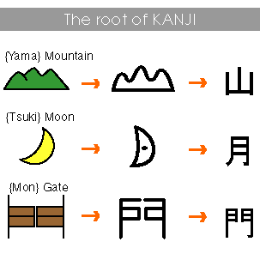
一
二
三
四
五
六
七
八
九
十
How old are you?
Next thing you need to know is to ask someone’s age.

なんさいですか。

_________________________________________________________________________________
(Write the Romaji above)

なん means _______________________
な | ん | さ | い | で | す | か

To answer the question, you simply say…
〜さいです。
__________________________________________
(Write your age using Kanji)

Activity: Ask other students their age in Japanese. How many students are 十三さい?

What year are you in?

Asking someone’s Year level is easy, it’s just like asking their age!

なんねんせいですか。

______________________________________________________________________
ねん means _________________________
せい means _________________________

To answer the question, you simply say…

〜ねんせいです。

__________________________________________________________________________
(write your year level in Japanese)
Activity: Write the following…
八 | ね | ん | せ | い | で | す

Where do you live?

Asking someone where they live is a little harder than the other questions.

どこにすんでいますか。

_____________________________________________________________________________________

It may be easier to break down the question to remember it.
どこ ・ に ・ すんで ・ います・か。

どこ means ________________
に means ________________
すんで means ______________
います means ______________
か means ______________

To answer the question, you would say…

〜にすんでいます。

______________________________________________________________

Activities: Using the suburb list, work out how you would answer the question

_______________________________________________________________________________________

Activity: Ask 4 students in JAPANESE where they live. Write down the answer in Japanese.

Name | は | Suburb | に | すんでいます。

じこしょうかい- Self Introduction

Task: Write your self introduction in Japanese using sentences you have learnt so far. This will include; name, age, year level and where you live.

___________________________________________________________________________________

___________________________________________________________________________________

___________________________________________________________________________________

___________________________________________________________________________________

___________________________________________________________________________________

___________________________________________________________________________________

Numbers Revision Task
A. Write numbers 1 to 20 in Kanji on the lines below:

1. _______________ 6. _______________ 11. _______________ 16. _______________
2. _______________ 7. _______________ 12. _______________ 17. _______________
3. _______________ 8. _______________ 13. _______________ 18. _______________
4. _______________ 9. _______________ 14. _______________ 19. _______________
5. _______________ 10. _______________ 15. _______________ 20. ______________

B. Complete the maths problem.
八 - 三 ＝ ＿＿＿＿＿＿ 九 － 二 ＝ ＿＿＿＿＿＿
十 ÷ 二 ＝ ＿＿＿＿＿＿ 十二 ÷ 三 ＝ ＿＿＿＿＿＿
十五 ＋ 四 ＝ ＿＿＿＿＿＿ 二十三 ＋ 六 = ＿＿＿＿＿＿
三十 ÷ 十 ＝ ＿＿＿＿＿＿ 四十四 ÷ 十一 ＝ ＿＿＿＿＿＿
二十四 － 七 ＝ ＿＿＿＿＿＿ 九十九 － 八 ＝ ＿＿＿＿＿＿
八十六 ＋ 四 ＝ ＿＿＿＿＿＿ 七十七 ＋ 二十 ＝ ＿＿＿＿＿

The months
Learning the months in Japanese is easy! Simple as saying the number of the month and adding “がつ” at the end.
Example
March is the third month--> さんがつ (三月)

The Kanji for month means moon.

月

Activity: Fill in the chart

Enflish | Hiragana | Romaji | Kanji
January
February
March
April
May
June
July
August
September
October
November
December

Dates
Dates are similar to the months, however, instead of using the moon Kanji,
the sun（にち） Kanji is used.
Example
26th --> にじゅうろくにち（二十六日）
Question: Why do you think the moon Kanji is used for the month and the sun kanji is used for the day?

-----------------------------------------------------------------------------------------------

日

Task: Write down your birthday in Hiragana, Romaji and Kanji
(Remember month comes first)
Hiragana | Romaji | Kanji

Task: Ask 4 people for their birthday and write them down in Hiragana, Romaji and Kanji
なまえ | Hiragana | Romaji | Kanji

Days of the week
The days of the week in Japanese is named after the planets, just like in English!
Task: Practice writing the kanji
Sun  日  niche | 日
Mon  月  getu | 月
Tues  火  ka | 火
Wed  水  sui | 水
Thrus  木  moku | 木
Fri  金  kin | 金
Sat  土  do | 土
To day the actual date you need to add ようび at the end.
_______
Monday would be --> げつようび （月ようび）

Japanese Festivals
Japan is known for many of their festivals throughout the year. Here are some of the festivals they celebrate.

Cherry blossom festivals
Japan celebrates the entire season of the cherry blossoms. All over Japan festivals are held which include food and at night beautiful lanterns.

Doll Festival (Hina-matsur^{i})
Date: March 3
Other Names: Sangatsu Sekku (3rd month Festival), Momo Sekku (Peach Festival), Joshi no Sekku (Girls' Festival)
Information: This is the day when families pray for the happiness and prosperity of their girls and to help ensure that they grow up healthy and beautiful. The celebration takes place both inside the home and at the seashore. Both parts are meant to ward off evil spirits from girls. Young girls put on their best kimonos and visit their friends' homes. Tiered platforms for hina ningyō (hina dolls; a set of dolls representing the emperor, empress, attendants, and musicians in ancient court dress) are set up in the home, and the family celebrates with a special meal of hishimochi (diamond-shaped rice cakes) and shirozake (rice malt with sake).

Tanabata
Date: July 7
Other Names: The Star Festival
Information: It originated from a Chinese folk legend concerning two stars-the Weaver Star (Vega) and the Cowherd Star (Altair)-who were said to be lovers who could meet only once a year on the 7th night of the 7th month provided it didn't rain and flood the Milky Way. It was named Tanabata after a weaving maiden from a Japanese legend, named Orihime who was believed to make clothes for the gods. People often write wishes and romantic aspirations on long, narrow strips of coloured paper and hang them on bamboo branches along with other small ornaments.

"7-5-3" Festival (Shichi-go-san)
Date: November 15
Information: Five-year-old boys and seven- or three-year-old girls are taken to the local shrine to pray for their safe and healthy future. This festival started because of the belief that children of certain ages were especially prone to bad luck and hence in need of divine protection. Children are usually dressed in traditional clothing for the occasion and after visiting the shrine many people buy chitose-ame ("thousand-year candy") sold at the shrine.

