ファーストフード店での会話

店員：いらっしゃいませ。ごをどうぞ。

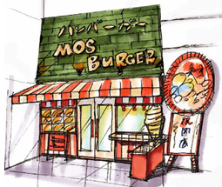
お客：ハンバーガーを１つと、コーヒーを１つください。

：コーヒーはS、M、Lの３サイズございますが、どちらになさいますか。

お客：Sをください。

店員：ハンバーガーが１つとコーヒーのSを１つですね。以上でよろしいでしょうか。
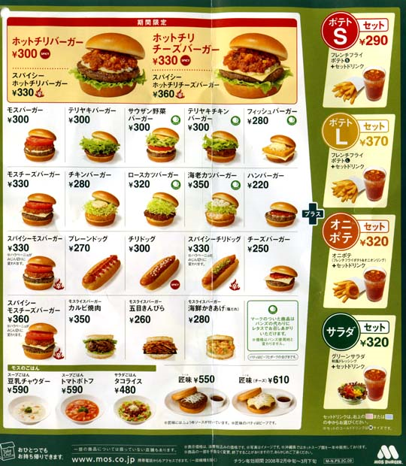
お客：あ、フライドポテトのSもください。

：フライドポテトのSを１つですね。以上でよろしいでしょうか。

お客: それで全部です。

：こちらでお召し上がりですか。おち帰りですか。

お客：こちらで。／ち帰りで。

：780円です。ありがとうございます。
その他の表現

お客: セットAをコーラーのLで。

店員：申し訳ございません。このセットにLサイズのお飲み物はつきません。Mサイズのみです。

店員：コーヒーはアイスとホットがありますが、どちらになさいますか。

お客: ホットをお願いします。

At a fast food shop: English translation

Shop assistant: Hello. What would you like to have?

Customer: One hamburger and a coffee please.

Shop assistant: We have 3 sizes for coffee. Small, medium and large. Which
size would you like?

Customer: A small one please.

Shop assistant: One hamburger and a small coffee. Anything else?

Customer: One small French fries (chips) please.

Shop assistant: One small French fries. Anything else?

Customer: That’s all.

Shop assistant: Eat here or take away?

Customer: Eat here, please/ take away, please.

Shop assistant: ¥780. Thank you very much.

Customer: I will have combo A with a large coke.

Shop assistant: Sorry, a large drink doesn’t come with this combo.
You can only choose a medium-sized drink with this
combo.

Shop assistant: We have hot and iced coffee. Which do you prefer?

Customer: Hot coffee, please.

