Year 8 Reading and Writing exercise for family (own family)
Name: _________________ Class:_________ Date:___________

Look at the pictures below and describe: How many people in the family, who are in the family
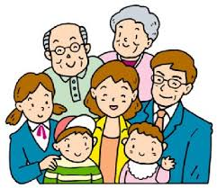
How many people?

_______________________________________________________________
Family members

________________________________________________________________

How many people?

_________________________________________________________________
Family members

__________________________________________________________________

How many people?

___________________________________________________________________
Family members

____________________________________________________________________

How many people in your family?

_____________________________________________________________________
Your family members

_____________________________________________________________________
ぼく

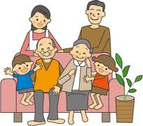
わたし

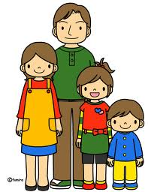
ぼく

Your family

Translate the following sentences.

- かぞく は 八人 です。そ父 と 母 と 父 と あに が 二人 と いもうと と あね と ぼく です。

＿＿＿＿＿＿＿＿＿＿＿＿＿＿＿＿＿＿＿＿＿＿＿＿＿＿＿＿＿＿＿＿＿＿＿

- かぞく は 五人 です。そ母 と 父 と いもうと が 二人 と わたし です。

＿＿＿＿＿＿＿＿＿＿＿＿＿＿＿＿＿＿＿＿＿＿＿＿＿＿＿＿＿＿＿＿＿＿＿

- There are 7 people in my family. Mother, father, three older sisters, younger brother and I are in my family.

_______________________________________________________________________

- There are 6 people in my family. Grandmother, father, mother, two younger sisters and I are in my family.

______________________________________________________________________

