A The people in your family
You are the child highlighted in grey so write who you are わたし or ぼくin the empty space. Now draw a line from the family member to their matching picture in relation to who you are.
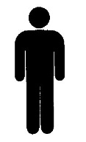
いもうと
おとうさん
おにいさん
おとうと

おかあさん
おねえさん

B Write information about each picture as if you were the person who is circled. You need to write a) how many people are in your family and b) say who they are.
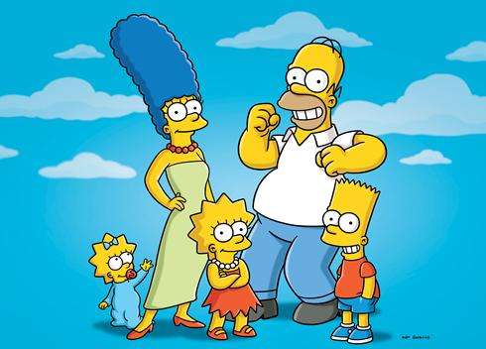
C
B
A
A かぞく は です。 と おかあさん と
と と わたし です。
B は です。
と です。
C かぞく は です。 と と
と と わたし です。

