Exploring Japanese Coins
Japan's unit of currency is the Yen (symbol: ¥ or 円)
From the left, there is the aluminium one yen coin, which costs more to make than it's worth, then the 5, 10, 50, 100, and 500 yen coins.
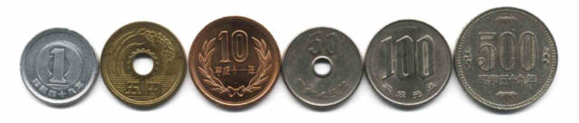
Quiz:

The lightest coin also has the oldest design on it (a young tree which symbolizes the healthy growth of Japan). How much is it worth? Answer: ¥

Which two coins have holes in the middle? Answer: ¥ and ¥

Which two coins feature pictures of traditional Japanese flowers? Answer: ¥ and ¥

Can you work out which one has the chrysanthemum flower? Answer: ¥

And which has the cherry blossom flower? Answer: ¥

What do the three pictures on the five yen coin represent?

Kanji

Can you find the following Kanji symbols? Are there any more Kanji symbols? Copy them into your Japanese books.

日本 | 国 | — | 五 | 十 | 百 | 円
Japan | Nation | One (1) | Five (5) | Ten (10) | One Hundred (100) | Yen

In your Japanese books, using a crayon or grey led, make some rubbings of the coins and label them. You may want to make a table or grid.
Alternatively, you may want to sketch or draw the coin designs.

For more information on Japanese coins, check out the kids’ web page at the Japanese Mint: http://www.mint.go.jp/eng/kids/circulating_c.html

