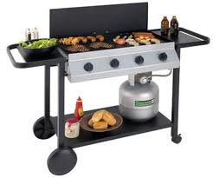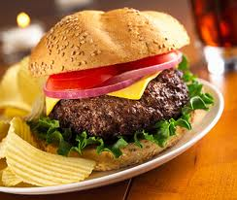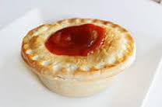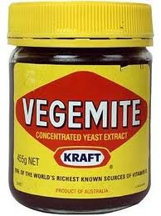

|  |  |  |
| --- | --- | --- |
| ENGLISH | HIRAGANA | ROMAJI |
| Meat pie | みーとぱい | mitopai |
| BBQ | ばーべーきゅー | |  | | --- | | babekyu | |
| Tim tam | てぃむたむ | |  | | --- | | timutamu | |
| Hamburger | はんばーがー | hanbaga |
| Lamb chops | らむちょっぷす | lamuchopusu |
| Cereal | しりある | siriaru |
| Vegemite sandwhich | べじまいとさんどいっち | Bejimaito sandoichi |
| Pavlova | ぱぶろば | paburoba |
| Steak and chips | すてーきとちっぷす | Suteiki to chipusu |
| Baked beans | べいくどびーんず | beikudobinzu |
| Sausage | そーせーじ | soseiji |
| Fish ‘n’ chips | ふぃっしゅとちっぷす | fuishyonchipusu |
| Laminghton | れみんとん | leminton |
| Roast | ろーすと | rosuto |
| Chicken parmigiana ‘Pamri” | ちきんぱーめじゃーな | chikinpamejiyana |
| PIzza | ぴざ | piza |

# VOCAB LIST: Australian Food

**たべものとのみもの**

Food & Drink

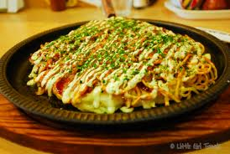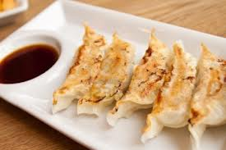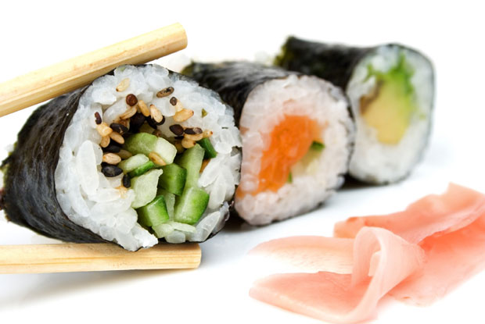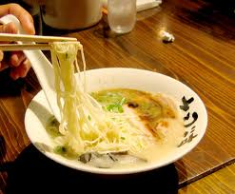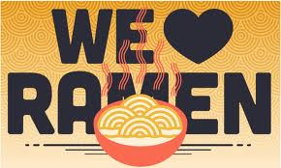

# VOCAB LIST: Japanese food

|  |  |  |
| --- | --- | --- |
| ENGLISH | HIRAGANA | ROMAJI |
| Food | たべもの | tabemono |
| Drink | のみもの | |  | | --- | | nomimono | |
| Breakfast | あさごはん | |  | | --- | | asagohan | |
| Lunch | ひるごはん | hirugohan |
| Dinner | ばんごはん | bangohan |
| Meal/Cooked Rice | ごはん | Gohan |
| Sushi | すし | sushi |
| Miso Soup | みそしる | misoshiru |
| Ramen | ラーメン | ra-men |
| Dumpling stuffed with Minced Pork and Vegetables | ギョウザ | gyouza |
| Japanese style pancake | おこのみやき | Okonomiyaki |
| Thin Slices of Beef cooked with various Vegetables in a Heavy Iron Pan | すきやき | Sukiyaki |
| Curry and Rice | カレーライス | kare-raisu |
| Pan Fried Noodle | やきそば | yakisoba |
| Fermented soybeans | なと | nato |
| Dried seaweed | のり | nori |

**たべものとのみもの**

Food & Drink