Namae: Nensei:
DAYS OF THE WEEK- Word Search
Look at the list of the days of the week below and then find and circle them.
Heijitsu Getsuyoubi Kayoubi Suiyoubi Mokuyoubi Kinyoubi Doyoubi Nichiyoubi Shuumatsu
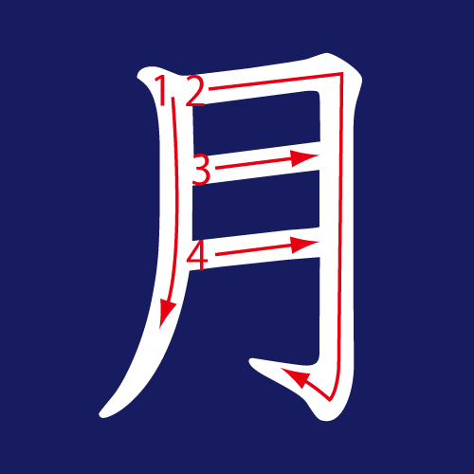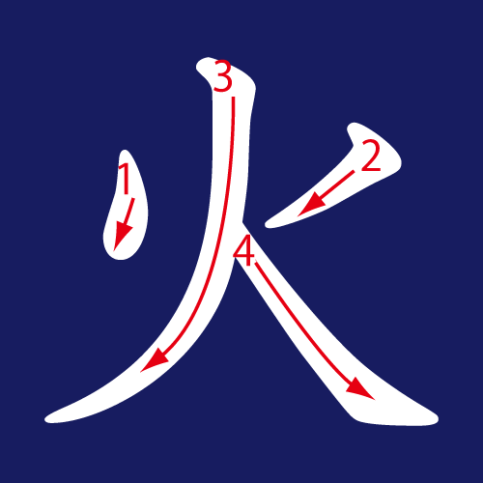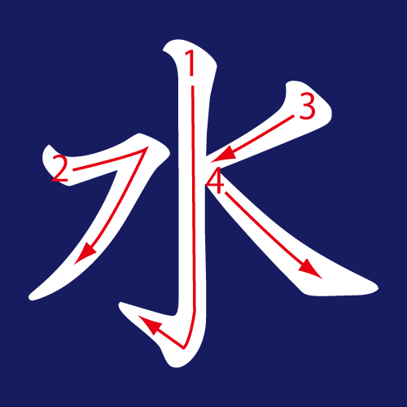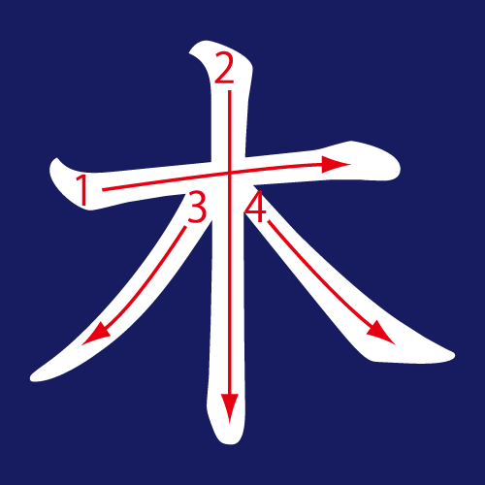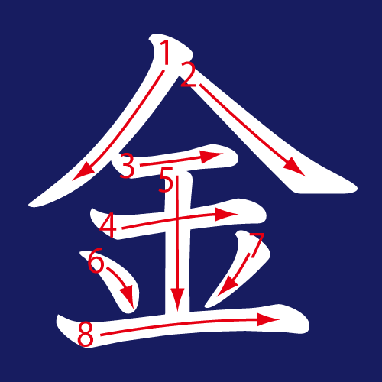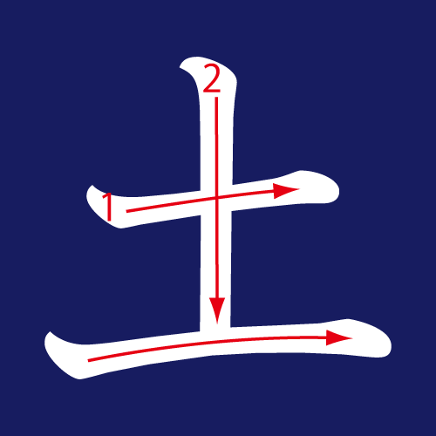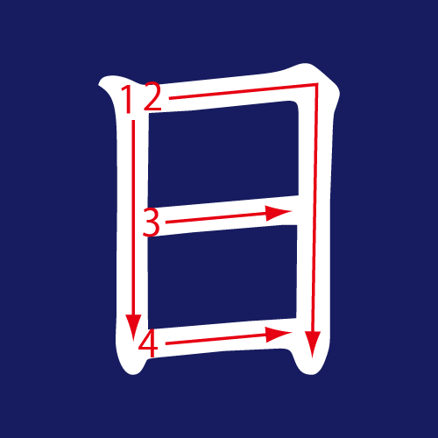

I | H | D | I | R | H | N | B | I | Y | N | I | K
K | A | Y | O | U | B | I | B | S | K | T | I | I
I | I | O | I | E | M | U | O | E | A | N | C | N
N | A | S | E | B | O | M | O | S | Y | A | H | N
B | R | H | E | Y | U | O | K | O | I | C | I | I
I | I | U | I | U | I | O | U | K | Y | H | B | Y
D | G | U | D | S | S | B | Y | O | M | U | I | O
O | S | M | O | H | I | T | K | I | O | M | O | U
Y | U | A | Z | U | O | O | I | Y | H | E | H | B
O | I | T | O | U | G | I | U | J | S | C | D | O
Y | Y | S | B | B | A | K | R | I | I | U | I | B
I | B | U | O | Y | O | D | A | N | H | E | N | N
B | I | H | D | M | H | O | N | D | O | O | H | K
G | E | T | S | U | Y | O | U | B | I | M | E | O

Here are some more time expressions for you to learn.
Next week- senshu せんしゅ Morning- asa あさ Noon-hiru ひる Night-yoru よる
Last month-sengetsu せんげつThis month-kongetsu こんげつ Nextmonth-raigetsuらいげつ
Last year-kyonenきょうねん This year-kotoshiことし Next year-rainenらいねん

