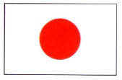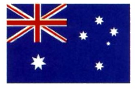

**COUNTRIES, NATIONALITIES & LANGUAGE**

|  |  |  |  |
| --- | --- | --- | --- |
| **COUNTRY（えい語）** | **COUNTRY（日本語）** | **NATIONALITY** | **LANGUAGE SPOKEN** |
| Japan |  |  |  |
| Australia |  |  |  |
| America |  |  |  |
| France |  |  |  |
| Germany |  |  |  |
| Spain |  |  |  |
| Italy |  |  |  |
| UK |  |  |  |
| China |  |  |  |
| Korea |  |  |  |
| Thailand |  |  |  |
| New Zealand |  |  |  |
| Canada |  |  |  |
| Philippines |  |  |  |
| Iran |  |  |  |

**どこ から きましたか。- WHERE ARE YOU FROM?!?**

**COUNTRY から きました。**

C:\Users\Leah\AppData\Local\Microsoft\Windows\Temporary Internet Files\Content.IE5\PD6KM5NE\MC900018789[1].wmf

1. _______________________________________________________________________________



1. ________________________________________________________________________________



1. ________________________________________________________________________________



1. ________________________________________________________________________________



1. ________________________________________________________________________________

あなたは どこ から きましたか。

