Find go akai things and write them down.
________________________________________________________________________________________________________________________________

Write kiiroi in its colour yon times.
________________________________________________________________________________________________________________________________

Collect juu midori leaves and stick them on your sheet.

Count the number of kuroi shoes in the room and write it down.
________________________________________________________________
Draw ichi shiroi ghost.

Colour in roku bears chairo.
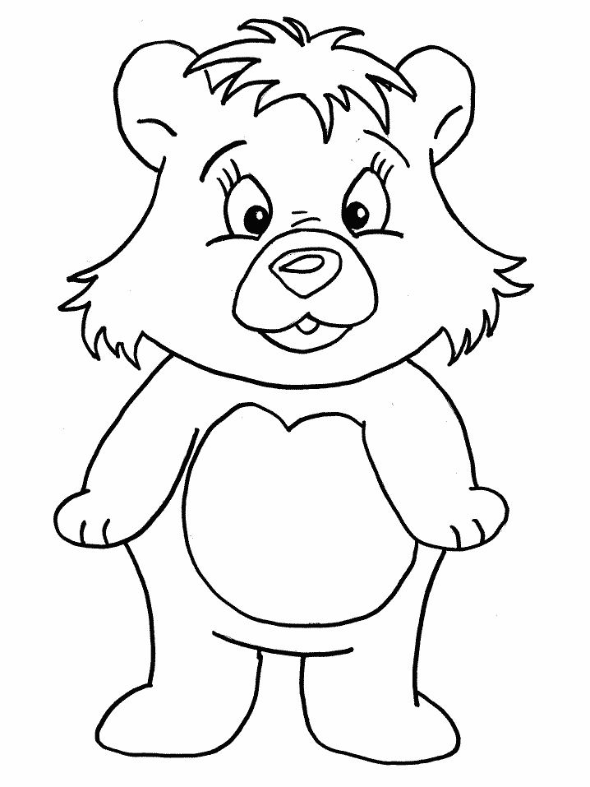
Find ni haiiro stones.
Write the names of san people with aoi eyes.
________________________________________________________________________________________________________________________________
Draw nana pinku balloons.

Find hachi orenji things in the classroom and write them down.
________________________________________________________________________________________________________________________________
Draw a rainbow with juuichi colours.

Trace these juu Japanese numbers in aoi.
First finished collect kyuu murasaki lollies!

