

C:\Users\billinge\AppData\Local\Microsoft\Windows\Temporary Internet Files\Content.IE5\N8MUZGEO\MC900238192[1].wmf











C:\Users\billinge\AppData\Local\Microsoft\Windows\Temporary Internet Files\Content.IE5\J59WJ6FM\MC900440591[1].wmf

C:\Users\billinge\AppData\Local\Microsoft\Windows\Temporary Internet Files\Content.IE5\31PHUDXI\MC900197733[1].wmf



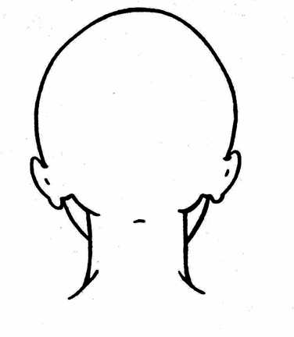

C:\Users\billinge\AppData\Local\Microsoft\Windows\Temporary Internet Files\Content.IE5\UF8547TX\MC900446376[1].wmf



C:\Users\billinge\AppData\Local\Microsoft\Windows\Temporary Internet Files\Content.IE5\31PHUDXI\MC900018399[1].wmf