Are you allowed to…?

Allowed to: CAUSATIVE + てくれます。

Not allowed to: CAUSATIVE + てくれません。

Ru verbs (one hiragana/’e’ sound before masu)
+ させます | 食べます＝食べさせます  見ます＝見させます
U verbs (‘i’ sound before masu)
+ change ‘i’ to ‘a’ sound + せます | 行きます＝行かせます  読みます＝読ませます

1. Using the following picture prompts, talk about what your parents allow you to do or not do. 例：夜遅くテレビを見させてくれません。

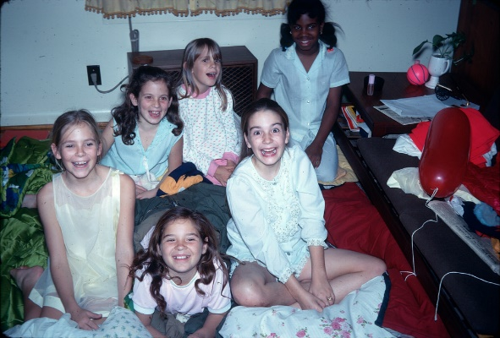

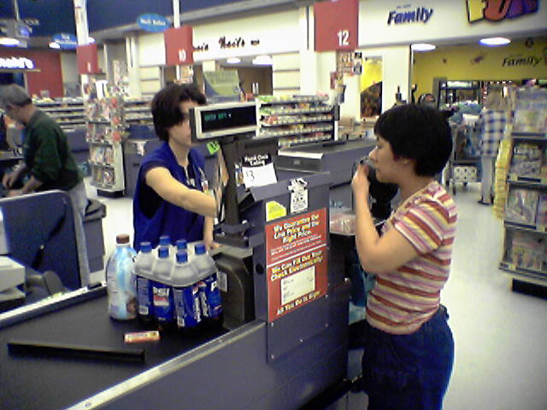

2. Can you think of any other things your parents, friends, teachers or roommates allow you to do or not do?
3. Think about the past. Were you allowed to do these things? Use the past tense to talk about it.

例：子供の時、夜遅くテレビを見させてくれません。

