QR Code Scavenger Hunt
Preparation: Print and laminate the QR codes. NOTE: The information written in Japanese is just for the teacher’s reference and does not need to be printed/laminated. It is advisable to number the codes to keep track of which is which. Display one red QR Code (instructions to the students on where to go next) and one black QR Code (an audio question which must be answered on the answer sheet at each station) at the locations included in the QR code messages (i.e. library, Japanese classroom, staffroom, hall, tuckshop and Prep Classrooms). They must be displayed in such a way as they will require the students to go from place one (library) to place two (Japanese classroom), so QR Code No.2 would be displayed at the library. Also print out one extra set of the Place (red) QR codes on paper. These will be handed out, one per group, to start off the hunt and show each team their starting point.

The activity: Divide the class into groups and issue each group with an answer sheet and one red QR code. The students go to each red QR code and complete the activity/question stated on the black QR code.

Aim: The object is to visit each station, respond to each QR coded question and record the answer on the answer sheet and then use the black QR code to learn where to go next.

Extra information: For a longer, more involved scavenger hunt, add extra activities for the students to complete at each station such as folding an origami, looking at a picture of something Japanese and trying to work out what it is etc. This activity also works very well when there are visiting Japanese students at the school and one Japanese student can be included in each group.

Useful links:
- QR Code Generator Website Links: http://www.qrcode-monkey.com/#text (to create coloured QR Codes)
- http://qrvoice.net (to create audio QR codes)

Additonal information:

What is a QR Code?
A QR Code (also known as a Quick Response Code) is a two-dimensional barcode that consists of black squares of varying sizes arranged on a white background. They were created by Denso-wave in Japan in 1994 and have become the most popular form of two-dimensional barcodes. QR Codes were originally designed for use in the Automotive industry for tracking parts and high-speed data decoding.
How do I scan a QR Code?
If you have a cell phone with a camera, you can scan a QR Code. You do however need a special application to scan the code. If you have an iPhone, Android, or Blackberry device, you’re in good shape as there are many applications available for your device. If you don’t have one of the aforementioned devices, fear not, you too have options. Below, we’ve listed a number of great applications that can be used for your phone. Please note, the listed apps are only suggestions.
iPhone QR Code Scanners
- I-nigma QR Datamatrix Barcode Reader
- AT&T Code Scanner
- QR Reader for iPhone
- Bakodo – Barcode Scanner and QR Bar Code Reader
Android QR Code Scanners
- I-nigma QR Datamatrix Barcode Reader (Author Favorite)
- Barcode Scanner
- Scanlife Barcode Reader
- Quickmark QR Code Reader
- QR Droid
Blackberry QR Code Scanners
- BeeTagg QR Reader
- CertainTeed QR Code Reader
- Code Scanner Pro
- Scanlife 2D Code Reader
Non-Smart Phone QR Code Scanner Resources
- Visit: http://www.mobile-barcodes.com/qr-code-software/
Information from: http://www.dealsavant.com/blog/what-is-a-qr-code-and-how-do-i-use-one/

Places around school:

1.としょかん に いって ください。 | 2.にほんご の きょうしつ に いって ください。
3.しょくいんしつ に いって ください。 | 4.ホール に いって ください。
5.ばいてん に いって ください。 | 6.プレップ の きょうしつ に いって ください。

Questions:

なんさい ですか。  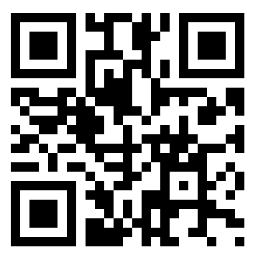 | すきなどうぶつはなんですか。  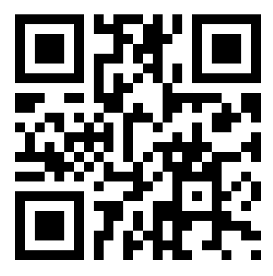
すきなきょうかはなんですか。 | すきなスポーツはなんですか。  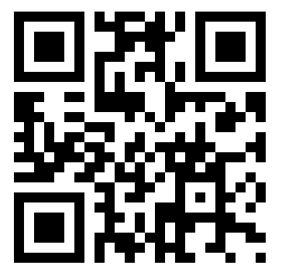
すきないろはなんですか。  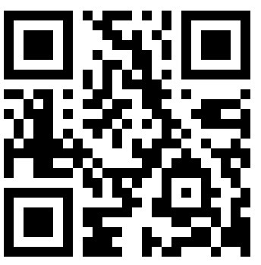 | すきな きせつ は なんですか。  