Hiragana/Katakana or Kanji Practice Game

This is a simple game where players use hiragana/katakana or Kanji in place of X or O on a naughts and crosses board. Teachers can write in the Hiragana/Katakana/Kanji with stroke order to pass out amongst the students. It can be played by beginner learners and more experienced by simply having a beginner use hiragana and the experienced person using kanji.

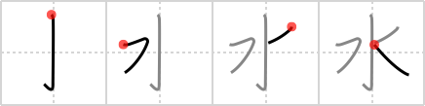
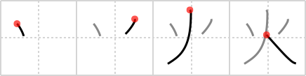
火

水

Blank Form for Hiragana/Katakana

Blank Form for Kanji
Kanji definition and readings:
Kanji definition and readings:

