Maneki Neko
Name: ___________________
Fun Fact: How does a cat cry in Japanese? How does a cat cry in English?
- a) Label the Maneki Neko and indicate the following items in Hiragana: Collar, gold coin, bell
b) Give the colours of the following: 1) ears 2) eyes 3) collar 4) face and body 5) bell
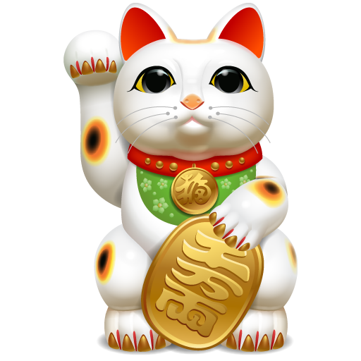
5)
4)
3)
2)
1)
- What is the value of the gold coin that the Maneki Neko is holding? Provide the exact figure.

- Name two places where you will find Maneki Neko in New Zealand. Write the places’ names in Japanese.

- What does Maneki Neko mean literally?

- Why do Japanese people buy Maneki Neko sculpture?

- If you go on a WBHS Japan trip and find Maneki Neko sculptures in a souvenir shop, would you get one for yourself, friends or family? Give reasons for your answer.

- Do we have anything similar to Maneki Neko in our own culture? Name at least one and write a short description about it. Be prepared to report back to the class.

