Task
Read and complete the activities on the next page.

Japanese Traditional Music: The Koto
The history of traditional music in Japan is rich and varied. Many musical forms were imported from China more than a thousand years ago, but over the years, they were reshaped into distinctively Japanese styles of expression. Of the traditional instruments, the koto is probably the most familiar and popular.
The koto is a large, wooden instrument with 13 strings. It's around 160cm, 200cm long and about 20cm across. It has a curved face, and the pitch is adjusted with movable bridges placed under each string. It's played with picks worn on the fingers, similar to those used in playing the guitar. The left hand presses down on the strings to bend notes and create other effects.
Historians think the koto was born around the fifth to third century B.C. in China. Originally it had only 5 strings but increased to 12 strings and then to 13. It was the 13-string koto that was carried to Japan during the Nara period (710-794).
Initially, it was performed in ensembles with other stringed and wind instruments, but eventually it came to be performed by itself. Sadly, modern Japanese rarely hear traditional instruments such as the koto being played live these days. A number of elementary and middle schools hold classes in traditional music, though, and arrange outings to theatres and concert halls to see and hear traditional performing arts.

(Information from http://web-japan.org/kidsweb/)
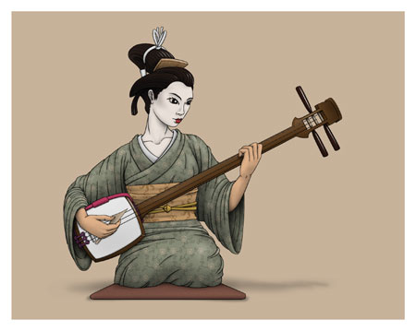
- Look at the pictures below. According to the description in the passage on page 7, which of these traditional Japanese instruments is the koto?
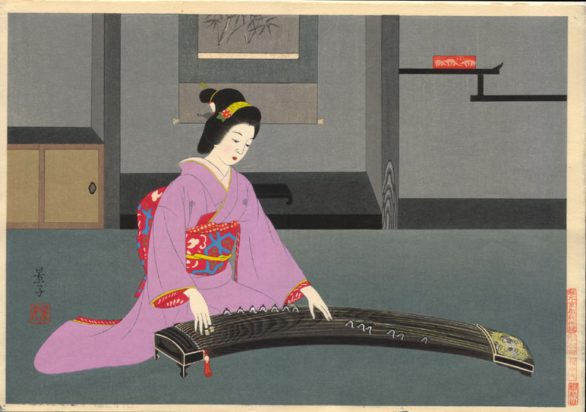
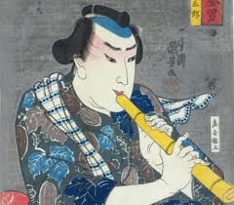
- Complete these facts about the koto by circling the correct response:
- The koto first came from (China / Russia / North Japan).
- The first koto had (5 / 12 / 13) strings.
- Today the koto is usually played (with string and wind instruments / in a band / by itself).
- Modern Japanese (rarely / sometimes / always) hear the koto being played live.

3. Two other traditional instruments are called the Shakuhachi and the Shamisen. Do some research and find out which picture in question 1 is the Shakuhachi and which is the Shamisen.

4. Select one instrument. In small groups, find information about the instruments such as origin, appearance, and who plays the insturment. Report to the rest of the class what you found.
- taiko
- biwa
- mokugyo

