**C:\Documents and Settings\hmansfield\Local Settings\Temporary Internet Files\Content.IE5\6Y1W0V15\MC900294178[1].wmfC:\Documents and Settings\hmansfield\Local Settings\Temporary Internet Files\Content.IE5\85X6F4N1\MC900295005[1].wmf**

**C:\Documents and Settings\hmansfield\Local Settings\Temporary Internet Files\Content.IE5\H7DH8J01\MC900031089[1].wmf**C:\Documents and Settings\hmansfield\Local Settings\Temporary Internet Files\Content.IE5\85X6F4N1\MC900433692[1].wmf**ー**

**C:\Documents and Settings\hmansfield\Local Settings\Temporary Internet Files\Content.IE5\R91EPP6V\MC900353090[1].wmfJapanese Sports and Hobbies**

Namae:___________________________________

Kurasu: ________________________________________

Vocabulary Lists

Sports:

|  |  |  |
| --- | --- | --- |
| **English** | **Romaji** | **Hiragana/Katakana** |
| Golf | Gorufu | ゴルフ |
| Tennis | Tenisu | テニス |
| Basketball | Basukettobo-ru | バスケットボール |
| Baseball | yakyuu | やきゅう |
| Swimming | Suie | すいえ |
| Volleyball | Barebo-ru | バレバール |
| Soccer | Sakka | サッカ |
| Cricket | Kuriketto | クリケット |
| Football | Futtobo-ro | フットボール |
| Skiing | Suki- | スキー |
| Rugby | Ragubi | ラグビ |
| Surfing | Sa-fin | サーフィン |
|  |  |  |
|  |  |  |

Hobbies

|  |  |  |
| --- | --- | --- |
| **English** | **Romaji** | **Hiragana/Katakana** |
| Fishing | Tsuri | つり |
| Reading | Dokushyou | どくしょう |
| Music | Ongaku | おんがく |
| Computing | Conpyu-ta | コンピュータ |
| Piano | Piano | ピアノ |
| Cooking | Ryouri | りょうり |
| Sports | Supo-tsu | スポーツ |
| PlayStation | Pureisute | プレイステ |
| Bike-riding | Jitenshya | じてんしゃ |
| Skateboarding | Suke-tobo-do | スケートボード |
| Dance | Dansu | ダンス |
| Calligraphy | Shyodo | しょど |
| TV | terebi | テレビ |
| Gaming | ge-mu | ゲーム |
| Movies | eiga | えいが |
| Camping | kyanpingu | キャンピング |
|  |  |  |
|  |  |  |

C:\Documents and Settings\hmansfield\Local Settings\Temporary Internet Files\Content.IE5\H7DH8J01\MC900241893[1].wmfTalking about Sports:

Here are some sentences you can use when talking about sports:

*Hint: The answers don’t always have to be answers to questions; you can also use them as statements on their own*

*Question:*

What sport do you play?

どんなスポーツをしますか。

donna supotsu o shimasuka.

*Answer:*

I play/do _____­­­­______.

＿＿＿＿をします。

_______ o shimasu.

*Question*

Do you like_______?

＿＿＿がすきですか。

______ ga suki desuka

*Question*

What’s your favourite sport?

いちばんすきなスポーツはなんですか。

ichi ban sukina supotsu wa nan desuka.

*Answers*

Yes, I like______

はい、＿＿＿＿がすきです

Hai, ___________ga sukidesu.

No I don’t like __________

いいえ、＿＿＿＿がすきじゃないです。

iie, ­­­_____________gasukijyanaidesu.

*Answer*

My favourite sport is _______________

いちばんすきなスポーツは＿＿＿です。

ichi ban sukina supotsu wa _______ desu.

Talking about Hobbies:

Here are some sentences you can use when talking about hobbies:

*Question:*

What is your hobby?

しゅみはなんですか。

Shyumi wa nandesu ka.

*Answer:*

My hobby is _____­­­­______.

しゅみは＿＿＿＿です。

Shyumi wa _______desu

*Question*

Do you like_______?

＿＿＿がすきですか。

______ ga suki desuka

*Question*

What’s your favourite hobby?

いちばんすきなしゅみはなんですか。

ichi ban sukina shyumi wa nan desuka.

Sports Joke!

When is a baby good at basketball?

When it’s dribbling!

*Answers*

Yes, I like______

はい、＿＿＿＿がすきです

Hai, ___________ga sukidesu.

No I don’t like __________

いいえ、＿＿＿＿がすきじゃないです。

iie, ­­­_____________gasukijyanaidesu.

*Answer*

My favourite hobby is _______________

いちばんすきなしゅみは＿＿＿です。

ichi ban sukina shyumi wa _______ desu.

What does it say?

1. Write the English Translation

いちばんすきなスポーツはなんですか。

Ichi ban sukina supo-tsu wa nan desu ka

_____________________________＿＿________________________

1. How would you answer the above question? (in romaji)

_______________________________________＿＿______________

1. Write the English Translation

ゴルフがすきじゃないです。

Gorufu ga suki jyanai desu

__________________________________________________________________________

1. Answer the following question in romaji

しゅみはなんですか

Shyumi wa nan desuka?

_________________________________________________________________________

1. Answer the following question in a full sentence, in romaji

りょうりがすきですか

Ryouri ga suki desuka?

__________________________________________________________________________

Talk Time!

Survey your classmates and find out the most popular sport in the class, by asking

‘ichi ban sukina supotsu wa nan desuka’

Ask at least 10 students and make a graph of your findings below:

|  |  |  |  |  |  |  |
| --- | --- | --- | --- | --- | --- | --- |
| Number of Students (colour in) |  |  |  |  |  |  |
|  |  |  |  |  |  |
|  |  |  |  |  |  |
|  |  |  |  |  |  |
|  |  |  |  |  |  |
|  |  |  |  |  |  |
| Sport | C:\Documents and Settings\hmansfield\Local Settings\Temporary Internet Files\Content.IE5\6Y1W0V15\MC900351615[1].wmf | http://www.sportbetaustralia.com/images/afl.jpg | C:\Documents and Settings\hmansfield\Local Settings\Temporary Internet Files\Content.IE5\DL4988AB\MC900439815[1].png | C:\Documents and Settings\hmansfield\Local Settings\Temporary Internet Files\Content.IE5\85X6F4N1\MC900199071[1].wmf | Other _______ | Other _______ |

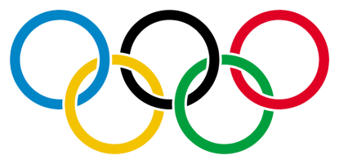

Did you know…….?

Japan first completed in the Olympic Games in 1912.

Japan hosted the Games on three occasions:

* [1964 Summer Olympics](http://en.wikipedia.org/wiki/1964_Summer_Olympics) in [Tokyo](http://en.wikipedia.org/wiki/Tokyo)
* [1972 Winter Olympics](http://en.wikipedia.org/wiki/1972_Winter_Olympics) in [Sapporo](http://en.wikipedia.org/wiki/Sapporo), [Hokkaidō Prefecture](http://en.wikipedia.org/wiki/Hokkaid%C5%8D_Prefecture)
* [1998 Winter Olympics](http://en.wikipedia.org/wiki/1998_Winter_Olympics) in [Nagano](http://en.wikipedia.org/wiki/Nagano), [Nagano Prefecture](http://en.wikipedia.org/wiki/Nagano_Prefecture)

Japanese athletes have won 361 medals at the [Summer Olympic Games](http://en.wikipedia.org/wiki/Summer_Olympic_Games), with the most gold medals won in [judo](http://en.wikipedia.org/wiki/Judo), and the most total medals won in gymnastics. Japan has also won 32 medals at the [Winter Olympic Games](http://en.wikipedia.org/wiki/Winter_Olympic_Games).

Talking about Schedules…

*Question*

What do you do on __day?

＿ようびになにをしますか。

__youbi ni nani o shimasuka

*Question*

What day of the week do you do ______?

なんようびに______をしますか。

Nanyoubi ni ______ o shimasuka

*Answer*

On __day, I do _______

＿ようびに＿＿をします。

__youbi ni ______ o shimasu

*Answer*

On ___day, I do _______.

___ようびに______をします。

___youbini ______o shimasu

*Read the schedule and answer the questions below…*

|  |  |  |
| --- | --- | --- |
| **Day of the Week** | **Activity 1** | **Activity 1** |
| nichiyoubi | footobo-ru | ge-mu |
| getsuyoubi | basukettobo-ru | sakka |
| kayoubi | conpyu-ta | footobo-ru |
| suiyoubi | ragubi | ryouri |
| mokuyoubi | ongaku | tenisu |
| kinyoubi | dokushyou | gorufu |
| doyoubi | sa-fin | tsuri |

1. nanyoubi ni tenisu o shimasuka

__________________________________________________________________________

1. nanyoubi ni ragubi o shimasuka

__________________________________________________________________________

1. kinyoubi ni nani o shimasuka (*hint: ‘to’ means ‘and’ in Japanese)*

__________________________________________________________________________

1. getsuyoubi ni nani o shimasuka

Expanding Sentences…..

As well as saying ‘I play/do ______’, we can also say

‘I learn______’ and ‘I watch _____’

|  |  |  |
| --- | --- | --- |
| **English** | **Romaji** | **Hiragana/Katakana** |
| I do/play______ | ______ o shimasu | ______をします |
| I learn ______ | ______ o naraimasu | ______をならいます |
| I watch _______ | ______o mimasu | ______をみます |

*Join the appropriate verb to the appropriate hobby, and write the English translation*

eiga o naraimasu Translation:___________________________________

piano o shimasu Translation: __________________________________

tenisu o mimasu Translation: ___________________________________

*Write 3 sentences about something you do on 3 days of the week, using the above verbs (use hiragana where you can!)*

e.g. On Sunday I watch football

　　にちようびにフットボールをみます

　　nichiyoubi ni footobo-ru o mimasu

1. ____________________________________________________________________
2. ____________________________________________________________________
3. ____________________________________________________________________

C:\Documents and Settings\hmansfield\Local Settings\Temporary Internet Files\Content.IE5\7UUJ0K03\MC900446290[1].wmf

### Vocabulary

**sumō すもう**

**mawashi　 まわし**

**rikishi　 りきし**

**sumō-beya　 すもうべや**

# Purification

When wrestlers (**rikishiりきし**) enter the ring, they spend several minutes before their match lifting their legs high in the air and stomping them down, a practice said to scare away any demons. They also throw several handfuls of salt into the ring, which is said to purify the ring. Many **りきし**will also sprinkle salt around their bodies as a means of protecting them from injury.

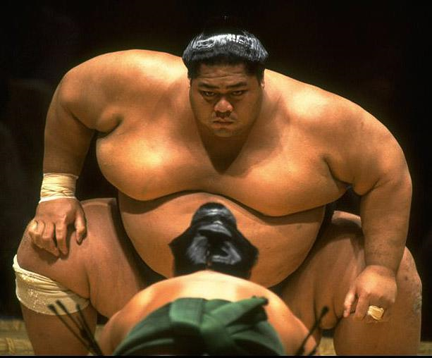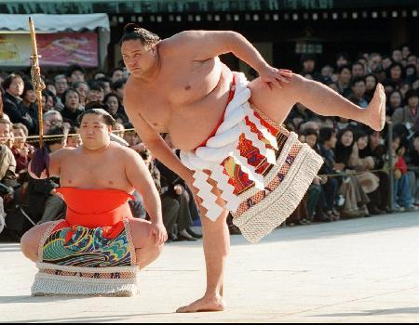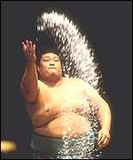

# Sumo stables

**りきし** belong to a sumo stable (**sumo-beyaすもうべや**) and practice daily under oyakata, who is a stable master. The **すもうべや** relationships follow the old feudal system -those lowest on the ranking list serve those higher up, doing such things as the dishes.

**りきし**are not the only ones who belong to **すもうべや**, there are also referees, professional **すもう** hairdressers and people who do promotions for tours.

## Japan’s national sport

**Sumō すもう** is traditional Japanese wrestling and in 1909 became Japan’s national sport. In ancient times, it was practiced as agricultural and Shinto religion rituals; so today it still includes many of the ceremonial elements. In a **すもう** match, two wrestlers wearing only a **すもう** wrestler’s loincloth (a **mawashi まわし**) enter the ring, and they fight until one either leaves the ring or touches the ground with any part of his body other than the bottom of his feet. The *Japan* **すもう** *Association* puts on six annual tournaments of the professional **すもう** per year, and these are broadcast on both television and radio.

*Read about sumō wrestling, watch the YouTube clip and then answer the questions.*

1. How long has sumō been the national sport? __________________________________
2. What is a mawashi **まわし**?__________________________________________________
3. How do you lose a sumō match? ______________________________________________

__________________________________________________________________________

1. I want to see a sumō match. What can I do?______________________________________

__________________________________________________________________________

1. Why do sumō wrestlers stomp the ground and throw salt around the ring?

__________________________________________________________________________

__________________________________________________________________________

1. What is an oyakata? _________________________________________________________
2. Who lives in a sumō-beya? ____________________________________________________
3. Would you like to live in a sumō-beya? Why/ Why not?___________________________

________________________________________________________________________________

1. Would you like to watch a sumō match? Why/ Why not? __________________________

________________________________________________________________________________

________________________________________________________________________________

**Traditional Japanese Sports and Hobbies**

Can you name these traditional Sports of Japan? (Aikido, Kyudo, Karate, Judo, Kendo)

|  |  |  |  |  |
| --- | --- | --- | --- | --- |
| http://newspaper.li/static/22e129defd0358f0d0e6d1a9167e9685.jpg | http://www.thealmightyguru.com/Database/Pictures/Karate.jpg | http://www.infinitymartialarts.com.au/images/stories/Classes/inoue_judo.jpg | http://www.northsideaikido.com/pictures/kyudo4.jpg | http://3.bp.blogspot.com/-ue1sfpF9FI4/Txry7bXx3zI/AAAAAAAAAU0/j8WYxbKHt3w/s1600/aikido.jpg |
|  |  |  |  |  |

Last Task! Choose three of the following traditional Japanese sports and hobbies. Research more about it and include the following:

* A description of the sport/hobby
* A brief history of the sport/hobby
* How to play

Kendo

Judo

Sumo

Aikido

Kyudo

Karate

Manga

Anime

Origami

Ikebana

Fukuwari

Daruma Otoshi

Jankenpon

Karaoke

Go

Sport/Hobby 1:

________________________________________________________________________________________________________________________________________________________________________________________________________________________________________________________________________________________________________________________________

Sport/Hobby 2:

________________________________________________________________________________________________________________________________________________________________________________________________________________________________________________________________________________________________________________________________

Sport/Hobby 3:

________________________________________________________________________________________________________________________________________________________________________________________________________________________________________________________________________________________________________________________________

Choose one Traditional Japanese Sport/Hobby to present to the class. Include the above information in your presentation. You need to include images (PowerPoint or printed) as well as either a demonstration or teach other students how to do the activity. You will be peer-assessed on your presentation, on these criteria:

* The quality of your information (relevent, interesting information)
* The quality of your presentation/demonstration (was it easy to understand, was it presented in a good manner, with pictures etc)
* The overall demonstration (was it fun, was it interesting, did you learn something new?)