|  |  |  |  |
| --- | --- | --- | --- |
| **ichi**  **D:\Users\08158437\AppData\Local\Microsoft\Windows\Temporary Internet Files\Content.IE5\H3OF3DV1\MC900133591[1].wmf** | **1**  <http://i671.photobucket.com/albums/vv73/masterright31/howtowriteinjapanese/kanji/how%20to%20write%20numbers%20in%20japanese/-order-25.gif> | **rokuD:\Users\08158437\AppData\Local\Microsoft\Windows\Temporary Internet Files\Content.IE5\H3OF3DV1\MP900433052[1].jpg** | **6**  <http://i671.photobucket.com/albums/vv73/masterright31/howtowriteinjapanese/kanji/how%20to%20write%20numbers%20in%20japanese/-order-28.gif> |
| <http://i671.photobucket.com/albums/vv73/masterright31/howtowriteinjapanese/kanji/how%20to%20write%20numbers%20in%20japanese/-order-31.gif>**ni** | **2** | **nanaD:\Users\08158437\AppData\Local\Microsoft\Windows\Temporary Internet Files\Low\Content.IE5\GV7DQNII\MC900358779[1].WMF** | **7**  <http://i671.photobucket.com/albums/vv73/masterright31/howtowriteinjapanese/kanji/how%20to%20write%20numbers%20in%20japanese/-order-33.gif> |
| **san**  <http://i671.photobucket.com/albums/vv73/masterright31/howtowriteinjapanese/kanji/how%20to%20write%20numbers%20in%20japanese/-order-24.gif>**D:\Users\08158437\AppData\Local\Microsoft\Windows\Temporary Internet Files\Content.IE5\I6BQAZG3\MC900440405[1].png** | **3** | **D:\Users\08158437\AppData\Local\Microsoft\Windows\Temporary Internet Files\Content.IE5\H3OF3DV1\MC900329259[1].wmfhachiD:\Users\08158437\AppData\Local\Microsoft\Windows\Temporary Internet Files\Content.IE5\GS8YTP3T\MC900237923[1].wmf** | **8**  <http://i671.photobucket.com/albums/vv73/masterright31/howtowriteinjapanese/kanji/how%20to%20write%20numbers%20in%20japanese/-order-29.gif> |
| <http://i671.photobucket.com/albums/vv73/masterright31/howtowriteinjapanese/kanji/how%20to%20write%20numbers%20in%20japanese/-order-26.gif>**shi (yon)**  **D:\Users\08158437\AppData\Local\Microsoft\Windows\Temporary Internet Files\Content.IE5\GS8YTP3T\MP900403650[1].jpg** | **4** | **kyuu**  **D:\Users\08158437\AppData\Local\Microsoft\Windows\Temporary Internet Files\Content.IE5\H3OF3DV1\MC900363088[1].wmf**  **D:\Users\08158437\AppData\Local\Microsoft\Windows\Temporary Internet Files\Content.IE5\GS8YTP3T\MP900411831[1].jpg**  like:queue | **9**  <http://i671.photobucket.com/albums/vv73/masterright31/howtowriteinjapanese/kanji/how%20to%20write%20numbers%20in%20japanese/-order-32.gif> |
| **go**  <http://i671.photobucket.com/albums/vv73/masterright31/howtowriteinjapanese/kanji/how%20to%20write%20numbers%20in%20japanese/-order-30.gif>**D:\Users\08158437\AppData\Local\Microsoft\Windows\Temporary Internet Files\Content.IE5\I6BQAZG3\MC900139349[1].wmf** | **5** | **jyuu**  **D:\Users\08158437\AppData\Local\Microsoft\Windows\Temporary Internet Files\Content.IE5\I6BQAZG3\MP900423058[1].jpg**  like: dew | **10**  <http://i671.photobucket.com/albums/vv73/masterright31/howtowriteinjapanese/kanji/how%20to%20write%20numbers%20in%20japanese/-order-16.gif> |

**Name:____________________**

**Japanese**

**More Numbers….**

**Numbers & Counting…**

|  |  |  |  |
| --- | --- | --- | --- |
| jyuu ichi | 11 | jyuu roku | 16 |
| jyuu  ni | 12 | jyuu hachi | 17 |
| jyuu san | 13 | jyuu kyuu | 18 |
| jyuu shi | 14 | jyuu jyuu | 19 |
| jyuu  go | 15 | ni  jyuu | 20 |

**greetings…**

**Ohayou gozaimasu. Konnichiwa.**

おはようございます。 こんにちは。

*goodmorning hello / good afternoon*

**Sayounara. Konbanwa.**

さようなら。 こんばんは。

*goodbye good evening*

**Oyasuminasai. Sensei.**

おやすみなさい。 せんせい。

*good night teacher*

**Kudasai Hajime mash'te.**

てください。 はじめまして。

*please nice to meet you*

**Arigatou. Arigatou Gozaimasu.**

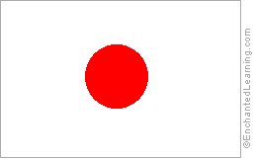**Japanese Flag** [ありがとう](http://www.omniglot.com/soundfiles/japanese/thanks2_jp.mp3)。[ありがとうございます](http://www.omniglot.com/soundfiles/japanese/thanks3_jp.mp3)。

*Land of the thanks thank you very much*

*Rising Sun*

|  |  |  |
| --- | --- | --- |
|  |  |  |

**Nihongo-Japanese Minnasan.** みんなさん *everyone*

**food and drink…**

**colours…**

|  |  |
| --- | --- |
| **Japanese** | **English** |
| aka　あかい | red |
| ao　あおい | blue |
| chaiiro　ちゃいろ | brown |
| haiiro　はいいろ | grey |
| iro　いろ | colour |
| kiiro　きいろい | yellow |
| kuro　くろい | black |
| midori　みどり | green |
| murasaki　むらさき | purple |
| orenji　オレンジ | orange |
| pinku　ピンク | pink |
| shiroi　しろい | white |
| dou ブロンズ | bronze |
| gin シルバー | silver |
| kin ゴールド | gold |

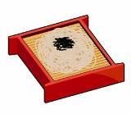

**soba**

そば

*buckwheat noodles*

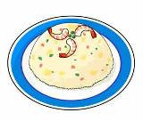

**chaahan**

チャーハン

*fried rice*

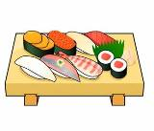

**sushi**

すし

*sushi*

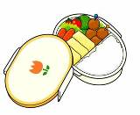

**o’bento**

おべんとう

*lunchbox*

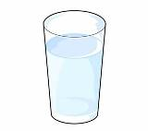

**mizu**

みず

*water*

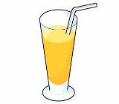

**juusu**

ジュース

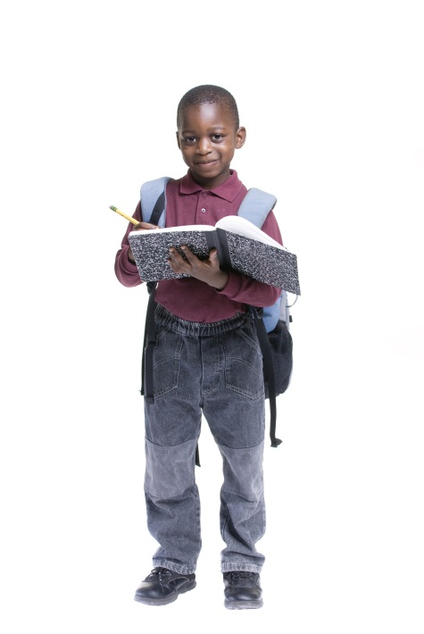*juice*

atama – *head*

あたま

hiza – *knees*

ひざ

me – *eyes*

mimi – *ears*

kuchi – *mouth*

hana - *nose*

kata – *shoulders*

かた

ashi – *feet, foot, leg*

あし

**Body Parts…**