[](http://images.google.co.jp/imgres?imgurl=http://www.clker.com/cliparts/a/0/e/1/1216139760278927551lemmling_Cartoon_cow.svg.med.png&imgrefurl=http://www.clker.com/clipart-23284.html&usg=___0ZN0nn4t3-zN5ieOnU5LL6bcxo=&h=299&w=264&sz=34&hl=ja&start=4&tbnid=yFgCEEL5Q5TKJM:&tbnh=116&tbnw=102&prev=/images?q=cow+clip+art&gbv=2&hl=ja&sa=G)[](http://images.google.co.jp/imgres?imgurl=http://www.clker.com/cliparts/8/9/9/d/11949855741697952186small_house_01.svg.med.png&imgrefurl=http://www.clker.com/clipart-3518.html&usg=__tYOE2K9wI9KNOEW17hu9WOeivlU=&h=297&w=288&sz=5&hl=ja&start=7&tbnid=a01vMjbYM7AAFM:&tbnh=116&tbnw=112&prev=/images?q=house+clip+art&gbv=2&hl=ja&sa=G)[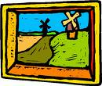](http://images.google.co.jp/imgres?imgurl=http://www.clipartheaven.com/clipart/art_&_design/fine_art/painting_-_landscape_2.gif&imgrefurl=http://www.clipartheaven.com/show/clipart/art_&_design/fine_art/painting_-_landscape_2-gif.html&usg=__HvWFE8Jo3enpqY8CW1HLgfH1xIU=&h=416&w=490&sz=13&hl=ja&start=76&tbnid=s0NdcS5T4psj-M:&tbnh=110&tbnw=130&prev=/images?q=painting+clip+art&gbv=2&ndsp=20&hl=ja&sa=N&start=60)[](http://images.google.co.jp/imgres?imgurl=http://travel.live-japanese.com/images/oni_omen.gif&imgrefurl=http://travel.live-japanese.com/?eid=467052&usg=__zXvhCGcxpe4Kctxo9Pdrsp7P8hw=&h=90&w=83&sz=5&hl=ja&start=20&tbnid=HhJhelKOTKNgRM:&tbnh=78&tbnw=72&prev=/images?q=oni+clip+art&gbv=2&hl=ja&sa=G)[](http://images.google.co.jp/imgres?imgurl=http://clipartmountain.com/clipart1/turtle1.gif&imgrefurl=http://clipartmountain.com/clipart1/turtles1.htm&usg=__Xlr3rBGoGUv1b3LtAD9I6RY_1X0=&h=104&w=137&sz=4&hl=ja&start=32&tbnid=yEDCIElupU3nQM:&tbnh=71&tbnw=93&prev=/images?q=turtle+clip+art&gbv=2&ndsp=20&hl=ja&sa=N&start=20)[](http://images.google.co.jp/imgres?imgurl=http://www.aperfectworld.org/clipart/plants/tree09.gif&imgrefurl=http://www.aperfectworld.org/plants.html&usg=__ZZyVIxlZKCnEaAm-oSTShwRqBHc=&h=422&w=309&sz=14&hl=ja&start=1&tbnid=bOAY5TFAKTZtcM:&tbnh=126&tbnw=92&prev=/images?q=tree+clip+art&gbv=2&hl=ja&sa=G)[](http://images.google.co.jp/imgres?imgurl=http://www.iloveclipart.com/downloads/free-bear-clip-art.png&imgrefurl=http://www.iloveclipart.com/bear-clip-art.html&usg=__agcCZRGJfKA4Vil1lkJss8Pftew=&h=547&w=370&sz=55&hl=ja&start=1&tbnid=RfcEsSWaJzFC7M:&tbnh=133&tbnw=90&prev=/images?q=bear+clip+art&gbv=2&hl=ja&sa=G)[](http://images.google.co.jp/imgres?imgurl=http://members.cox.net/knittingabout/graphic/cpy-yarn.gif&imgrefurl=http://haveaball.clothslineezine.com/aam.html&usg=__LbsqrMNFhn2OmPPVEsF--ASEyVY=&h=101&w=128&sz=2&hl=ja&start=2&tbnid=wtbYZG1R8-CFAM:&tbnh=72&tbnw=91&prev=/images?q=ball+of+wool+clip+art&gbv=2&hl=ja&sa=G)[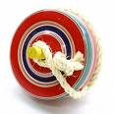](http://images.google.co.jp/imgres?imgurl=http://thumbnail.image.rakuten.co.jp/@0_mall/wakei-seijyaku/cabinet/toy/img20364877.jpg&imgrefurl=http://item.rakuten.co.jp/wakei-seijyaku/10001258/&usg=__PE29D3kF9I_MsbyhX3A3sSqVNhA=&h=300&w=300&sz=17&hl=ja&start=4&tbnid=amtlFc63kW1RpM:&tbnh=116&tbnw=116&prev=/images?q=%E7%8B%AC%E6%A5%BD%E3%80%80&gbv=2&hl=ja&sa=G)[](http://images.google.co.jp/imgres?imgurl=http://fc.burlesonisd.net/~sdalby/S01BDFBF2.3/animal_clipart_monkey0.gif&imgrefurl=http://fc.burlesonisd.net/~sdalby/&usg=__yMcb6SKgJYaBQBa5j9Ez1IxMG5g=&h=200&w=190&sz=7&hl=ja&start=1&tbnid=muJv0gsXV2aoQM:&tbnh=104&tbnw=99&prev=/images?q=monkey+clip+art&gbv=2&hl=ja&sa=G)[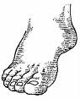](http://images.google.co.jp/imgres?imgurl=http://www.cdc.gov/diabetes/pubs/images/frontfoo.gif&imgrefurl=http://www.cdc.gov/diabetes/pubs/gallery.htm&usg=__uUo7cToFUwbkGYqTM3H0JAgUkNY=&h=308&w=250&sz=8&hl=ja&start=7&tbnid=B4I6sLBzRCDIYM:&tbnh=117&tbnw=95&prev=/images?q=foot+clip+art&gbv=2&hl=ja&sa=G)[](http://images.google.co.jp/imgres?imgurl=http://www.hinderthemnot.com/clip_art_duck.jpg&imgrefurl=http://www.hinderthemnot.com/classtripdoylefarm.html&usg=__a5W4tLdb5_cRWuwPIQDn5UNkK6c=&h=400&w=329&sz=36&hl=ja&start=3&tbnid=zup0oUH-qFxS6M:&tbnh=124&tbnw=102&prev=/images?q=duck+clip+art&gbv=2&hl=ja&sa=G)

[](http://images.google.co.jp/imgres?imgurl=http://www.free-clipart-pictures.net/free_clipart/dog_clipart/dog_clipart_puppy.gif&imgrefurl=http://www.free-clipart-pictures.net/dog_clipart.html&usg=__sX_VpJlz10litO-FKsU9RzmRvcQ=&h=200&w=200&sz=7&hl=ja&start=2&tbnid=6DMFnAZPQC-qzM:&tbnh=104&tbnw=104&prev=/images?q=dog+clip+art&gbv=2&hl=ja&sa=G)

[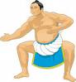](http://images.google.co.jp/imgres?imgurl=http://www.fotosearch.jp/bthumb/UNC/UNC112/u10239238.jpg&imgrefurl=http://www.fotosearch.jp/illustration/%E7%9B%B8%E6%92%B2.html&usg=__05fuJjaZI7W6YDj_0hdLZWP6HoA=&h=170&w=158&sz=8&hl=ja&start=4&tbnid=F26F5JH4mg2YfM:&tbnh=99&tbnw=92&prev=/images?q=sumo+clip+art&gbv=2&hl=ja&sa=G)

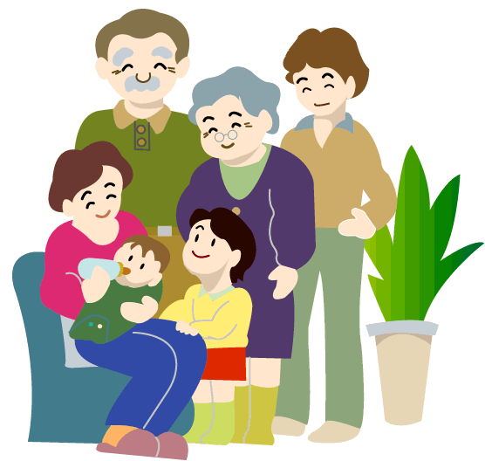

おじいさん

おばあさん

おとうさん

おかあさん

おねえさん

おにいさん

あかちゃん

Year 6 Japanese Speech

1. はじめまして。
2. こんにち　は。
3. わたし　の　なまえ　は　＿＿＿＿＿　です。
4. ＿＿＿＿＿　さい　です。
5. Suburb　に　すんで　います。
6. Kind of pet　を　かって　います。
7. Kind of pet の　なまえ　は　＿＿＿＿＿　です。
8. ２　Descriptive sentences　　　　　　　　　　　　　（e.g.はな　が　くろい　です。）
9. ２nd descriptive sentence. 　　　　　　　　　　　　(e.g.　あし　が　みじかい　です。)
10. Pet’s name　が　だいすき　です。
11. どうぞ　よろしく。
12. ありがとう　ございました。

No. 3 Boys may use ぼく instead of わたし

Only one adjective to be used per sentence in No 8 and 9

*Be prepared to answer 1 or 2 questions at the end to check if you have understood what you have said.*

[](http://images.google.co.jp/imgres?imgurl=http://www.aperfectworld.org/clipart/cartoons/fish.gif&imgrefurl=http://www.aperfectworld.org/cartoons.html&usg=__CsTAAVocWP7vQgJF-uxfJDlUaDQ=&h=425&w=731&sz=21&hl=ja&start=4&tbnid=HB9DNmqENl0C8M:&tbnh=82&tbnw=141&prev=/images?q=fish+clip+art&gbv=2&hl=ja&sa=G)

[](http://images.google.co.jp/imgres?imgurl=http://www.lrhsd.org/823120711162810903/lib/823120711162810903/book_clipart_3.gif&imgrefurl=http://www.lrhsd.org/823120711162810903/&usg=__HZQerTG8qyYOK3qHObe1jhLhd6g=&h=300&w=300&sz=18&hl=ja&start=2&tbnid=o4yq_xk8ekRrCM:&tbnh=116&tbnw=116&prev=/images?q=book+clip+art&gbv=2&hl=ja&sa=G)

[](http://images.google.co.jp/imgres?imgurl=http://ngfl.northumberland.gov.uk/dt/dtclip/Food_Alb/images/clock_jpg.jpg&imgrefurl=http://ngfl.northumberland.gov.uk/dt/dtclip/Food_Alb/pages/clock_jpg.htm&usg=__1OYjVCte1P9cafB2pCEf_x_ze8Y=&h=220&w=200&sz=14&hl=ja&start=2&tbnid=KfaBx0AduWxQQM:&tbnh=107&tbnw=97&prev=/images?q=clock+clip+art&gbv=2&hl=ja&sa=G)

[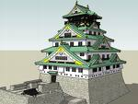](http://images.google.co.jp/imgres?imgurl=http://farm1.static.flickr.com/139/324602632_4b3b3ef480_o.jpg&imgrefurl=http://pub.ne.jp/seagate/?entry_id=443913&usg=__XXLmPqWY3fjWo-6YizXOwl0gCwM=&h=768&w=1024&sz=218&hl=ja&start=4&tbnid=ZH_1Tl7VEEnerM:&tbnh=113&tbnw=150&prev=/images?q=%E5%A4%A7%E9%98%AA%E5%9F%8E&gbv=2&hl=ja&sa=G)

[](http://images.google.co.jp/imgres?imgurl=http://etc.usf.edu/clipart/45300/45362/45362_hands_lg.gif&imgrefurl=http://etc.usf.edu/clipart/45300/45362/45362_hands.htm&usg=__jTSjGDdOOujvoWuHGpILLQVJwwY=&h=452&w=700&sz=27&hl=ja&start=10&tbnid=GbLPQcqqRKpZ8M:&tbnh=90&tbnw=140&prev=/images?q=hands+clip+art&gbv=2&hl=ja&sa=G)

[](http://images.google.co.jp/imgres?imgurl=http://images2.disneysites.com/clipart/images41/Movies/Peter_Pan/Crocodile/crocodile01a.gif&imgrefurl=http://clipart.disneysites.com/display.php?catID=188&usg=__A3zYCyzlWRWHMFWOamlqv1DnuAo=&h=125&w=97&sz=5&hl=ja&start=11&tbnid=SC3kU1Q0hlR_HM:&tbnh=90&tbnw=70&prev=/images?q=crocodile+clip+art&gbv=2&hl=ja&sa=G)

[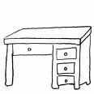](http://images.google.co.jp/imgres?imgurl=http://www.funfonix.com/clipart/desk.gif&imgrefurl=http://www.funfonix.com/clipart1.php&usg=__DxEFG3KPu1HwRGjTho2F8B8YARQ=&h=300&w=300&sz=14&hl=ja&start=5&tbnid=voJrb9Jk99PxWM:&tbnh=116&tbnw=116&prev=/images?q=desk+clip+art&gbv=2&hl=ja&sa=G)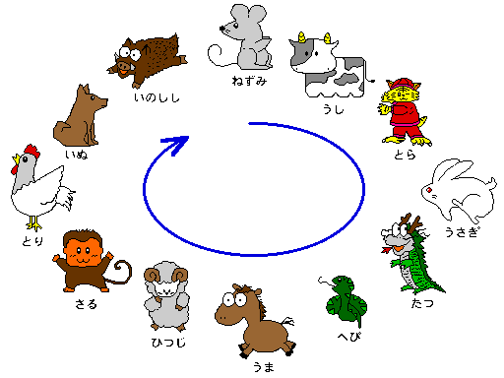

[](http://images.google.co.jp/imgres?imgurl=http://www.roycemoreschool.org/teacher/sheehan/clip_art_frog_1.jpg&imgrefurl=http://www.roycemoreschool.org/teacher/sheehan/&usg=__Z40p5hGIKsVLLMUzPXG9G4iwb5g=&h=421&w=300&sz=22&hl=ja&start=1&tbnid=IOcOn_BfwaoejM:&tbnh=125&tbnw=89&prev=/images?q=frog+clip+art&gbv=2&hl=ja&sa=G)

[](http://images.google.co.jp/imgres?imgurl=http://www.fotosearch.com/bthumb/UNC/UNC161/u24352631.jpg&imgrefurl=http://www.fotosearch.com/valueclips-clip-art/weather-symbols/UNC161/&usg=__MxlTi8NoRGltBNJUl5rLQWsubhA=&h=161&w=170&sz=9&hl=ja&start=3&tbnid=5KaihYVECYvL7M:&tbnh=94&tbnw=99&prev=/images?q=snow+clip+art&gbv=2&hl=ja&sa=G)

[](http://images.google.co.jp/imgres?imgurl=http://frontpage.wagonerps.org/jsimpson/bee_clipart_bumble_bee.png&imgrefurl=http://frontpage.wagonerps.org/jsimpson/&usg=__f3VSDtN8AkNFUwM4svJ_8V4clSA=&h=163&w=200&sz=4&hl=ja&start=2&tbnid=qqRP_0oGYCnOdM:&tbnh=85&tbnw=104&prev=/images?q=bee+clip+art&gbv=2&hl=ja&sa=G)

[](http://images.google.co.jp/imgres?imgurl=http://cmsweb2.loudoun.k12.va.us/512_4151883033/lib/512_4151883033/clipart_tiger28.jpg&imgrefurl=http://cmsweb2.loudoun.k12.va.us/512_4151883033/&usg=___aDj3HkNK6bP3ZM2pCRfAigdnfc=&h=296&w=232&sz=17&hl=ja&start=6&tbnid=OPcTZwB6S69hRM:&tbnh=116&tbnw=91&prev=/images?q=tiger+clip+art&gbv=2&hl=ja&sa=G)

[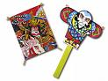](http://images.google.co.jp/imgres?imgurl=http://www.dagashino-shibasaki.com/photo/Products-463-1.jpg&imgrefurl=http://www.dagashino-shibasaki.com/cgi/products.cgi?Category=B&usg=__a4SF8-VCcTVW1x0C199Rtr1o7y8=&h=285&w=380&sz=92&hl=ja&start=28&tbnid=Rwc6y0yUIoAS2M:&tbnh=92&tbnw=123&prev=/images?q=%E5%87%A7+%E3%82%AF%E3%83%AA%E3%83%83%E3%83%97%E3%82%A2%E3%83%BC%E3%83%88&gbv=2&ndsp=20&hl=ja&sa=N&start=20)

[](http://images.google.co.jp/imgres?imgurl=http://ngfl.northumberland.gov.uk/clipart/Animals/images/cat_jpg.jpg&imgrefurl=http://ngfl.northumberland.gov.uk/clipart/Animals/pages/cat_jpg.htm&usg=__4xoYZO7muGFPO_2JzedEAgm-mns=&h=350&w=312&sz=17&hl=ja&start=5&tbnid=HbmNTNtrKN5iQM:&tbnh=120&tbnw=107&prev=/images?q=cat+clip+art&gbv=2&hl=ja&sa=G)[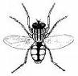](http://www.google.com/imgres?imgurl=http://greennature.com/images/insects/fly.gif&imgrefurl=http://greennature.com/article2543.html&h=242&w=250&sz=6&tbnid=4oHBfyUh0mbVuM:&tbnh=107&tbnw=111&prev=/images?q=insect+clip+art&usg=__gWROVw_s0b7kGKpBks4wru9jUyw=&ei=s_pbS7jTCtCGkAXKofGcAg&sa=X&oi=image_result&resnum=3&ct=image&ved=0CA0Q9QEwAg)[](http://images.google.co.jp/imgres?imgurl=http://school.discoveryeducation.com/clipart/images/gluestik.gif&imgrefurl=http://school.discoveryeducation.com/clipart/clip/gluestik.html&usg=__U289NLHVn08_Wtllc1vuIroNCKw=&h=407&w=500&sz=4&hl=ja&start=1&tbnid=qQf_MdFgfmX4MM:&tbnh=106&tbnw=130&prev=/images?q=gluestick+clip+art&gbv=2&hl=ja&sa=G)[http://t3.gstatic.com/images?q=tbn:xgkjOg6a8ZUbPM%3Ahttp://www.imajlar.com/free_clipart/vehicle_clipart/vehicle_clipart_ship.gif](http://images.google.co.jp/imgres?imgurl=http://www.imajlar.com/free_clipart/vehicle_clipart/vehicle_clipart_ship.gif&imgrefurl=http://www.free-clipart-pictures.net/vehicle_clipart.html&usg=__1Nx1Ts-oUYfyrEafBeJO3TrAem0=&h=100&w=200&sz=5&hl=ja&start=8&tbnid=xgkjOg6a8ZUbPM:&tbnh=52&tbnw=104&prev=/images?q=ship+clip+art&gbv=2&hl=ja&sa=G)[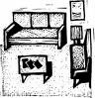](http://images.google.co.jp/imgres?imgurl=http://www.fotosearch.com/bthumb/ARP/ARP112/Waitroom.jpg&imgrefurl=http://www.fotosearch.com/clip-art/waiting-room.html&usg=__MYE3EuIVHONQvDeqJMxz0oGuIDw=&h=170&w=164&sz=13&hl=ja&start=17&tbnid=x6UmWxQf2rouWM:&tbnh=99&tbnw=96&prev=/images?q=room+clip+art&gbv=2&hl=ja&sa=G)[](http://images.google.co.jp/imgres?imgurl=http://4.bp.blogspot.com/_UuScIsE4twE/SmaZvKR3npI/AAAAAAAAAgE/kiZw-n_HYRM/S220/star_clipart.gif&imgrefurl=http://kystarshomeschool.blogspot.com/&usg=__VTgRA1vzGgXkwrU7D-oQouAIrBA=&h=200&w=200&sz=4&hl=ja&start=2&tbnid=JoWaw5m0N1sTqM:&tbnh=104&tbnw=104&prev=/images?q=star+clip+art&gbv=2&hl=ja&sa=G)[](http://images.google.co.jp/imgres?imgurl=http://www.clker.com/cliparts/3/0/3/8/1194986541442028018ear_-_body_part_nicu_buc_01.svg.hi.png&imgrefurl=http://www.clker.com/clipart-4337.html&usg=__npvJccP0KWMOFunfA1pf8A0y3yU=&h=599&w=360&sz=31&hl=ja&start=3&tbnid=Mf_JrxWcaFaEmM:&tbnh=135&tbnw=81&prev=/images?q=ear+clip+art&gbv=2&hl=ja&sa=G)[](http://images.google.co.jp/imgres?imgurl=http://www.clker.com/cliparts/c/1/1/f/11949846161220251482eyes_lumen_design_studio_01.svg.med.png&imgrefurl=http://www.clker.com/clipart-2412.html&usg=__HLPbFfzfacyrEHv5ySxyK8iFarc=&h=271&w=300&sz=9&hl=ja&start=4&tbnid=6ChYm64hr_2wbM:&tbnh=105&tbnw=116&prev=/images?q=eyes+clip+art&gbv=2&hl=ja&sa=G)[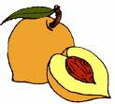](http://images.google.co.jp/imgres?imgurl=http://www.sevensistersobgyn.com/clipart/images/Peach.gif&imgrefurl=http://www.sevensistersobgyn.com/&usg=__yUZak974CvK9oTrIKi-1qsjbU9Y=&h=351&w=388&sz=8&hl=ja&start=6&tbnid=36lk2U9hsaxEvM:&tbnh=111&tbnw=123&prev=/images?q=peach+clip+art&gbv=2&hl=ja&sa=G)[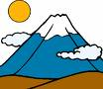](http://images.google.co.jp/imgres?imgurl=http://www.beorcscire.co.uk/pirates/mountain_clipart_9_1_.gif&imgrefurl=http://www.beorcscire.co.uk/pirates/word.htm&usg=__7y3_PXmPEDTXqghnyFBj2lJeSuc=&h=174&w=200&sz=5&hl=ja&start=1&tbnid=voRmd2fyZB3aHM:&tbnh=90&tbnw=104&prev=/images?q=mountain+clip+art&gbv=2&hl=ja&sa=G)[](http://images.google.co.jp/imgres?imgurl=http://www.dailyclipart.net/wp-content/uploads/medium/clipart0076.jpg&imgrefurl=http://www.dailyclipart.net/clipart/squirrel-clip-art/&usg=__KYVDZ1UEbYp9WBxzZgKN9NqirKo=&h=340&w=340&sz=17&hl=ja&start=1&tbnid=Pz_5iAl4XkqQhM:&tbnh=119&tbnw=119&prev=/images?q=squirrel+clip+art&gbv=2&hl=ja&sa=G)

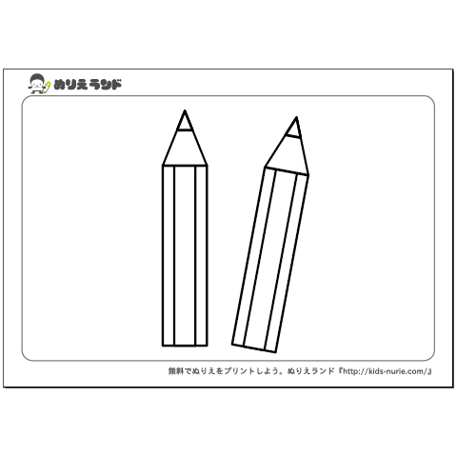なに　いろ　です　か。

**なん　ようび　です　か。**

日

月

火

水

木

金

土



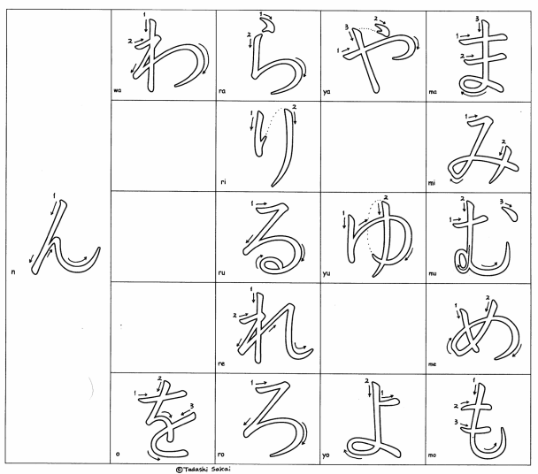　　　あお



　　　あか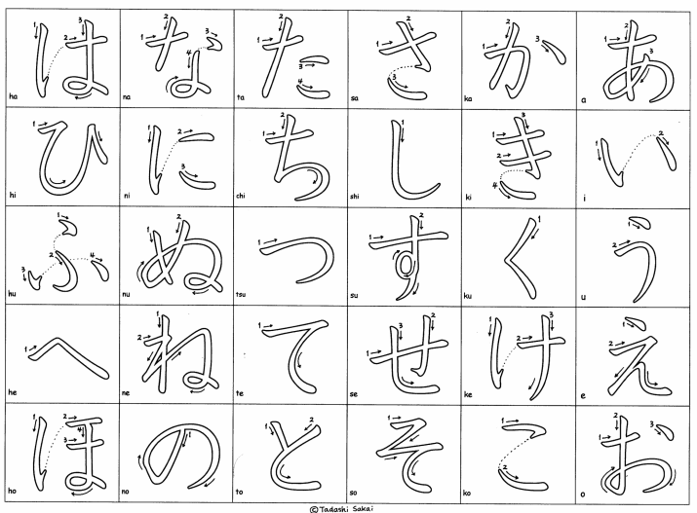



　　　しろ

くろ



みどり

きいろ



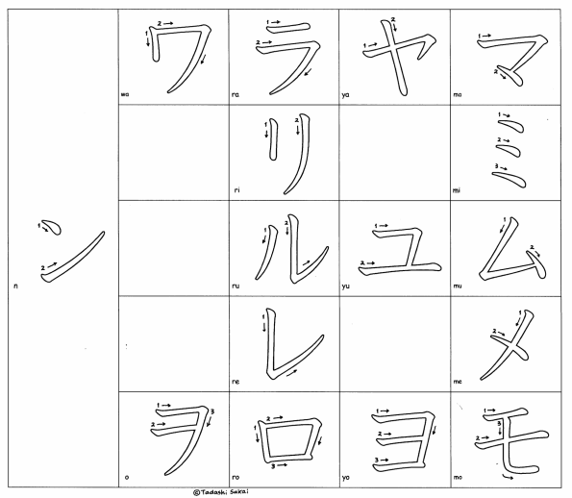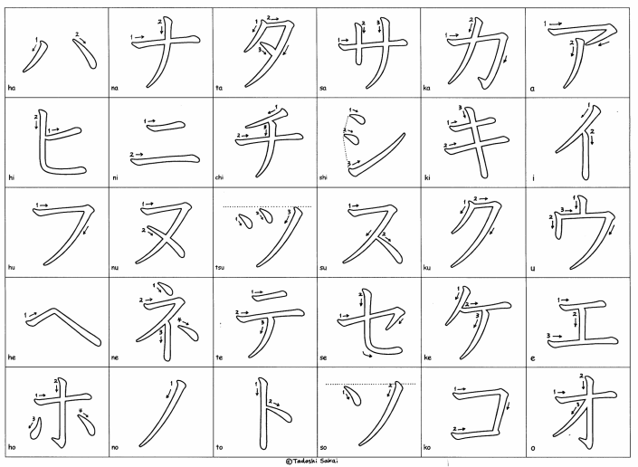ちゃいろ



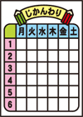むらさき



きんいろ

ぎんいろ



　　　ピンク

オレンジ

*Make a comment about the weather!*

*いいてんきですね。*

*あついですね。*

*さむいですね。*

*あめですね。*



はれ　　 　 あめ　　　　くもり　　　ゆき　　　　あつい　　　さむい

[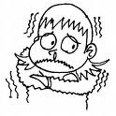](http://images.google.co.jp/imgres?imgurl=http://www.wesdarc.org.au/clipart/images/0_drug_effects/0004_cold.jpg&imgrefurl=http://www.wesdarc.org.au/clipart/drug.html&usg=__c5M_h4petsSBUDr9CbalSZRHQQM=&h=399&w=400&sz=40&hl=ja&start=18&um=1&tbnid=4oYAVCVZ8zs1sM:&tbnh=124&tbnw=124&prev=/images?q=cold+clip+art&hl=ja&lr=&sa=G&um=1)グレー

[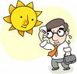](http://images.google.co.jp/imgres?imgurl=http://www.fotosearch.com/bthumb/UNC/UNC251/u10591574.jpg&imgrefurl=http://www.fotosearch.com/clip-art/hot-weather.html&usg=__nDQAzrWpsXi3RloP7zs5FzZFbhQ=&h=163&w=170&sz=10&hl=ja&start=1&um=1&tbnid=DiTSsvyC6orLnM:&tbnh=95&tbnw=99&prev=/images?q=hot+weather+clip+art&hl=ja&lr=&sa=G&um=1)[](http://images.google.co.jp/imgres?imgurl=http://www.clker.com/cliparts/3/4/e/d/12284285361061964999sivvus_weather_symbols_5.svg.hi.png&imgrefurl=http://www.clker.com/clipart-25249.html&usg=__2IXifaz5doLd3QNYj-W_6AJu6TM=&h=497&w=600&sz=95&hl=ja&start=29&um=1&tbnid=f8TZiVjZo21c-M:&tbnh=112&tbnw=135&prev=/images?q=weather+clip+art&ndsp=20&hl=ja&lr=&sa=N&start=20&um=1)[](http://images.google.co.jp/imgres?imgurl=http://www.clipartreview.com/_gallery/_TN/r_181.jpg&imgrefurl=http://www.clipartreview.com/_gallery/_search_term_pages/weather.html&usg=__NJV8_7lmT18mNGFSlUh2ti6M4Ug=&h=150&w=150&sz=7&hl=ja&start=5&um=1&tbnid=76UDo-AtYlxvdM:&tbnh=96&tbnw=96&prev=/images?q=weather+clip+art&hl=ja&lr=&sa=G&um=1)

こん

ワインレッド