なまえ：_______________________________________________ 組：5, 6, 7 _______月_____日
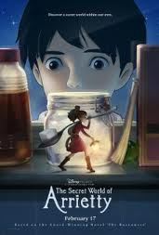
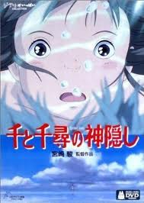
”The Secret World of Arrietty” by Hayao Miyazaki
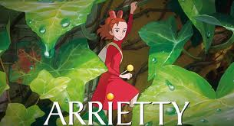
QUIZ! ！
1. Is this a Disney/ film?
A) Yes
B) No

2. How do the Borrowers survive?
A) Catching and eating bugs that enter the household
B) Praying on live animals and killing them with spears
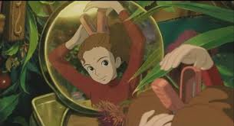
C) Borrowing items from the human’s household

3. What is the main young borrower’s name?
A) Naomi
B) Miya
` C) Arrietty

4. What is the name of the young boy the young girl borrower befriends?
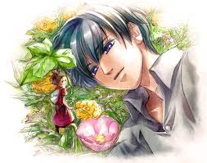
A) Takao
B) Sho
C) Nishiomiya

5. What does Sho see just before he discovers Arrietty?
A) He sees the cat, Niya, trying to attack something in the bushes.
B) He sees his great aunt flying a kite.
C) He sees the cat, Niya, chasing a mouse.

6. Arrietty’s Father, Pod, takes her on her first “borrowing” mission to collect which objects?
A) Sugar and tissue
B) Sugar and milk
C) Milk and tissue

7. Who is the director of this film?
A) Akiko Furusawa
B) Hayao Miyazaki
C) Hideki Mitsubishi

8. What happens the day after Arrietty loses the sugar cube during her first “borrowing” mission?
A) Sho goes straight to his grand aunt and tells her
B) Sho leaves the dropped sugar cube beside the underground air vent where he first saw
Arrietty
C) Sho leaves a bowl of sugar cubes near the entrance to the underground

9. Why did Pod and Homily decide they must move out of the house?
A) They had been detected by Sho
B) They could not afford the rent any more
C) They decided they needed a larger house

10. What does Sho do in the hope the Borrowers would accept his knowledge of their existence?
A) Offers them money
B) Replaces their kitchen with the one from the doll’s house
C) Paints their home
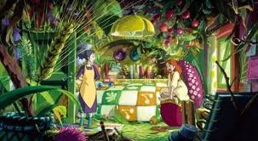
11. Who helps Pod home when he is injured?
A) Spiller
B) Splinter
C) Sam

12. What medical condition does Sho suffer from?
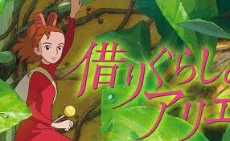
A) A heart condition
B) Cancer
C) The flu

13. How does Haru, the maid, try to get rid of the Borrowers?
A) She uses food as a trap
B) She used a mouse trap to capture them
C) She calls the pest control company
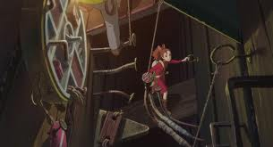
14. What does Arrietty give show as a token of her remembrance?
A) Her hair clip
B) Her bracelet
C) Her head band

How many stars did you give The Secret World of Arrietty?

15) On the lines below, write a DIFFERENT ending to the story. Use your imagination!
______________________________________________________________________________________________________________________________________________________________________________________________________________________________________________

Answers:
1. a
2. c
3. c
4. b
5. a
6. a
7. b
8. b
9. a
10. b
11. a
12. a
13. c
14. a

