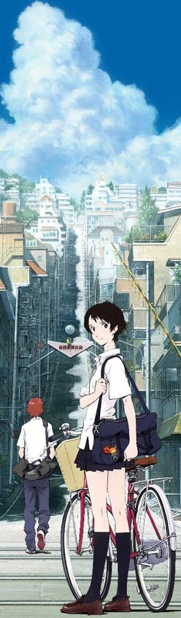
The girl who leapt through time
ときを かける しょうじょ
DVD Task Sheet

- Name three main characters in Japanese.
………………………………………………………………
……………………………………………………………….
- What food does Makoto have difficulty cooking in cooking class?
……………………………………………………………………
- At what time does Makoto have a bicycle accident?
………………………………………………………………
- Who did she talk to about her powers? What was her job?
……………………………………………………………………………………………………………………………………………………………………………...
- What did Makoto’s aunt tell her about her experience in high school?
…………………………………………………………………………………………………………………............................................................................................
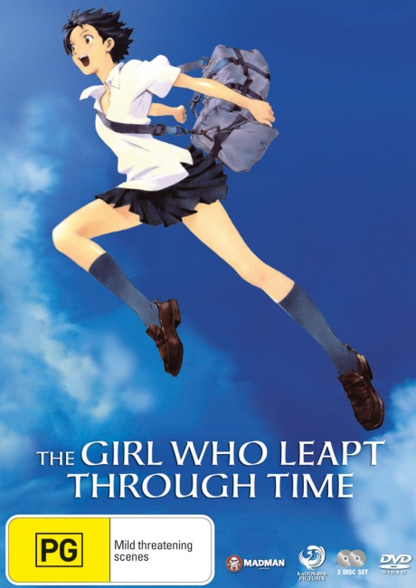
- What difference does she say Makoto has which she didn’t?
………………………………………………………………………………………………………………….............................................................................................
- What did Makoto do with her newly found power?
………………………………………………………………………………………………………………….............................................................................................
………………………………………………………………………………………………………………….............................................................................................

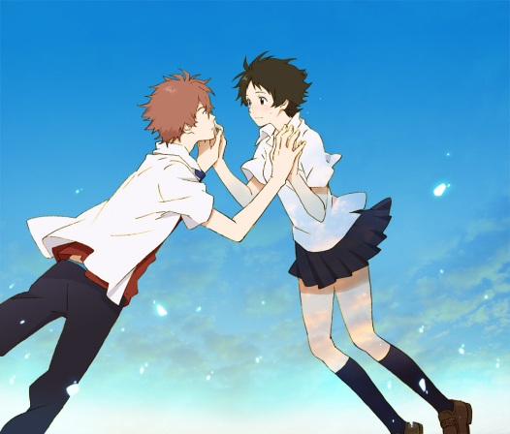
- What differences exist in the era that Chiaki is from? Name three.
……………………………………………………………………………………..
…………………………………………………………………………………………………………………...............................................................................
- What is the purpose of Chiaki coming back from his time?
…………………………………………………………………………………………………………………............................................................................................
- Discuss the implications of time travel with reference to problems Makoto faced.
…………………………………………………………………………………………………………………..................…………………………………………………………………………………………………………………..................
…………………………………………………………………………………………………………………...............

11. A theme that runs throughout the whole movie is “Time waits for no one”.
Discuss this in relation to issues seen throughout the movie.




