相撲（すもう）sumo
What is sumo?

Sumo is the national sport of Japan. It is a match of two sumo wrestlers
Rikishi(りきし)
(りきし) who wear only belly belt(まわし) in the ring(どひょう).
Mage（まげ）
Topknot
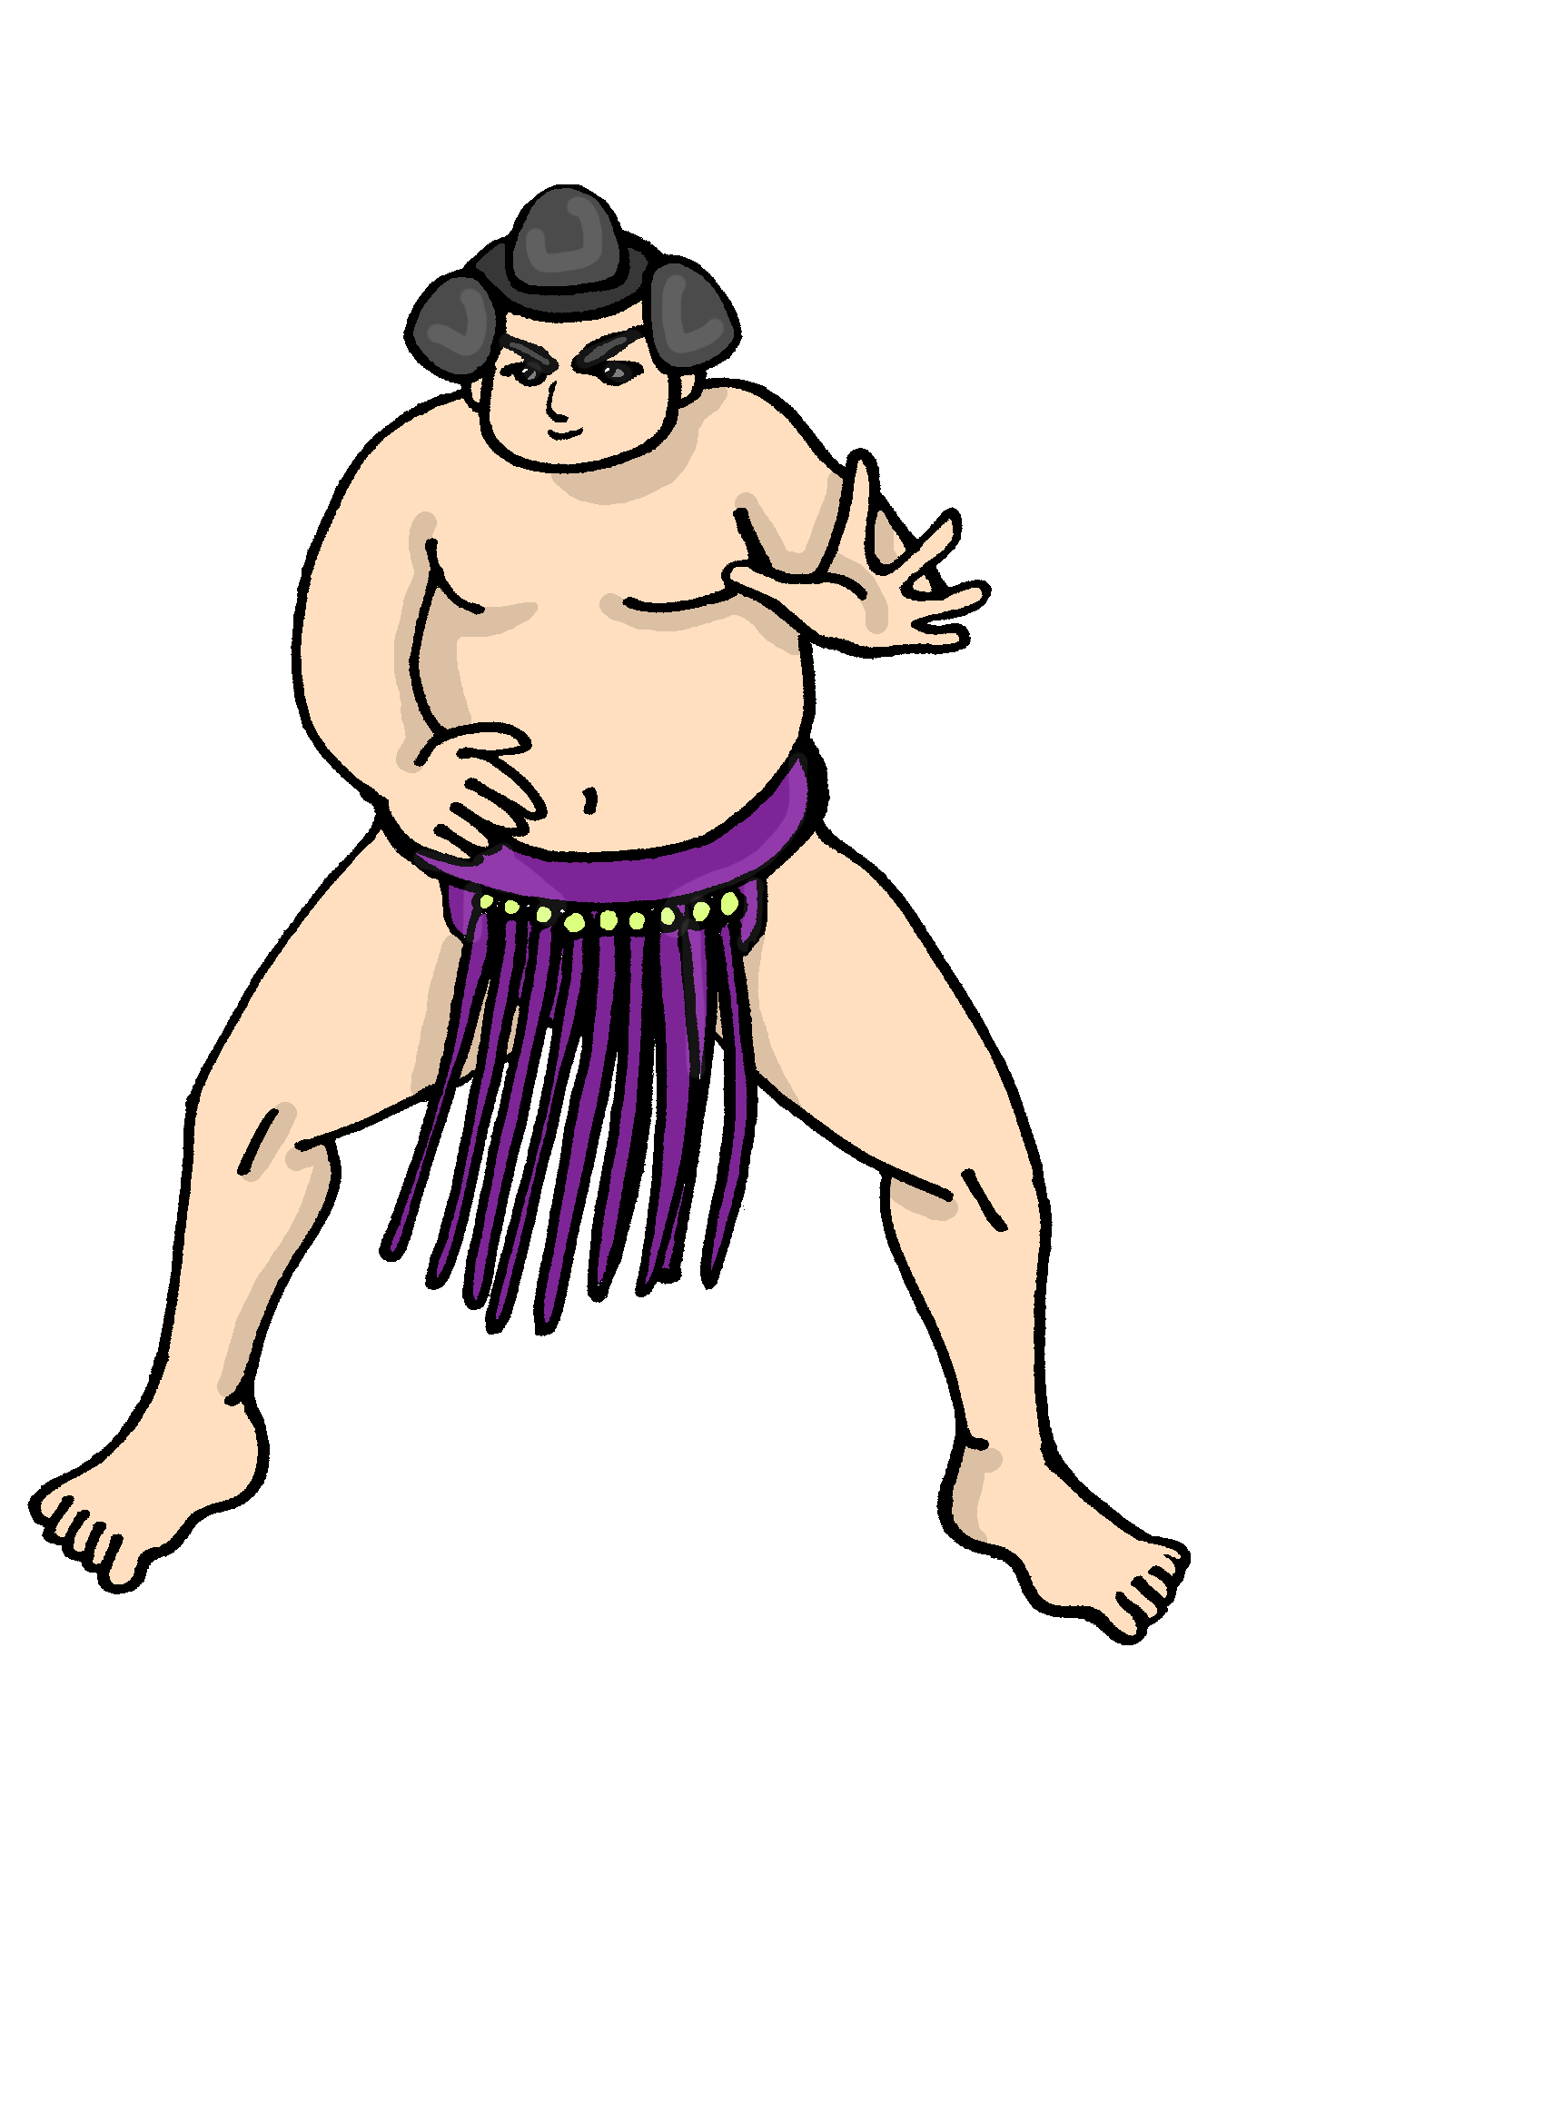
What is ozumo?
The Japan Sumo Association
Height
Over 173 cm

Weight
Over 75 kg
holds 6 tournaments a year on
Jan, Mar, May, Jul, Sep and Nov.
Mawashi（まわし）
Silk belt
10m long
4-5 kg
Who is the winner?
The winner is decided when the
Sagari（さがり）
Stiff fringe 17-21 pieces
opponent is forced out of the ring
or when any part of his body
touches the grand.
Gyoji
（ぎょうじ）
Referee
Gunbai
（ぐんばい）
Referee’s fan
Dohyo（どひょう）

Shikirisen
（しきりせん）
Starting line
Chikaramizu
（ちからみず）
Water bucket to purify the mouth and body with water.
Salt basket
To purify the ring
4.55m across
