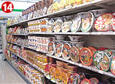
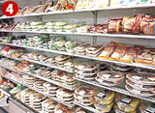
SHOPPING – JAPAN

Go to http://web-japan.org/nipponia/archives/en/life_culture/shopping.html and answer the questions below.

- What is the Japanese word for “convenience store”?
_______________________________________________________________________________

- When did convenience stores come to Japan and when?
_______________________________________________________________________________

- Why were they popular?
_______________________________________________________________________________

- What are some advantages of having a POS system that links back the main franchisor?
_____________________________________________________________________________________________________________________________________________________________________________________________________________________________________________

- When and where did the first Seven-Eleven convenience store open in Japan?
_______________________________________________________________________________

- In what year did convenience stores start to sell video games?
_______________________________________________________________________________

- On average, there is one convenience store for how many people?
_______________________________________________________________________________

- What type of food is “Onigiri”? (describe it)
_______________________________________________________________________________

- Why is it convenience stores do so well? (make reference to buying trends)
_______________________________________________________________________________

- How are some convenience stores evolving beyond ordinary services?
_______________________________________________________________________________

- What is the emergency telephone number in Japan?
_______________________________________________________________________________

- What are the top ten product types sold in convenience stores?
_______________________________________________________________________________

- What is the benefit of a “100 Yen Shop”?
_______________________________________________________________________________
