Main Characters:

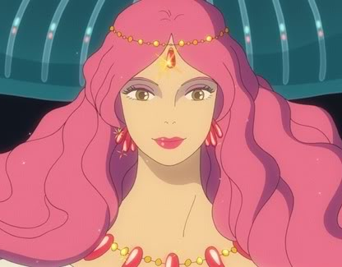
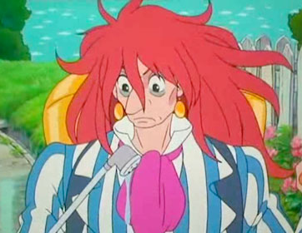
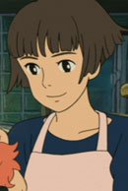
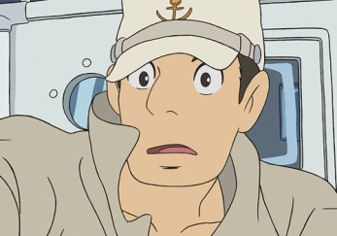

FUJIMOTO
GRANMAMARE
KOUICHI
LISA
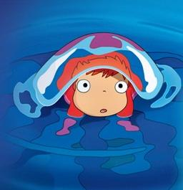
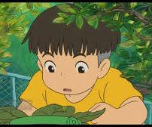

PONYO
SOUSUKE

1) How do you write “In the beginning”? _____________________________

2) ポニョは＿＿＿＿＿です。
Choose one(いぬ、ねこ、きんぎょ、とり、にんげん)

3) Why is Fujimoto spraying water on the ground? ________________________________________________________________________________________________________________________________

4) ポニョは＿＿＿＿がすきです。
(くだもの、はむ、けーき、にく、やさい)

5) How do you say “Hurry up”? ________________________________________________________________

6) What does ‘いってらしゃい’ mean in English? ________________________________________________________________

7) What does ‘いってきます’ mean in English? ________________________________________________________________

8) In the school’s げんかん(entrance) the children put their shoes in a
げたばこ. What do you think this is in English? ________________________________________________________________

9) What Japanese word do Lisa and the ladies at the senior centre use to describe Ponyo?
________________________________________________________________

10) そうすけくん は ＿＿ さいです。
（三、四、五、六、七）

11) What is Ponyo’s real name? ________________________________________________________________

12) ポニョは＿＿＿がほしいです。
（て-hands, あし-legs, は-teeth）

13) ばんごはんに ＿＿＿＿＿＿をたべます。
(すし、ぴざ、らーめん、さかな)

14) What does Ponyo have to do in order to become human permanently? ________________________________________________________________________________________________________________________________________________________________________________________________
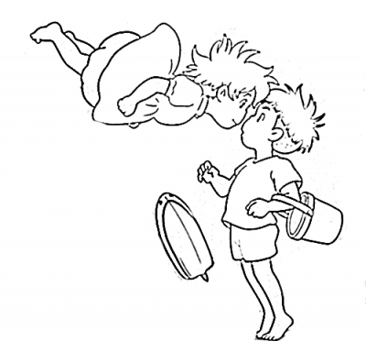
いろ

あか 一

みどり 二

くろ 三

しろ 四

おれんじ 五

きいろ 六

ちゃいろ 七

はいいろ 八

ぴーち 九

四
五
一
三
九
九

六

二
八
七

