の
- Read this text about New Year in Japan. Then answer the questions.
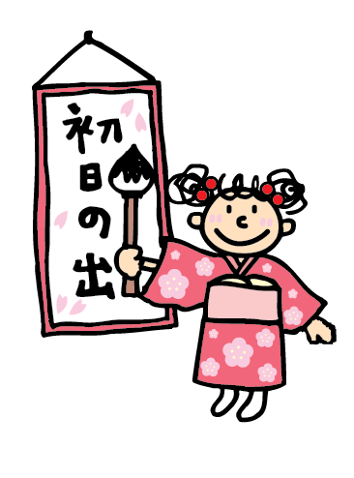
は普通一月一日から七日までを言います。日本では最も大切な行事の一つで、親戚が集まって新年のあいさつをしたり、初詣に行ったりします。伝統的な食べ物、遊び、行事などもたくさんあります。会社や店も休むところが多いです。

NEW WORDS
正月 New Year
最も大切 the most important
行事 event/activity
親戚 relatives
初詣 first shrine visit of the year
伝統的 traditional

- 正月はいつからいつまでですか。___________________________________________

- 正月の時、何をしますか。___________________________________________

- 会社や店は開いていますか。
___________________________________________

- How do you say ‘Happy New Year’ in Japanese? Read and listen to the two conversations below. Then practice them with a partner.

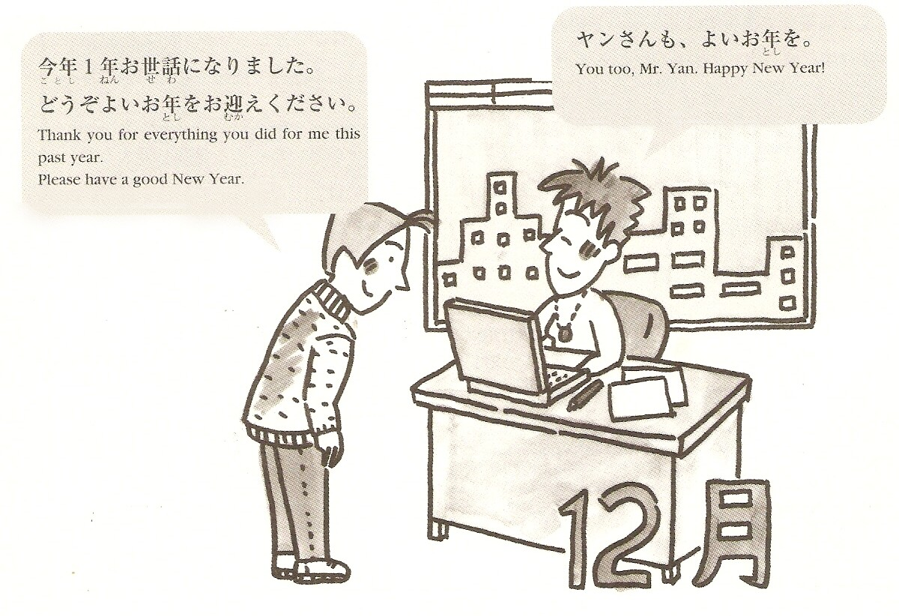
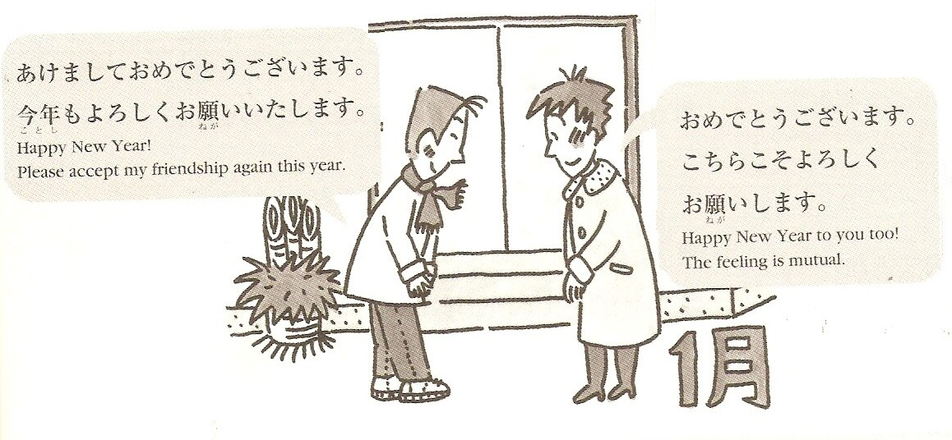
Pictures and texts adapted from: Nihongo Journal December 2002 ALC press inc www.alc.co.jp

- In Japan there are a variety of customs and events in the New Year period. Look at the traditions below. Match the pictures with the Japanese in the box.

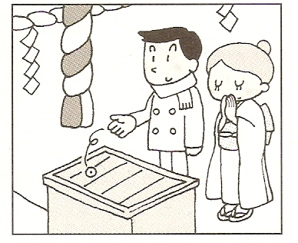
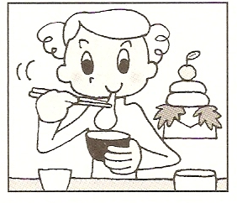
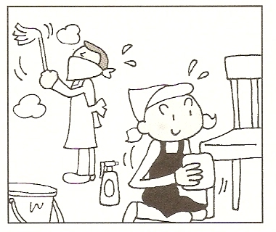

________________________ _________________________ _____________________
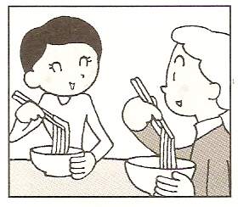
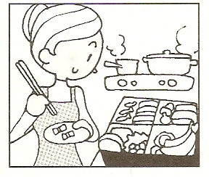
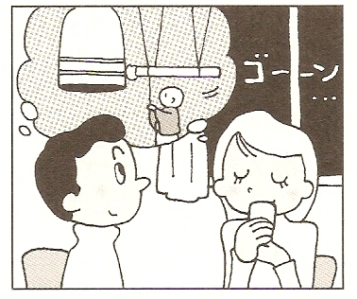

________________________ _________________________ _____________________
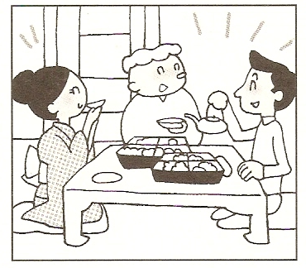
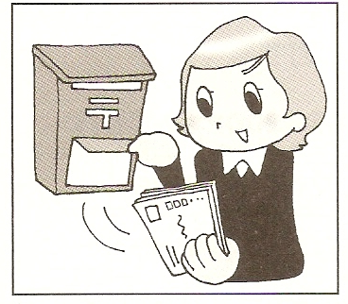
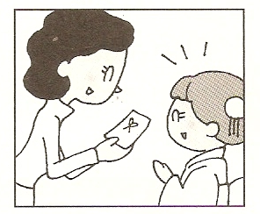

________________________ _________________________ _____________________
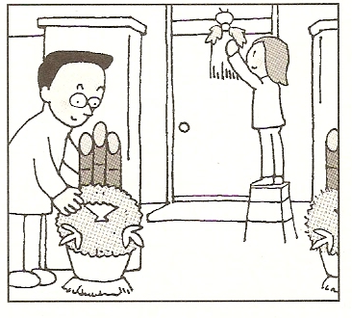
に行く お雑煮を食べる
門松やお飾りを飾る 年越しそばを食べる
大掃除をする お年玉をあげる
おせち料理を作る 年賀状をもらう
除夜の鐘を聞く 新年会を開く

________________________
- Discuss with a partner:
オーストラリアでは、年末年始をどのように過ごしますか。

- Japanese 年賀状 （New Year postcards） often use the present year’s Chinese zodiac (干支) as the main design. 2008 was the year of the ねずみ. What is this year’s zodiac?
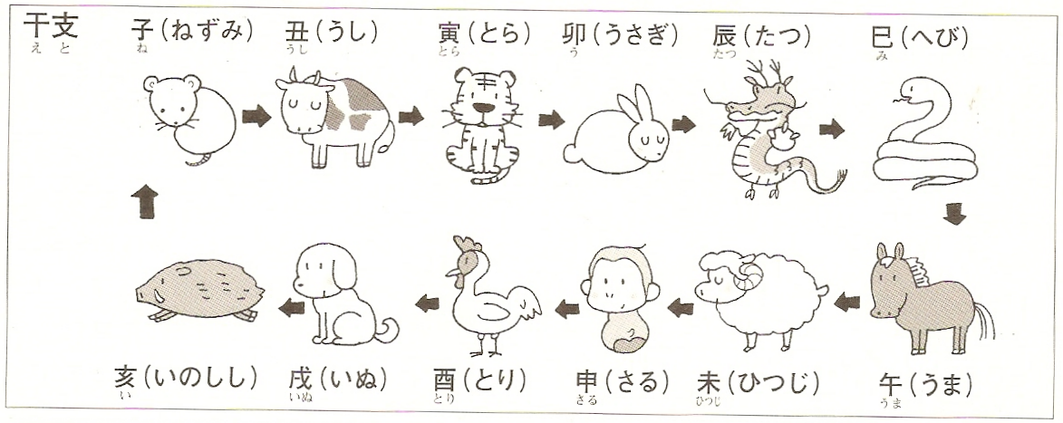
- Let’s make a 年賀状.
Research ‘nengajoo’ or ‘nengajyo’ on the Internet. These sites might help you get some ideas:
- http://www.nengajoo.com/unique/
- http://print-e-shop.com/service_menu/nenga_design/nenga_design-b.html
- http://www.japaneseform.com/en/otherhtm/nengajyo.htm

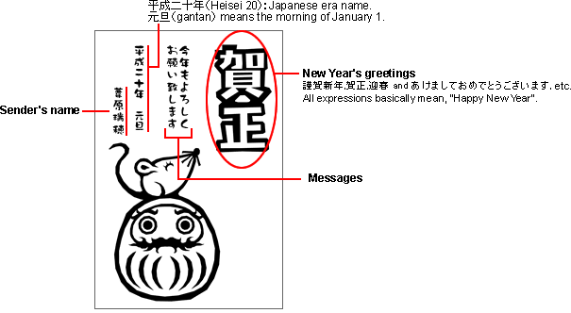

‘Happy New Year’ in Japanese: | Other expressions
けましておめでとうございます｡  おめでとうございます｡  んでのお喜びを申し上げます｡ | はお世話になりありがとうございました｡  Thank you for all your kind help during the past year.  もどうぞよろしくおいします｡  I hope for your continued favour this year.  のごをお祈り申し上げます｡  Wishing everyone good health.

Use this template to make a New Year’s card. Use this year’s 干支 as your main theme.

ANSWERS:
1.
- からまで From January 1 until January 7
- がまって新年のあいさつをしたり、初詣に行ったりします。伝統的な食べ、遊び、行事などもたくさんあります。Relatives get together to exchange New Year greetings and to make their first visit of the year to a shrine. There are many kinds of traditional foods, games and activities for the New Year.
- あいていません。会社やも休むところが多いです。They’re not open. Businesses and shops often close down for this period.

3.
にく 大掃除をする おを食べる
First shrine visit of the year Big clean up Eat mochi cake soup

のを聞く おせちを作る 年越しそばをべる
Listen to the temple bell Make New Year obento Eat ‘Year end’ soba
rung 108 times on New Year's Eve

おをあげる 年賀状をもらう 新年会をく
Give New Year money gift Receive New Year postcards Have a New Years party

やお飾りを飾る
Hang up ‘Gate pine’ and
New Year ‘offering’ decorations

2009 うし
2010 とら
2011 うさぎ
2012 たつ
2013 へび etc.

