名前＿＿＿＿＿＿＿＿＿＿
＿＿＿＿月＿＿＿＿日
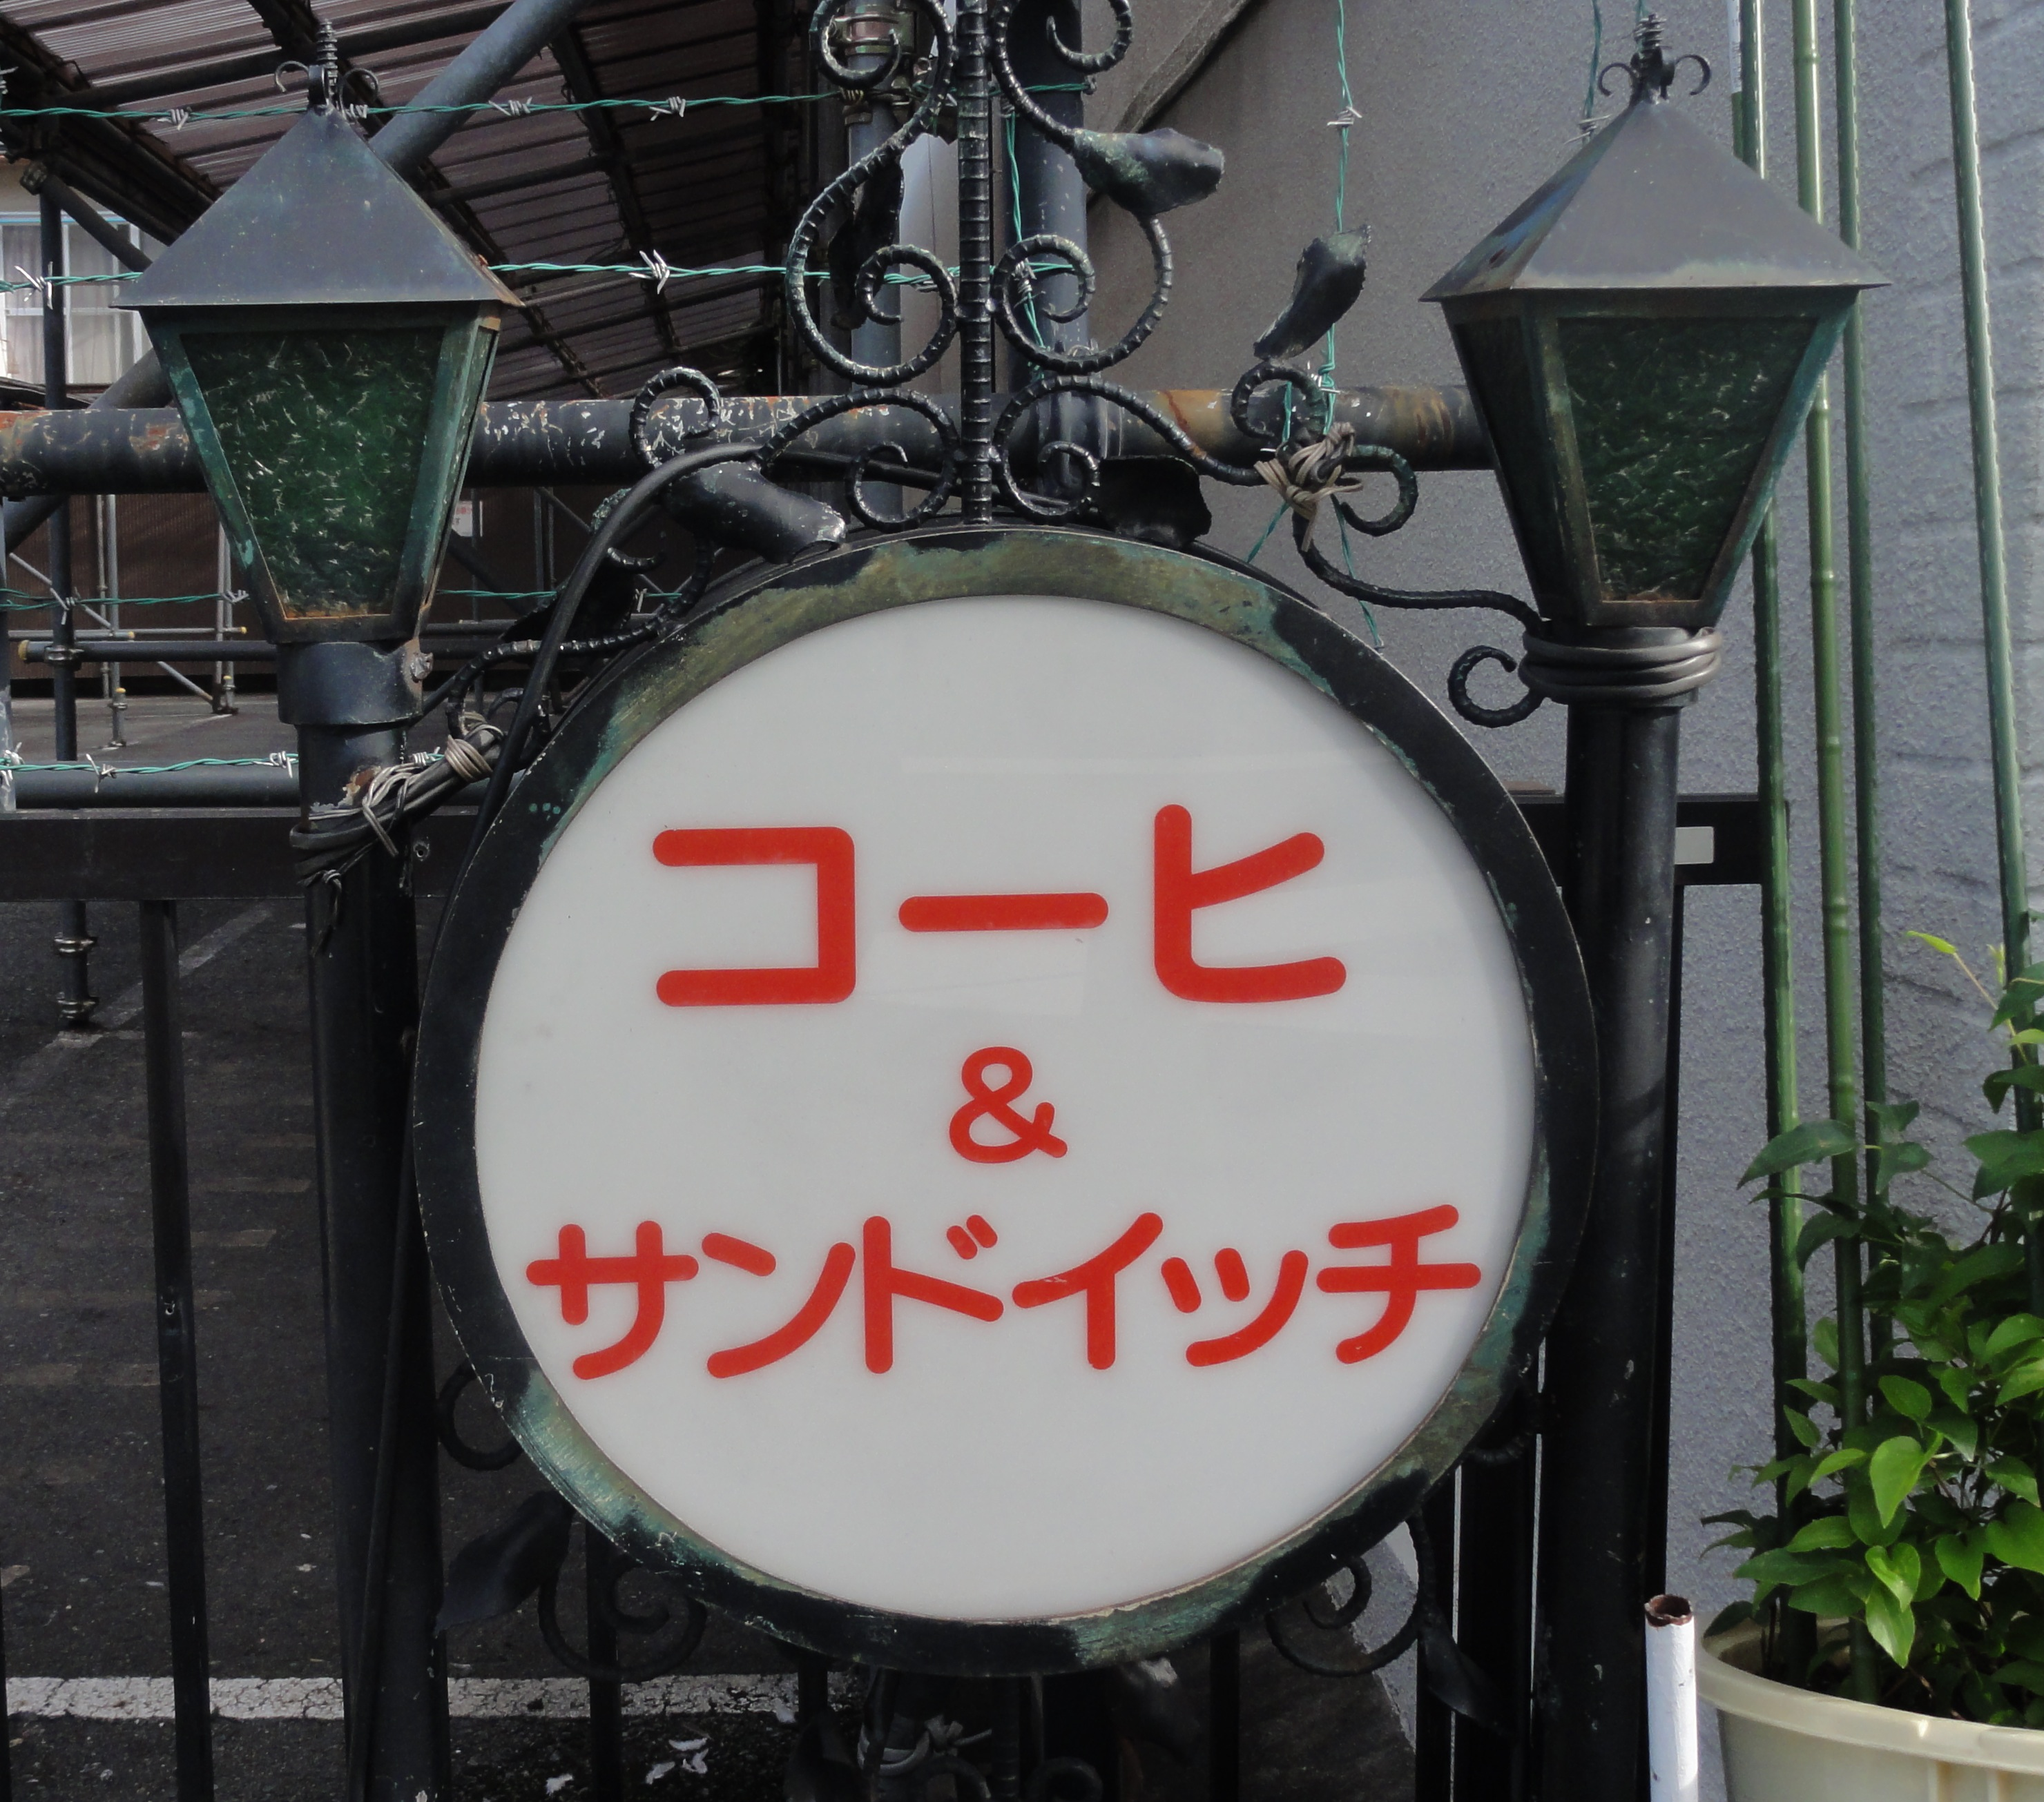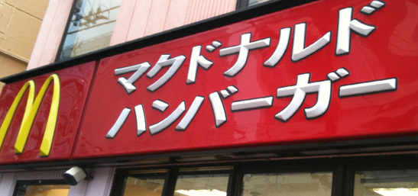
Katakana Assignment
Rules
- For a long vowel sound simply add a dash.
e.g. taa ター niiニー

2. The small tsu rule still applies to make a double consonant.
e.g. mappu マップ (map) chiketto チケット(ticket)

3. The small ya, yu, yo rule still applies. You can also make other sounds
by combining katakana.
e.g. sha シャ jyo ジョ tiティ sheシェ

4. Pay attention to the difference between tsu and shi , n and so. With
tsu, so and no the tick starts from the top and with shi and n the tick
starts from the bottom.
e.g. tsu ツ so ソ noノ shi シ nン

5. Remember that katakana are drawn a lot squarer than hiragana (which
should be soft)

Task 1
Design your own katakana chart. /10

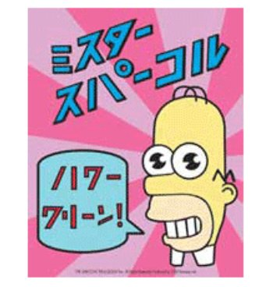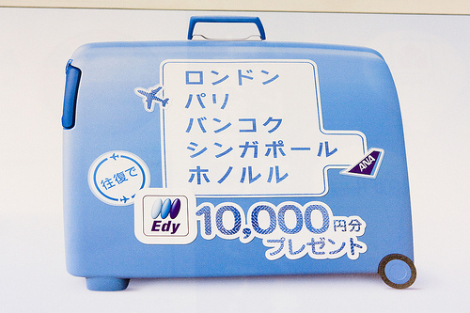
Task 2
Match up the following:
シ |  | A | SU |  | ネ
ラ |  | MA | KO |  | ヨ
ヘ |  | SHI | HA |  | ツ
ヌ |  | N | TO |  | ケ
ア |  | RA | HI |  | ミ
リ |  | TE | YO |  | ス
エ |  | I | SA |  | ハ
ノ |  | NO | MI |  | ヒ
ク |  | FU | KE |  | サ
レ |  | SE | TSU |  | ロ
イ |  | KU | NE |  | ム
ン |  | NU | SO |  | コ
フ |  | WA | U |  | ト
マ |  | RI | MU |  | ユ
ワ |  | HE | RU |  | ソ
テ |  | CHI | HO |  | ナ
ニ |  | E | KI |  | タ
セ |  | YA | ME |  | ウ
モ |  | RE | O |  | ホ
ヤ |  | WO | NA |  | ル
チ |  | KA | YU |  | メ
カ |  | NI | RO |  | オ
ヲ |  | MO | TA |  | キ
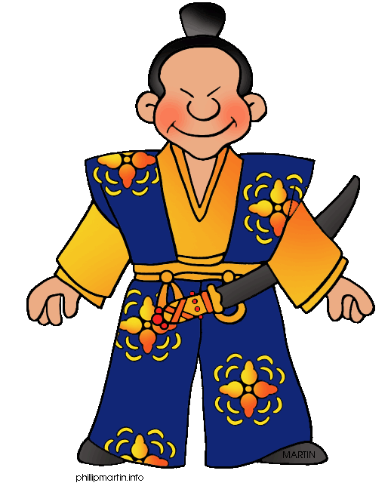 /10
Task 3
Write the names of members of your class:

ENGLISH | ROMAJI | KATAKANA

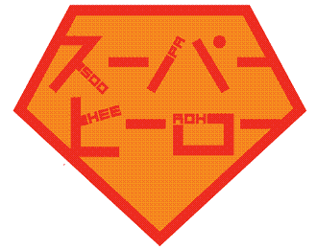 /20

Task 4
Can you recognize the following TV programs or movies?
KATAKANA | ROMAJI | ENGLISH
ザ シンプソンズ
ネイバーズ
バッグズ バニー
トワイライト
ビグ・バン・セオリ
マスター シェフ
シュレック
ハリー・ポッター
ザ ホビット
アバター

Can you recognize the following famous people?
KATAKANA | ROMAJI | ENGLISH
ワン ダイレクション
ケビン ラッド
リアナ
レディ ガガ
イアン ショープ
デルター グッヅラム
リッキー ポンティング
ケーチー ペリー
ウィル スミシュ
バディー フランクリン

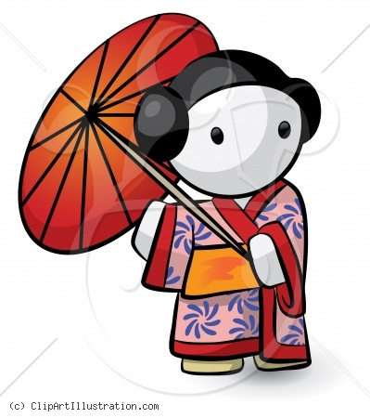 /20
Task 5 Choose one:

- Create a cartoon strip, use lots of action/sound words (these are written in katakana in Japanese manga)
e.g. キイイ！=Shriek!, オリャ! = Take that!,ドン = explosion

- Create a menu for your own restaurant (Western food is
written in katakana)
e.g. パスター = past, ピザ = pizza, ステーキ = steak

- Create a TV guide for your own sports channel. (Western
sports are written in katakana)
e.g. バスケットボール = basketball, ゴルフ = golf,
サッカー = soccer

- Create a fashion catalogue and label the clothes in katakana. (Western clothes are written
in katakana)
e.g. Tシャツ = T shirt, スカート = skirt, ベルト = belt

5. Create a map and label the countries and cities in katakana. (Most country names are written in katakana)
e.g. オーストラリア = Australia, アメリカ = America,
イギリス = England

- A creative product using katakana of your own choosing.

/20
