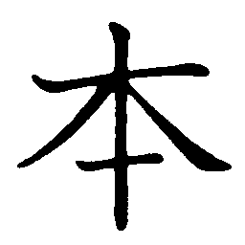 |  |  |  | On Readings  ホン  Kun Readings  もと |  |  |  | Meaning  book; present; main; origin; true; real; counter for long cylindrical things |  |  |  |  |  | 5 Strokes
 |  |  |  | 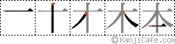

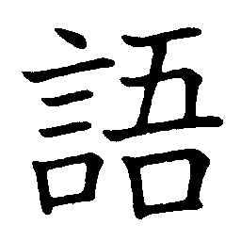 |  |  |  | On Readings  ゴ  Kun Readings  かたる |  |  |  | Meaning  Word, speech, language |  |  |  |  |  | 14 Strokes
 |  |  |  | 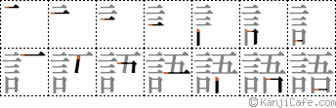

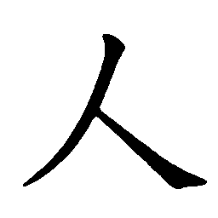 |  |  |  | On Readings  ジン・ニン  Kun Readings  ひと |  |  |  | Meaning  person |  |  |  |  |  | 2 Strokes
 |  |  |  | 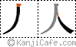

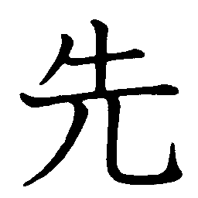 |  |  |  | On Readings  sen  Kun Readings  saki |  |  |  | Meaning  Ahead, before, previous, future, precendence |  |  |  |  |  | 6 Strokes
 |  |  |  | 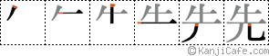

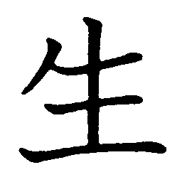 |  |  |  | On Readings  せい  Kun Readings  うまれる |  |  |  | Meaning  Life, genuine, birth |  |  |  |  |  | 14 Strokes
 |  |  |  | 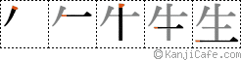

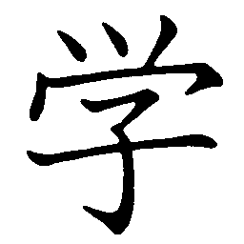 |  |  |  | On Readings  がく  Kun Readings  まなぶ |  |  |  | Meaning  Study, learning, science |  |  |  |  |  | 8 Strokes
 |  |  |  | 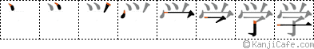

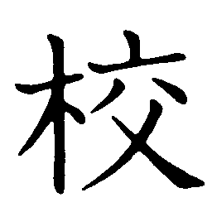 |  |  |  | On Readings  こう  Kun Readings |  |  |  | Meaning  Exam, school, printing, proof, correction |  |  |  |  |  | 14 Strokes
 |  |  |  | 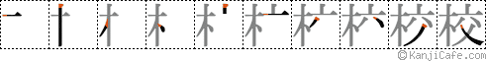

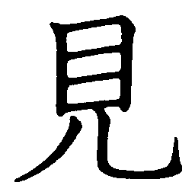 |  |  |  | On Readings  けん  Kun Readings  みる |  |  |  | Meaning  see, hopes, chances, idea, opinion, look at, visible |  |  |  |  |  | 7 Strokes
 |  |  |  | 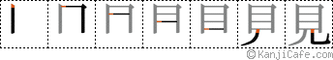

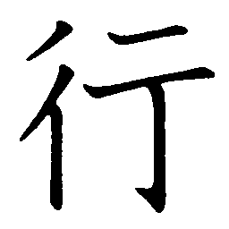 |  |  |  | On Readings  こう  Kun Readings  いく |  |  |  | Meaning  Going, journey |  |  |  |  |  | 6 Strokes
 |  |  |  | 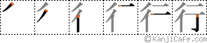

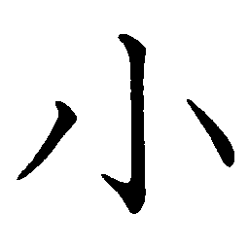 |  |  |  | On Readings  しょう  Kun Readings  ちいさい |  |  |  | Meaning  Small, little |  |  |  |  |  | 3 Strokes
 |  |  |  | 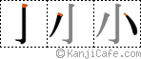

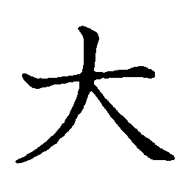 |  |  |  | On Readings  だい  Kun Readings  おおきい |  |  |  | Meaning  big |  |  |  |  |  | 3 Strokes
 |  |  |  | 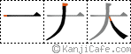

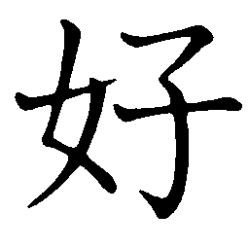 |  |  |  | On Readings  すき  Kun Readings  このむ |  |  |  | Meaning  Fond, pleasing, like something |  |  |  |  |  | 5 Strokes
 |  |  |  | 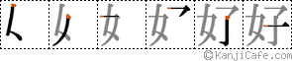

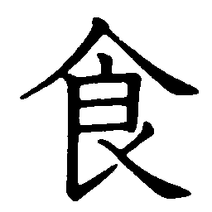 |  |  |  | On Readings  しょく  Kun Readings  たべる |  |  |  | Meaning  Eat, food |  |  |  |  |  | 9 Strokes
 |  |  |  | 