Kanji Numbers を かいて ください。
Practise the kanji numbers in the boxes provided.
1 | Ichi  いち |  |  |  |  |  |  |  |  |  |  | 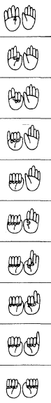
2 | ni  に
3 | san  さん | 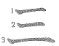
4 | yon  shi | 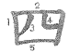
5 | go  ご | 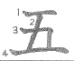
6 | roku  ろく | 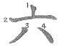
7 | nana  なな | 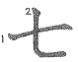
8 | hachi  はち | 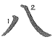
9 | kyuu  きゅう | 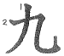
10 | juu  じゅう | 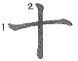
Continue with the next ten numbers. What do you think these would be?
11 |  |  |  | 16 |  |  |  | 26
12 |  |  |  | 17 |  |  |  | 28
13 |  |  |  | 18 |  |  |  | 34
14 |  |  |  | 19 |  |  |  | 47
15 |  |  |  | 20 |  |  |  | 51

