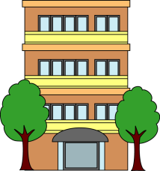
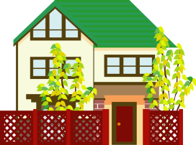
Japanese Houses
日本の家
Australian and Japanese houses have many similarities but there are some differences as well. Often Japanese houses are much smaller than what we are used to in Australia and sometimes the same room will be used for sleeping, eating and watching TV depending on the time of day. There are also a number of customs that should be followed when visiting a Japanese house, such as taking off your shoes before entering and wearing special slippers to the toilet. Explore these differences using the website below and complete the following activities.

Japanese House Explorer
http://www1.curriculum.edu.au/nalsas/explorers/japanese/explorers.html

1. Write the meaning of the following words
ひょうさつ |  | すいはんき
いなか |  | こたつ
むら |  | せんたくき
入り口 |  | はし
ようしつ |  | うえき
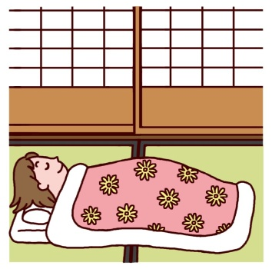
2. Answering the following questions in your exercise book.
- When renting a Japanese house you must pay しききん and れいきん. Explain the difference between these two.
- What is a げんかん?
- What should you say when entering the げんかん?
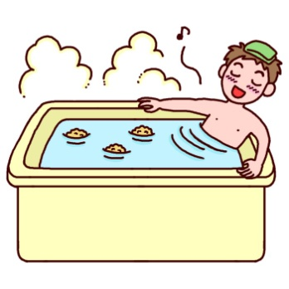
- When preparing your futon what are the different parts you need? (eg. pillow, mattress)
- How are room sizes measured in Japan?
- What is とこのま?
- Why aren’t ovens common in Japanese kitchens?
- Describe the process for taking a bath Japanese-style?
- What type of fish is often kept in Japanese garden ponds?

3. Practice writing the following kanji using The Shoji website (www.theshoji.com)
いえ カ  house  家 | にわ テイ  garden  庭 | デン  electric  電 | わ  peace, Japanese  和 | シツ  room  室

